AMERICAN Journal of Language, Literacy and
Learning in STEM Education
Volume 02, Issue 01, 2024 ISSN (E): 2993-2769

Analysis of Different Methods for Obtaining Cocoa Butter Substitutes from Cotton Salum and Palmitines

Bafoeva Gulzhamol Nusratovna, Kayimov Fazliddin Samievich,
Majidov Kobil Gulyamovich, Ruzieva Zulhumor Allokulovna
Bukhara Engineering and Technology Institute, Bukhara State University

Abstract: In the article are analyzed some ways of reception of substitutes of cocoa butter (SCB) from cotton saturated fat and palmitines. We made conclusion that during hydrogenation of cotton palmitin till fusion temperature 40-42 o C and, further, interesting the received saturated palmitin fat with received by priming palmitin, it is possible to receive SCB with fusion and hardening temperature of 36-37 o C and 27 -28 o C, accordingly.
Keywords: cocoa butter, substitute cocoa butter, hydrogenation, interesterification, cotton palmitin, saturated fat, triacylglyceride.

Due to a significant increase in prices for cocoa butter in the world, research and development work is being intensively carried out to obtain its substitutes from local vegetable oils. In this case, the following processes for processing vegetable oils are used: hydrogenation, fractionation and transesterification of triglycerols [1].
At the first stage of processing vegetable oils, the goal is to bring the fatty acid composition of the resulting substitute to the indicators of natural cocoa butter, and at the second, the triglyceride composition to the indicators of the latter [2]. It should be noted that vegetable oils rich in palmitic acid (C _{16:0} and C _{16:1} ) should be subjected to such processing. These include palm, palm kernel and cottonseed, which contain palmitine more than 24% of the total weight of the oil.
In the countries of Central Asia, incl. Uzbekistan produces large quantities of cottonseed oil and palmitine, from which margarine, confectionery and baking fats are produced on an industrial scale [3].
Unfortunately, the confectionery and baking fats produced by Tashkent Yog-Moy Kombinaty JSC do not meet the requirements for cocoa butter substitutes in terms of melting and solidification temperatures, as well as hardness. Their compatibility with natural cocoa butter is very low, which does not make it possible to use them in the production of chocolate confectionery products [4,5].
We have analyzed several methods for producing cocoa butter substitutes (CBS) from cottonseed oils and palmitines.
The first method of obtaining ZMK was carried out according to the following scheme:
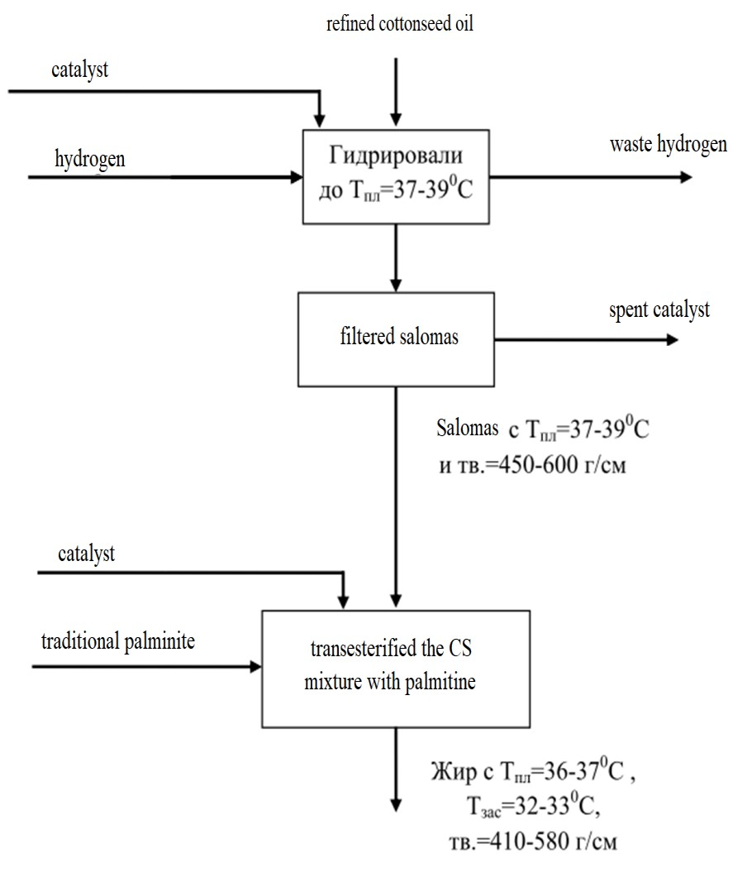
Fig. 1. The first scheme for obtaining ZMK using the methods of hydrogenation of CM and transesterification of a mixture of cottonseed oil with traditional palmitine.
From Fig.1. it is clear that the resulting fat has low hardness and a high pour point, which is far from these indicators of natural cocoa butter.
We carried out the second method of obtaining ZMK according to the following scheme:
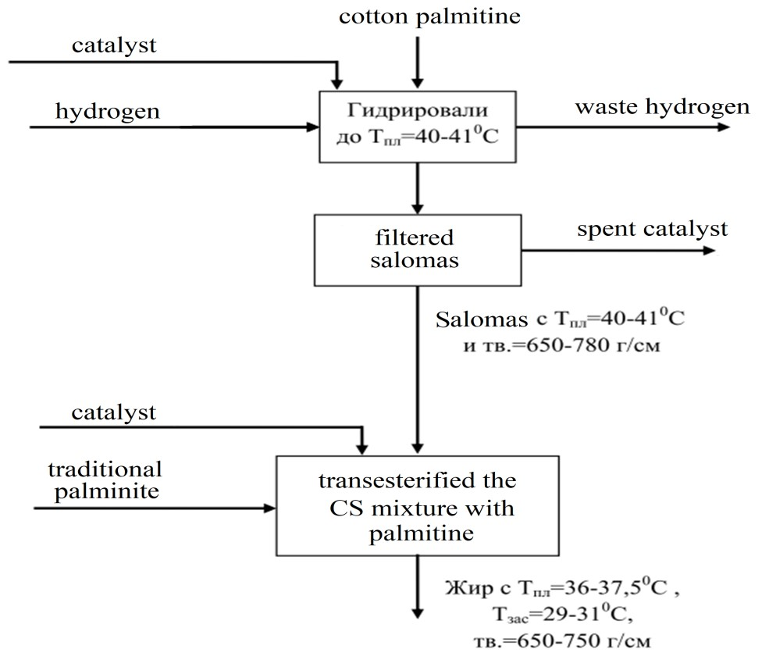
Fig.2. The second scheme for obtaining ZMK by hydrogenation of cotton palmitine and transesterification of a mixture of palmitic salomas with traditional palmitine.
From Fig.2. it is clear that the second method of obtaining ZMK by hydrogenation of cotton palmitine and transesterification of a mixture of palmitic lard with traditional palmitine also does not satisfy the requirements for natural cocoa butter in terms of the pour point and hardness of the resulting ZMK.
It is known that during low-temperature fractionation of cottonseed oil, the use of seeds (transesterified CM, beef or lamb fat, etc.) makes it possible to increase the content of palmitic acid in the resulting palmitic fraction by 7-10%, which gives grounds to use such palmitine in the production of ZMK [6 ,7].
We carried out the third method of obtaining ZMK according to the following scheme:
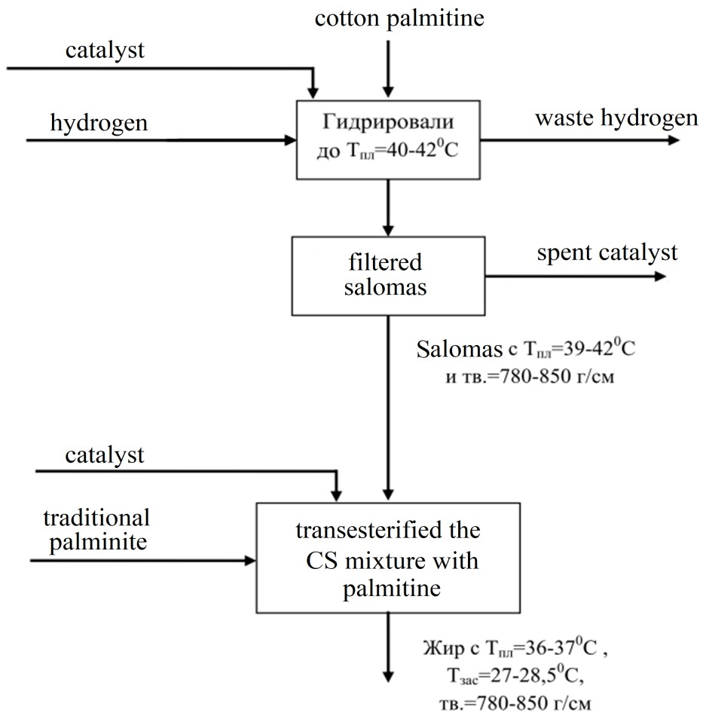
Fig.3. The third scheme for obtaining ZMK by hydrogenation of cotton palmitine and transesterification of a mixture of palmitic salomas with palmitine obtained with a seed.
From Fig. 3 it is clear that the fat obtained according to this scheme has similar melting and freezing temperatures, as well as hardness, to the corresponding indicators of natural cocoa butter. This is achieved by enriching the resulting fat, i.e. ZMK palmitic acid in triacylglycerides.
Table 1 presents comparative data on the main indicators of natural cocoa butter (control) and the obtained ZMK according to the three studied schemes. It should be noted that traditional palmitine had a melting point of 21 º C, and palmitine obtained with a seed - 27 º C.
Comparative quality indicators of natural cocoa butter (control) and ZMK obtained according to three schemes
The name of indicators | Natural cocoa butter (control) | ZMK obtained according to the scheme:
 |  | I | II | III
Melting point, º C  Hardness according to | 35.5 | 38.1 | 37.4 | 36.5
Kaminsky at 15 º C, g/cm  Pour point according to  Zhukov, º C  Acid number, mg KOH  /g  Mass fraction of solid  TAG, %  -at 10 º C  -at 20 º C  -at 25 º C  -at 30 º C  -at 35 º C | 990  26.0  0.45  84.0  78.6  71.5  51.3  3.5 | 600  29.8  0.37  89.7  84.3  75.1  57.3  6.9 | 750  28.9  0.33  88.3  82.2  73.9  55.1  5.6 | 850  27.5  0.35  86.1  80.3  72.8  53.1  4.7

From Table 1. it is clear that in terms of its main physicochemical indicators, the ZMK obtained according to the third scheme is close to natural cocoa butter, which gives grounds for its further use in the production of chocolate products individually or in a mixture with the latter.
Thus, we can conclude that by hydrogenating cotton palmitine to a melting point of 40-42 º C and further, transesterifying the resulting palmitic salomas with palmitine obtained with a seed, it is possible to obtain ZMK with a melting and solidification temperature of 36-37 º C and 27 -28 º C, respectively. In this case, the hardness of the resulting ZMK is 780-850 g/cm at 15 º C according to Kaminsky. Moreover, the mass fraction of solid TAG in the resulting ZMK according to the third scheme is close to the corresponding indicators of natural cocoa butter.
LITERATURE
- Shumateva N.F., Bizhanov F.B. Production of confectionery fats, analogues and substitutes for cocoa butter. Alma-Ata: Science, 1986 -63 pp.
- Normanova R.D., Ermakova T.P., Redko T.S. Solid fats used in confectionery production abroad. M.: TsNTIITEIPishcheprom, 1976, No. 11, pp. 1-7.
- Redko T.V., Smirnova A.T., Grauerman L.A. Production of cocoa butter substitute abroad M.: TsNIIIITEIPP, 1974, 16 p.
- Production of cocoa butter substitutes for the confectionery industry from vegetable raw materials / Redko T.V., Pavlova N.V. M.: AgroNIITEIPP, 1989, issue 12, pp. 1-32.
- Tillaeva G.U. Development of a technology for producing a cocoa butter substitute from cottonseed oil by crystallization in a solvent. Abstract of dissertation for candidate of technical sciences. Tashkent, TashPI, 1989-24 pp.
- US Patent No. 4268527 Method for producing cocoa butter substitute / MatsuoJakaharu , SawamuraNorio , HashimotoVuKio , HoshidaWataru . // Declared 11/7/79. Published 05/19/81. priority 11/21/78. No. 53-144736. Japan . RZhK , 1982-5. R.7417 . P.14 .
- Bafoyeva G.N, Ashurov F.B, Abduraximov S.A, Hamroyev E.O. Compatibility of cotton confectionary fat with natural cocoa butter // emulsions // Journal “Austrian Journal of Technical and Natural Sciences” – Vienna – 2018, No. 1–2 R. 8-13
- Qayimov F.S, Majidov K.H Using the methods of pulse electric field in the technology of extraction of cotton oilcake. Austrian Journal of Technical and Natural Sciences No. 5-6 2019 May-June 20-23.
- FSQayimov, NNSobirova, ZMKamolova. Impact of pulsed electric field on structure formation of cotton shell during extraction . International journal of advanced research in science, engineering and technology. Vol . 7, Issue 11, November 2020. 15914-15917 .
- Kayimov F.S., Mazhidov K.Kh. Extraction of cottonseed cake under the influence of a pulsed electric field. Chemistry and chemical technology scientific and technical journal. 2019, No. 3, 56-58 p .
- Kayimov F.S., Mazhidov K.Kh., Savriev Y.S. Extraction of cotton seed cake using electrophysical methods. "Development of science and technology." No. 3 Bukhara 2019. 37-40 p.

