MINISTRY OF HIGHER AND SECONDARY SPECIALIZED EDUCATION OF THE REPUBLIC OF UZBEKISTAN

Developing writing skills

Writing task 1 and task 2

PREFACE

This book is for students studying English as a foreign or second language, from intermediate to upper-intermediate students (B1-B2 levels). This book will help IELTS candidates to improve their writing skills and achieve their target score in short time with appropriet materials.

**Content**

**1. Information about task1**

**2. Line Graph**

**3. Map**

**4.** DIAGRAM & FLOW CHART – PROCESS

5. Multiple graph

6. Pie-chart

7. Information about task 2

8. Opinion essay ( Agree and disagree essay)

9.Advantage and disadvantages

10. Problem and Solution

11. Discuss both views essay

12. Two question esay

Mundarija

1. 1-topshiriq haqida ma'lumot

2. Chiziqli grafik

3. Xarita

4. DIAGRAMA VA OQIM CHARTASI – JARAYON

5. Bir nechta grafik

6. Pie-diagramma

7. 2-topshiriq haqida ma'lumot

8. Fikr insho (Roziman va rozi emasman insho)

9.Afzalliklari va kamchiliklari

10. Muammo va yechim

11. Ikkala qarashni ham muhokama qiling

12. Ikki savol insho

**Содержание**

**1. Информация о задаче1**

**2. Линейный график**

**3. Карта**

**4. СХЕМА И БЛОК-СХЕМА – ПРОЦЕСС**

**5. Множественный график**

**6. Круговая диаграмма**

**7. Информация о задании 2**

**8. Эссе-мнение (эссе «Согласен и не согласен»)**

**9.Преимущества и недостатки**

**10. Проблема и решение**

**11. Обсудите эссе с обеими точками зрения**

**12. Эссе из двух вопросов**

**IELTS WRITING TASK ONE**

**Dear user of this book , this book has been prepared in a simple, convenient and easy-to-understand format for you to prepare for the IELTS exam. Here is all the important information you need to know about the exam. This information will help you understand what the exam is all about and help you write effectively in your practice.**

**Information about writing task one**

* (Writing task one) Assesment
* *Task Achievement -* ***(25%)***
* *Coherence and Cohesion -* ***(25%)***
* *Lexical Resource–* ***(25%)***
* *Grammatical Range and Accuracy–* ***(25%)***
*  You can demonstrate that you can communicate clearly and beautifully in English.
*  The most important thing is to clearly understand what the examiner wants from you and fully answer this task. No matter how good your level of English is, in order to get a good score in the IELTS exam, you need to prepare well.
  + * Before you go deep into this exam study guide, you must have information about what types of graphs there are. There are usually 8 types*
  + *line graph - bar graph*
  + *maps - pie chart*
  + *flow chart - table*
  + *process - multi graph*

Writing task one –In this part, you will be given a set of data in the form of a special picture or report, and your task will be to present this data in written form.

Of course, answering this part has its own rules , a special structure that must be used. Writing task two, i.e., the difference is in the set of words to be written, the set time and of course the structure of the essay.

|  |  |  |  |  |
| --- | --- | --- | --- | --- |
| |  | | --- | | **Writing Task One**  Introduction   * Paraphrasing the question   **(10%)**   * Overview **(40%)** * Main feature 1 * Main feature 2 Body Paragraph 1 * Main feature 1 **(25%)**   Body Paragraph 2   * Main feature 2 **(25%)** | |  | |  | | --- | | **Writing Task Two**  Introduction   * Paraphrasing the question * Thesis Statement * Outline Statement   Body Paragraph 1   * Topic Sentence * Explanation * Example   Body Paragraph 2   * Topic Sentence * Explanation * Example   Conclusion | |
| |  | | --- | | ***Time:*** *20 minutes*  ***Word limit:*** *150 words*  ***No Conclusion is needed*** | |  |

As you can see, there is a significant difference in the specific structure required for writing an essay, and the most important point is that the "conclusion" section is not present in Writing Task One. The reason for this is that in an essay written based on given numbers and facts, we do not have the opportunity to add our own personal opinion or additional information that is not among the given information.

Now, in Writing task one, you will first learn about the structure of writing an essay and only then you can read about the types of questions.

**Introduction**

Introduction is the introduction part of the essay, in this part you will start writing the essay by introducing the graph given to you. The first sentence that you need to write is that you must write in your own words that you understand the question, and in addition, you will briefly comment on the most basic or important information in the graph. It is important to remember that the introduction is very important, and the rest of the essay will continue based on the information provided in your introduction.

**Paraphrasing the question**

Paraphrasing is simply writing the task question with another phrase or (synonym), sentences and different words without changing the meaning. This shows the examiner that you understand the question and that you can express the question in your own words. Paraphrasing is only the first sentence in the introduction part of the essay.

Paraphrasing is one of the most important skills to learn before doing your IELTS test .

|  |  |
| --- | --- |
| The chart below shows the  percentage of adults of  different age groups in the UK  who used the Internet every  day from 2003-2006 | The given chart depicts a  number of adults in percentage  who belonged to various age  sets who utilized the Internet  on a daily basis between 2003  and 2006 |

**Overview**

Overview is a commentary . Commentary is considered the most important paragraph of the essay. It is simply your summary of the main or most important parts of a graph, process, or map. It usually consists of 2-3 sentences and is the second sentence in your essay (introduction), i.e. after paraphrasing.

It's natural to wonder how to extract key pieces from a given report, and it can be difficult at first. But the more you practice, the easier it is to find the key pieces.

To understand and choose this, you first need to understand the type of graph. Usually graphs are divided into 2 types. They are considered dynamic and statistic.

When we look at dynamic graphics, we need to look for this information.

1. What does the given graph do from beginning to end?
2. Do the changes in the graph rise, fall or show oscillation?
3. Are there distinguishable differences in the overall statistics given?
4. In general, do the statistics in the graph increase or decrease?
5. Highest and lowest results

When we look at static graphics, we need to look for this information.

1. What are the highest or lowest values?
2. What are the most noticeable differences?
3. Are there any similarities?
4. Are there any significant exceptions?

Take a look at this example of how to find an overview. The question asked is "the line graph below shows changes in three types of crime in Manchester city center from 2003 to 2012" Crime types - burglary, car theft and robbery ( robbery) crimes.

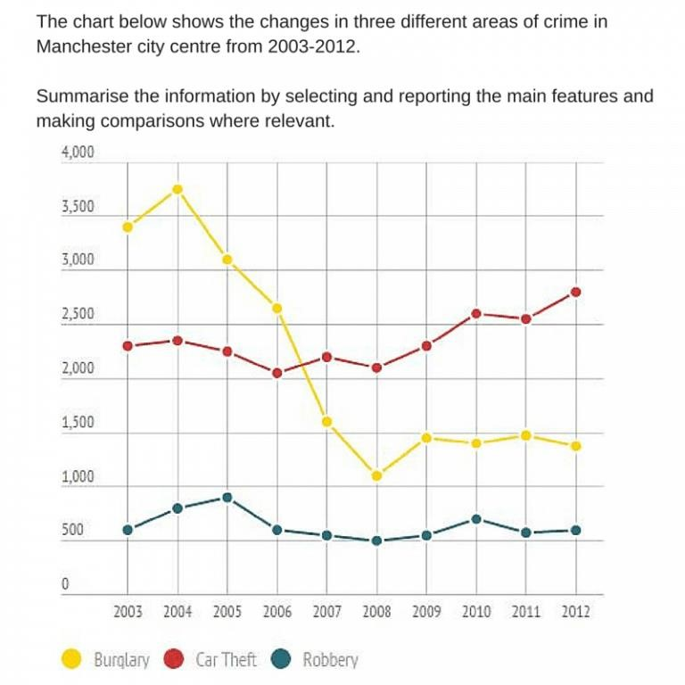

If you pay attention to the graph, the features that are more important than other data are:

1. Over the years, the number of violent crime has dropped dramatically
2. Over the years, the crime of car theft has gradually increased
3. Theft has been stable over the years (without significant changes)

Now let's combine this information into an overview.

The most noticeable trend is that burglary fell dramatically over the period. Car theft fluctuated until 2008, upon which it rose steadily; whereas the number of robberies remained relatively stable between 2003 and 2012.

**Body Paragraph**

The body paragraph is an important part of the essay and the main sections indicated in the overview (main feature) are divided into separate parts and detailed information is given about them.

# LINE GRAPH

**(Paraphrasing the question)**

If you have thoroughly studied the information given so far, you can easily and effectively complete this essay writing exam by dividing it into 4 parts. Test your knowledge by answering this line graph . As explained above, this sentence is considered the first sentence in the introduction of the essay. As mentioned, you need to describe the information in the given graph in your own words without changing the meaning of the sentence. Consider the example below.

**Example: Question**

*The chart shows the changes in three*

*different areas of crime in Manchester city*

*center from 2003*

*–*

*2012*

**Namuna: Paraphrased**

*The line graph displays alterations for*

*burglary, car theft and robbery in the center*

*of Manchester between 2003 and 2012*



If you've noticed, the meaning of the information has not changed, the name of the place where the crime was committed has not changed, the years of the crime have not changed either, only by writing the names of the crimes given in the lower part of the sentence graph that says three different types of crimes. was changed and some words were only changed with synonyms. The task is the same regardless of the type of graph, and the task you need to do is to identify the main parts of the graph and give a written report (essay) about them and compare them if necessary.

When writing this section, you will need a set of words, and by using these words, you can begin the introduction of the essay.

**Practice: Introductory words ---------Kirish so’zlari**

* ***The given --------- berilgan***
* ***The supplied --------- ta’minlangan***
* ***The presented ------- xavola etilgan***
* ***The shown -------- ko’rsatilgan***
* ***The provided ------- ta’minlangan***

|  |  |
| --- | --- |
| **VERBS** | **Fe’llar** |
| Depict | Tasvirlamoq |
| Enumerate | Sanab o’tmoq |
| Express | Ifoda etmoq |
| Give data on | Haqida ma’lumot bermoq |
| Provide information on | Haqida ma’lumot bermoq |
| Illustrate | Tasvirlamoq |
| Outline | Tasvirlamoq |
| Present | Taqdim qilmoq |
| Represent | Tasvirlamoq |
| Demonstrate | Ko’rsatmoq |

The graph belowhows the number of overseas visitors who came to Uk for different purposes between 1989 and 2009.

|  |  |  |  |  |  |
| --- | --- | --- | --- | --- | --- |
| The number of | Oversea | Visitor | Different | Purposes | Between/and |
| The quantity of | Foreign | Guest | Various | Aims | From/to |
| The amount of | International | People | Diverse | Goals | From /until |
| The figure of |  | Individual | Numerous | Intentions | Within |
| The sum of |  | Human being |  | Reasons | In |
| The volume of |  | Folks |  |  | Over the period |
|  |  |  |  |  | From uptil |

Example:

*The given line graph illustrates the amount of foreign people who visited the UK for various intentions from 1989 to 2009 .*

*The provided line graph provides the information on the volume of international guests who came to the UK for numerous reasons over the period of 20 years*.

*The presented line graph represents the sum of global individuals who visited the UK for diverse aims within 20 years*

**Part 2– (Overview)**

Your objective is to provide an overview of this information. If you pay close attention to the graph, you will notice that certain information is related to others.

For this, you must be familiar with the language's tenses, the rules expressed in the form of the verb, cases, and laws, as well as the essential vocabulary. You can compose the beginning to your essay by looking at the sentences you need help with and then connecting those words to the data in the graph.

|  |  |
| --- | --- |
| **Introductory words** | **Kirish so’zlari** |
|  |  |
|  | *Grafadan kuzatilganidek* |
| *As is presented in the graph that* | *Grafada taqdim etilganidek* |
| *As an overall trend in the graph* | *Grafada umumiy tendentsiya sifatida* |
| *At the first glance, it is clear that* |  |
|  | *Grafadan buni aniq ko'rish mumkinki* |
| *It is obvious from the graph that* | *Grafadan shu aniqki* |
| *Overall* |  |
| *To summarize, the most marked change in the graph is that* | *Xulosa qilish uchun, grafadagi eng muhim*  *o’zgarish shuki* |
|  |  |
| *In sum, the most noticeable trend in the graphs is that* | *Xulosa qilish uchun, grafadagi eng muhim o’zgarish shuku* |
| *According to the graph* | *Grafaga ko'ra* |

**For use:**

_____________________________________________________________________________ _____________________________________________________________________________ _____________________________________________________________________________ _____________________________________________________________________________ _____________________________________________________________________________ _____________________________________________________________________________ _____________________________________________________________________________

_____________________________________________________________________________

Now, let's try to write an overview of this graph. Of course, using the sentences given above.

|  |  |  |  |  |  |  |  |  |  |  |
| --- | --- | --- | --- | --- | --- | --- | --- | --- | --- | --- |
|  | |  |  | | --- | --- | | * Burglary decreases dramatically. | | | * Car theft increases steadily. * Robbery remains steady throughout the period. |  | | | * bosqinchilik jinoyati soni keskin tushib ketgan | | | * mashina o’g’irlash jinoyati asta-sekin ko’tarilgan * o’g’rilik jinoyati yillar mobaynida barqaror xolatda bo’lgan | | |

Example: The most obvious pattern is the sharp decline in burglaries within the time frame. The frequency of car thefts fluctuated from 2003 to 2008 before rising gradually after that. In contrast, the number of robberies was very consistent from 2003 and 2012.

Example: In conclusion, the graphs' most obvious pattern is the sharp decline of burglaries. Car theft rates gradually grew after experiencing a spike, whereas robberies remained constant from 2003 to 2012 despite fluctuating rates.

Example: The graph shows that, from the year 2003 through 2012, burglary crime had a sharp decline, whereas two other crime types showed stable increases and variations.

Example: In the last four years, burglaries have generally reduced quickly while auto theft has gradually climbed. Also, it is clear that between 2003 and 2012, robberies stayed essentially unchanged within 500 and 1000 iterations.

**Part 3 (Body Paragraphs)**

**The body paragraph is the main part of the essay, and in these parts we provide complete information about the main features that we have shown in the overview. If you noticed, in the overview, we found the important features of 3 graphs and shared our general thoughts about them. In the first and second body parts of the essay, we will give detailed information about the important features that have just been indicated.**

**If you've noticed, the line graph above shows three major aspects at once, whereas the overview often only shows two major features, or the key components. The question of what to do in this circumstance naturally arises, and in such a circumstance, we prepare main feature 2 by merging the remaining 2 forms of crime and taking 1 type of crime individually as main feature 1.**

**Note how the structure will be:Introduction**



- Paraphrasing the question - Overview

*Main feature 1 – burglary fell*

*Main feature 2 – car theft increased*

*Main feature 3 – robbery remained steady*

**Body Paragraph 1**

*burglary fell in detail*

**Body Paragraph 2**

*car theft increased , robbery remained steady in detail*

Body Paragraph 1

The number of burglaries began at just under 3.5 thousand in 2003 and, with the exception of a little increase of about 500 offenses in 2004, sharply decreased to just over a thousand events in 2008. It increased somewhat in 2009, peaking at just under 1500, and then steadily increased until the end of the time period.

Body Paragraph 2

The number of car thefts fluctuated between just under 2,500 and slightly over 2,000 from 2003 to 2008 before slowly increasing to about 3,000 in 2013. Robberies did not fall below 500 or rise above 1000 during the entire period

**Part 4 (Check your work)**

In the last fourth part, we will check the essay we just wrote. As mentioned above, this is a very important speech. This is because you can correct grammar, spelling, or punctuation errors by proofreading your essay.

**Line graph plan**

**Introduction**



**paraphrasing the question**



**overview**

*burglary fell*

*car theft increased*

*robbery remained steady*

**Body paragraph 1**

*burglary fell*

**Body paragraph 2**

*car theft increased*

*robbery remained Steady*



*The line graph shows changes in robbery, auto theft, and burglary in Manchester's downtown between 2003 and 2012.*

*The most obvious pattern is the sharp decline in burglaries within the time frame. Automobile theft fluctuated until 2008, when it started to increase significantly, although the number of robberies between 2003 and 2012 remained largely consistent.*

*The number of burglaries began at just under 3.5 thousand in 2003 and, with the exception of a little increase of about 500 offenses in 2004, sharply decreased to just over a thousand events in 2008. It increased somewhat in 2009, peaking at just under 1500, and then steadily increased until the end of the time period.*

*The number of car thefts fluctuated between just under 2,500 and slightly over 2,000 from 2003 to 2008 before slowly increasing to about 3,000 in 2013. Robberies did not fall below 500 or rise above 1000 during the entire period.* **Specific wordlist**

|  |  |
| --- | --- |
| **Upward trend – yuqoriga ko’tarilish** | |
| **Noun** | **Verb** |
| *A rise – ko’tarilish* | *Rise – ko’tarilmoq* |
| *An increase – o’sish* | *Increase – o’smoq* |
| *A growth – o’sish* | *Grow – o’smoq* |
| *An improvement – yaxshilanish* | *Improve – yaxshilanmoq* |
| *A jump – sakrash* | *Jump – sakramoq* |
| *A leap – sakrash* | *Leap – sakramoq* |
| *A boom – portlash, ko’tarilish* | *Boom – porlamoq, keskin ko’tarilmoq* |
| *A peak – cho’qqi* | *Peak – cho’qqiga ko’tarilmoq* |
| *A recover – yaxshilanish* | *Recover - yaxshilanmoq* |
| *A climb – o’sish, ko’tarilish* | *Climb – o’smoq ko’tarilmoq* |
| *A swell – o'sish, kattalashish* | *Swell – kattalashmoq* |
| *An escalation – ko’tarilish* | *Escalate – ko’tarilmoq* |
| *A surge – siljish* | *Surge – siljimoq* |
| *A double – ikki barobar ko’tarilish* | *Double – ikki barobar ko’tarilmoq* |
| *A climax – cho’qqiga chiqish* | *Climax – cho’qqiga ko’tarilmoq* |
|  | *Quadruple – to’rt barobar ko’tarilmoq* |
|  | *Triple – uch barobar ko’tarilmoq* |
|  | *Soar – ko’tarilmoq qanot qoqmoq* |
|  | *Skyrocket – keskin ko’tarilmoq* |
|  | *Rocket – keskin ko’tarilmoq* |
|  | *Go up – ko’tarilmoq* |

**For use:**

**_____________________________________________________________________________ _____________________________________________________________________________**

**_____________________________________________________________________________ _____________________________________________________________________________ _____________________________________________________________________________**

**_____________________________________________________________________________ _____________________________________________________________________________**

|  |  |  |  |
| --- | --- | --- | --- |
| **Downward trend – pastga tushish & pasayish** | | | |
| **Noun** | | **Verb** | |
| *A decrease – pasayish* | | *Decrease – pasaymoq* | |
| *A decline – tushish* | | *Decline – tushmoq* | |
| *A fall – tushish* | | *Fall – tushmoq* | |
| *A drop – keskin tushib ketish* | | *Drop – keskin tushib ketmoq* | |
| *A reduction – pasayish* | | *Reduce – pasaymoq* | |
| *A slump – pasayish* | | *Slump – pasaymoq* | |
| *A plunge – keskin tushib ketish* | | *Plunge – keskin tushib ketmoq* | |
| *A dip – tushish* | | *Dip - tushmoq* | |
| *A collapse – qulash* | | *Collapse – qulamoq* | |
| *A slide – sekin tushish* | | *Slide – sekin tushmoq* | |
| *A dwindle – kamayish* | | *Dwindle – kamaymoq* | |
| *A nosedive – keskin tushib ketish* | | *Nosedive – keskin tushib ketmoq* | |
| *A deterioration – kamayish* | | *Deteriorate – kamaymoq* | |
|  | | *Tail off - kamaymoq* | |
|  | | *Plummet – tushib ketmoq* | |
|  | | *Halve – ikkiga bo’linmoq* | |
|  | | *Go down – pasaymoq* | |
|  | | *Shrink – qisqarmoq* | |
|  | | *Dive – keskin pasaymoq* | |
| **(Verb) Stable trends – mo’tadilik, baqraror turmoq** | | | |
| *Remain the same* | *Stay the same* | | *Level off / Level out* |
| *Remain steady* | *Even out* | | *Plateau* |
| *Remain consistent* | *Remain static* | | *Reach a plateau* |
| *Remain constant* | *Stay a steady level* | | *Hold steady* |
| *Experience a period of stability* | | | |
| *Remain relatively unchanged* | | | |
| *Maintain the same level* | | | |
| *Remain fairly stable* | | | |

**(Verb) Fluctuating trends -** **o’zgaruvchanlik harakatlari**

*Fluctuate - tebranmoq Vary – o’zgarib turmoq*

*Go through an erratic period – keskin davrni boshidan o’tkizmoq*

*Experience a period of erratic behavior – keskin xulqni boshidan kechirmoq*

*Witness considerable variation – sezilarli o’zgarishni guvohi bo’lmoq*

*Enter a period of fluctuation – tebranish davriga kirmoq*

*Experience a period of instability – beqarorlik davrini boshidan o’zkizmoq*

*Show some variation - ayrim o’zgarishlarni ko’rsatmoq*

*Experience a period of volatility – o’zgaruvchanlik davrini boshidan o’tkizmoq*

*Rise and fall erratically – noodatiy ko’tarilib tushmoq*

|  |  |  |  |  |  |
| --- | --- | --- | --- | --- | --- |
| **(Adj) - (Adv) Degree of Change (large movements)**  **(Sifat) - (Ravish) o’zgarish darajalari (katta o’zgarishlar)** | | | | | |
| *Dramatic (ly)* keskin | | *Significant (ly) ahamiyatli* | | *Enormous (ly) kuchli* | |
| *Considerable (ly)* ahamiyatli | | *Rapid (ly) tez* | | *Substantial (ly) ahamiyatli* | |
| *Sharp (ly)* keskin | | *Noticeable (ly) sezilarli* | | *Abrupt (ly) keskin* | |
| *Marked (ly) sezilarli* | | *Massive (ly) katta* | | *Remarkable (ly) ahamiyatli* | |
| *Great (ly) yuqori* | | *Exponential (ly) katta* | | *Huge (ly) katta* | |
| **(Adjective) - (Adverb) Degree of Change (small movements)**  **(Sifat) - (Ravish) o’zgarish darajalari (kichik o’zgarishlar)** | | | | | |
| *Insignificant (ly) sezilmas* | | *Slight (ly) biroz* | | *Negligible ahamiyatsiz* | |
| *Gentle (ly) asta sekin* | | *Marginal (ly) sezilmas* | | *Relative (ly) bilinarli* | |
| *Minimal (ly) eng kam* | | *Inconsiderable (ly) sezilmas* | | *Slow (ly) sekin asta* | |
| *Gradual (ly) sekin* | | *Steady (ly) sekin* | | *Somewhat biroz* | |
| *Fractional (ly) sezilmas* | | *Modest (ly) oddiygina* | |  | |
| **Describing predictions – bashoratlarni ta’riflash** | | | | | |
| *It is predicted that* | | *It is anticipated that* | | *It is forecasted that* | |
| *It is expected that* | | *It is estimated that* | | *Another forecast is that* | |
| *Another anticipation is that* | | *Another prediction is that* | | *Another projection is that* | |

|  |  |  |
| --- | --- | --- |
| **Time phrases** | | **Vaqt jumlalari** |
| *Between ... (year/ month) ... and ... (year/ month) ...* | | *... (yil / oy) ... va ... (yil / oy) orasida ...* |
| *From ... (year/ month/ day/date) ...to ...*  *(year/month/day /date) …* | | *... (yil / oy / kun / sana) ... dan ...gacha (yil / oy / kun / sana) ...* |
| *In... (year/ month) ...* | | *yilda ... (yil / oy) ...* |
| *On ... (day/ day of the week/ a date) ...* | | *... (haftaning kuni / kuni / kuni) ...* |
| *At . ...., In ......, By ......* | | *Da . ...., Da ......, tomonidan ......* |
| *During ... (year)...* | | *... (yil) davomida ...* |
| *Over the period/ over the century/ later half of the year/ the year...* | | *Davr davomida / asr davomida / yilning oxirida / yilning oxirida ...* |
| *Over the next/past/previous days/weeks/months/years/ decades* | | *Keyingi / o'tgan / oldingi kunlar / haftalar / oylar / yillar / o'n yillar* |
| **Approximation phrases** | | **Taxminlar** |
| *About* | | *Taxminan* |
| *Roughly* | | *Qariyb* |
| *Around* | | *Atrofida* |
| *Almost* | | *Deyarli* |
| *Nearly* | | *Deyarli* |
| *Approximately* | | *Taxminan* |
| *just about* | | *taxminan* |
| *just below* | | *ozgina quyida* |
| *just over* | | *ozgina ko'proq* |
| *just under* | | *ozgina quyida* |
| *a little more than* | | *dan bir oz ko'proq* |
| *a little less than* | | *dan bir oz kamroq* |
| *more or less* | | *taxminan* |
| *practically the same* | | *deyarli bir xil* |
| *roughly the same* | | *taxminan bir xil* |
| *well above* | | *yuqorida* |
| *well below* | | *quyida* |
|  |  | |

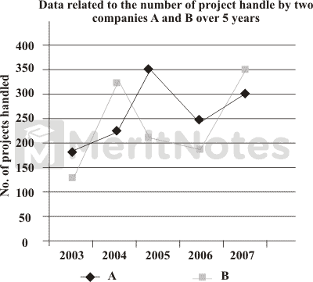**Practice:**

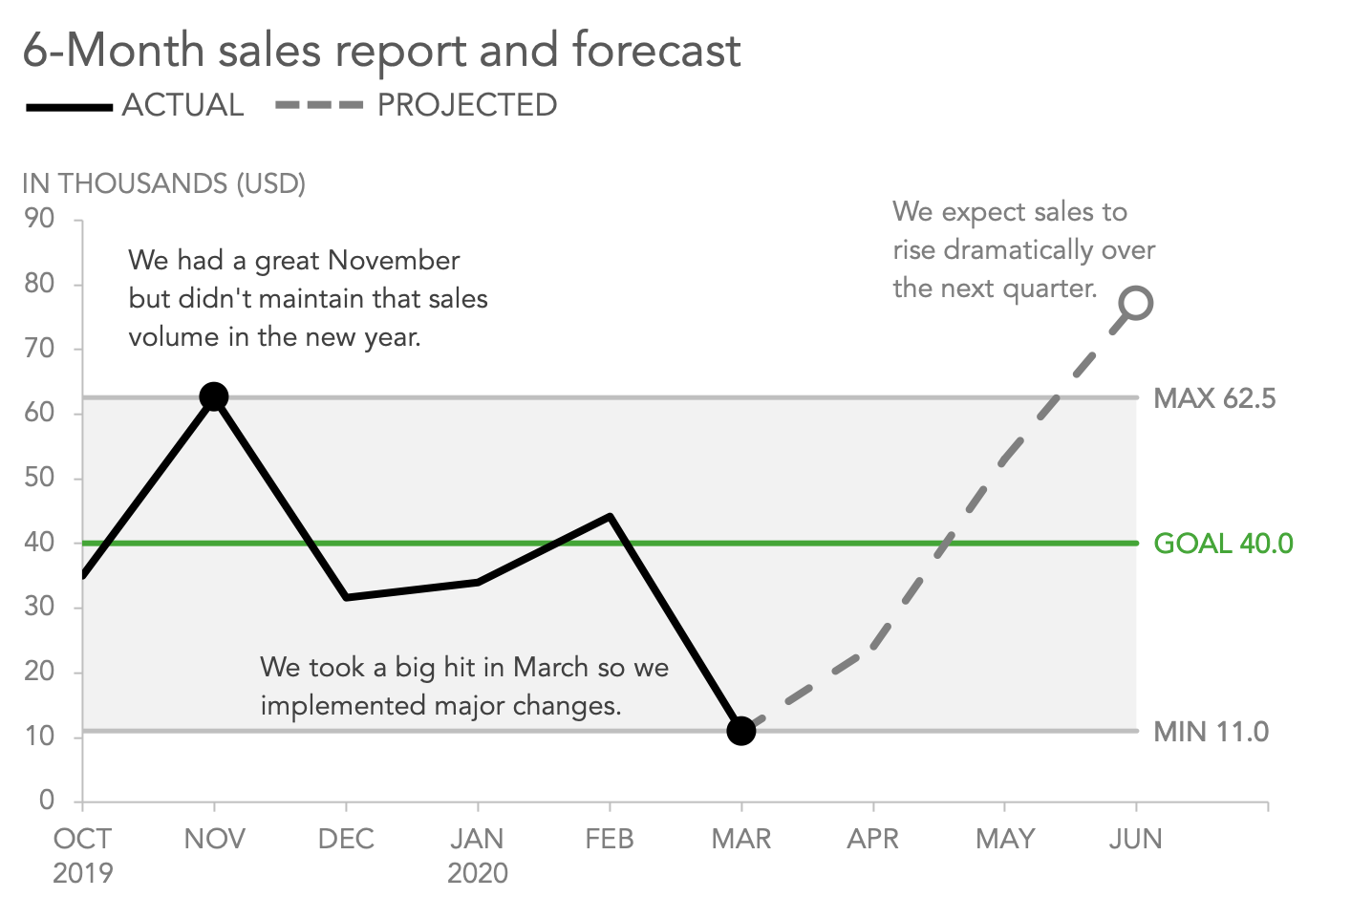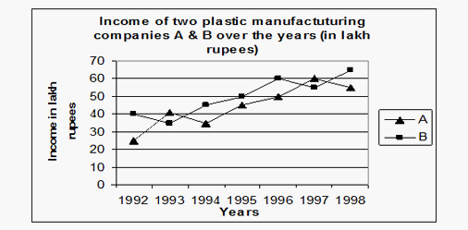

## IELTS Line Graph Examples

You should spend about 20 minutes on this task.

**The line graph shows thefts per thousand vehicles in four countries between 1990 and 1999.**

**Summarize the information by selecting and reporting the main features and make comparisons where relevant.**

Write at least 150 words.

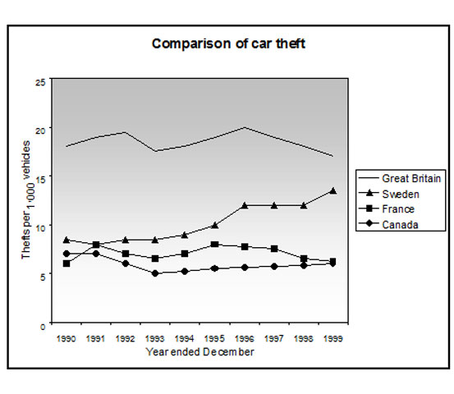

The line graph illustrates the quantity of autos reported stolen per 1,000 vehicles in four nations between 1990 and 1999. Overall, it is clear that for the entire period, Great Britain had a much greater rate of automobile thefts than the other three countries.

Throughout the first five years, car thefts in Sweden, France, and Canada all followed a trend that was quite similar, staying between 5 and 10 per thousand. Nonetheless, the overall trend for France and Canada during the period was a decrease in the number of vehicles stolen, with both at around 6 in 1999. Sweden, on the other hand, saw a rising tendency, starting the time period at around 8, and ending it at just under 15.

It's interesting to see that Great Britain had a much higher rate of car thefts than the other nations, with a starting rate of 18 per thousand. The rate then fluctuated over the following nine years, peaking in 1996 at 20 thefts per 1000, and concluding the era at roughly 17 thefts per thousand. It's interesting to see that Great Britain had a much higher rate of car thefts than the other nations, with a starting rate of 18 per thousand. The rate then fluctuated over the following nine years, peaking in 1996 at 20 thefts per 1000, and concluding the era at roughly 17 thefts per thousand.

Sample 2

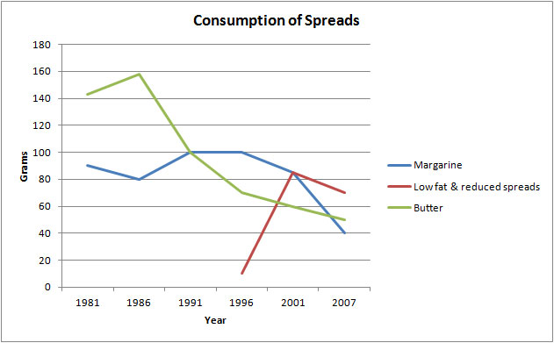

The line graph depicts the consumption of three types of spreads (butter, low-fat and reduced spreads, and margarine) over a 26-year period from 1981 to 2007. Grams are used to measure units.

Margarine and butter consumption overall dropped over the period given, however it increased for low fat and reduced spreads.

Butter was the most popular spread at the beginning of the time period. Margarine took its position from 1991 to 2001, and low fat and reduced spreads then overtook it in the last years.

The amount of batter used started at roughly 140 grams, reached a peak of 160 grams in 1986, and then dropped considerably to around 50 grams throughout the course of the last year. Margarine consumption peaked at 90 grams in the first year and then fluctuated somewhat before falling to a low of 40 grams in 2007.

Yet, the consumption of low-fat and reduced-fat spreads didn't begin until 1996, at a level of roughly 10 grams. This amount, which peaked at just over 80 grams five years later, decreased significantly in the subsequent years to reach almost 70 grams in 2007.

# MAP

* *One of the next exam questions of Writing task one is to describe the map. This type of question is becoming more and more popular. This is one of the easiest essays to write, and a well-prepared person can easily get a high grade.*
* *Many students, books and teachers ignore these types of questions during preparation and are a bit surprised when these types of questions come. Therefore, if you study this type of question well, you can probably score better than other students*
* *Khari (map) – types*
* *There are usually 3 different types of maps:*
* Discribe 1 to describe the given map in the present tense
* Describe 2 maps given in the present and future tenses
* Describe 2 maps given in present and past tense .

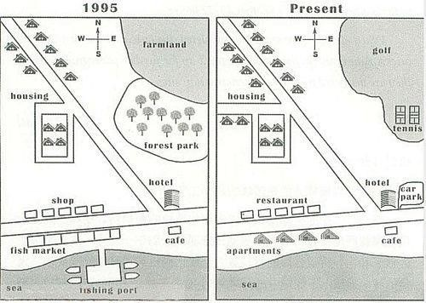

* • The first type is very rare because it requires you to use the present tense and there will be no comparison.
* The second type appears occasionally and requires you to use the present and future tenses. Such a question is usually about the future development of a city or town. Other both require the same word combinations .

The third is the most common, and in this type, a map is given mainly according to the state of the city or town in the past and present, and this textbook will be about this direction.

**1**

**–**

**Part 1**

**)**

**Paraphrasing the question**

**(**

**Question:**

*The diagram shows differences in the*

*infrastructure of London from 1995 until*

*present*

**Introductory words**

**Kirish so’zlari**

*The given*

*Berilgan*

*The supplied*

*Ta’minlangan*

*The presented*

*Xavola etilgan*

*The shown*

*Ko’rsatilgan*

*The provided*

*Ta’minlangan*



**Figure 2 Map of London**

*Difference*

*Distinctness*

*Discrepancy*

*Divergence*

*Change*

*Characteristic*

*Base*

*Framework*

*Look*

*Appearance*

*Foundation*

*Structure*

*Between / and*

*From / to*

*From / until*

*From / up to*

*Within*

*In*

*Over the period*

|  |  |
| --- | --- |
| **Verbs** | **Fe’l** |
| *Depict* | *Tasvirlamoq* |
| *Delineate* | *Belgilamoq* |
| *Enumerate* | *Sanab o’tmoq* |
| *Express* | *Ifoda etmoq* |
| *Give data on* | *Haqida ma’lumot bermoq* |
| *Provide information on* | *Haqida ma’lumot bermoq* |
| *Illustrate* | *Tasvirlamoq* |
| *Outline* | *Rejalamoq* |
| *Present* | *Taqdim qilmoq* |
| *Represent* | *Tasvirlamoq* |
| *Demonstrate* | *Ko’rsatmoq* |

Example: *The figure shows the infrastructural alterations that London has undergone since 1995.*

Example: *Information on differences between the structure of London in 1995 and now is provided by the map that is being presented.*

Example: The provided map illustrates how London's appearance has changed since 1995.

Example: The figure shows the structural alterations that have occurred in London over period of 25 years.

**Part 2 – (Overview)**

If you remember, when we described the line graph, we mainly found the main properties of the graph. However, in this type of map question, we now find completely different main features. That is, we will give 2 general comments about the changes in the maps. In this overview, we'll highlight some of the notable differences between the two maps. To find these points, you can look at the map and ask these questions.

|  |  |  |
| --- | --- | --- |
| *Is the map more or less residential?*  *Xarita ko’proq turar joylarmi yoki kamroq* |  | *Is there more or less countryside?*  *Xarita ko’proq qishloq joylarimi yoki kamroq?* |
| *Are there more or less trees?*  *Ko’proq daraxtlar bormi yoki kamroq?* |  | *Were the changes dramatic or negligible?*  *O’zgarishlar keskinmi yoki ahamiyatsizmi?* |
| *How have the buildings and leisure facilities changed?*  *Binolar va dam olish maskanlari qanday o’zgargan?* |  | *Has the number of buildings changed over the years or now?*  *Yillar o’tib inshoatlarni soni o’zgardimi yoki yo’q?* |

Note that when writing a general comment, you are not reporting specific changes. You don't have to answer all of the questions listed above, you can give an effective overview by answering only those questions that you think are worthy of the given map question. For this, of course, you need vocabulary and sentences.

Using the given sentences below, try to give your own general opinion

|  |  |
| --- | --- |
| **Words for overview** | **Kirish so’zlari** |
| *As can be seen from the map that* | *Xaritadan ko'rinib turganidek* |
| *As is observed from the map that* | *Xaritadan kuzatilganidek* |
| *As is presented in the map that* | *Xaritada taqdim etilganidek* |
| *As an overall trend in the map* | *Xaritada umumiy tendentsiya sifatida* |
| *At the first glance, it is clear that* | *Bir qarashda, bu aniqki* |
| *It can be clearly seen from the map that* | *Xaridatan buni aniq ko'rish mumkinki* |
| *It is obvious from the map that* | *Xaritadan shu aniqki* |
| *In sum, the most noticeable change in the map is that* | *Xulosa qilish uchun, xaritadagi eng muhim o’zgarish shuki* |
| *To summarize, the most marked change in the map is that* | *Xulosa qilish uchun, xaritadagi eng muhim o’zgarish shuki* |
| *Overall, it is clear from the map that* | *Umuman olganda xaritadan shu aniqki* |

Example:

It is immediately apparent that London's infrastructure has undergone a number of significant enhancements. The city, which was rural in 1995, had a rapid transformation into a developed community where additional homes and recreational amenities have been built.

Example:

Overall, the most obvious difference in the maps is that London, which was rural in 1995 but has undergone significant infrastructure modifications to become a contemporary city with an increased number of structures and recreational options, has changed significantly.

Example:

At first glance, it is obvious that London's foundation has undergone a few important improvements. Since 1995, the city has seen a significant transformation into a developed city with an increase in the number of private buildings and leisure centers.

Example:

The country has significantly changed from being a rural area to a brand-new metropolis, with more residential areas and recreational facilities, from 1995 to the present. This is the most obvious trend in the map.

**Part 3 – (Body Paragraphs)**

As for the main part of the essay, we will write 3 or 4 sentences about specific changes on the map in both the first and second parts. There are no numbers as you can see in these types of questions. What is meant is that it tells you what changes have happened on which side of the map, which buildings have been destroyed, or what they have been replaced with, or left unchanged at all.

Note that all changes to the map must be described. For this you must have a special vocabulary in the necessary amount.

|  |  |  |
| --- | --- | --- |
| **Noun** | **Synonyms** | **Ot va uning**  **ma’nodoshlari** |
| *House* | *Apartment* | *Xonadon* |
| *Building* | *Bino* |
| *Condo* | *Ko’p qavatli bino* |
| *Condominium* | *Ko’p qavatli bino* |
| *Home* | *Uy* |
| *Dwelling* | *Uy-joy* |
| *Residence* | *Yashash joyi* |
| *Housing area* | *Residential area* | *Yashash xududi* |
| *Living area* | *Yashash xududi* |
| *Sleeping area* | *Yashash xududi* |
| *Path* | *Way* | *Yo’l* |
| *Pathway* | *Yo’l* |
| *Road* | *Yo’l* |
| *Route* | *Yo’l* |
| *Area* | *Field* | *Xudud* |
| *Zone* | *Zona* |
| *County* | *Okrug* |
| *Locality* | *Joy* |
| *Section* | *Bo’lim* |
| *Sector* | *Sektor* |
| *Neighborhood* | *Mahalla* |
| *Territory* | *Xudud* |
| *Crossroad* | *Intersection* | *Kesishma yo’l* |
| *Junction* | *Kesishma yo’l* |
| *Tree* | *Forest* | *O’rmoq* |
| *Wood* | *Taxta, daraxt* |
|  |  |  |

|  |  |
| --- | --- |
| **Trees/Forests** | **Examples** |
| Cleared  Cut-down/chopped down  Removed  Planted | The forest was cut-down and replaced with a shopping center.  The trees were cleared to make way for houses. |

|  |  |
| --- | --- |
| **Roads,bridges and railways lines** | **Example** |
| Constructed/Built  Extended  Expanded  Removed | The main road was extended and a new bridge built over the river.  Leisure facilities opened ,set up , developed. |

|  |  |
| --- | --- |
| **Leisure facilities** | **Example** |
| Opened  Set up  Developed | A skate park was set up next to the swimmimg pool.  A park was developed beside the forest. |

You will be provided a compass in the given question to grade the sides. If not, you can draw a compass yourself on a spot on the map, which will greatly aid you in precisely assessing the sides.

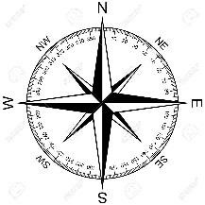

*North East*

*Shimoliy sharqiy*

*South East*

*Janubiy sharqiy*

*North West*

*Shimoliy g’arbiy*

*South West*

*Janubiy g’arbiy*

|  |  |  |  |
| --- | --- | --- | --- |
| *North – Shimol*  *East – Sharq*  *South - Janub*  *West – G’arb* |  | *North East* | *Shimoliy sharq* |
| *South East* | *Janubiy sharq* |
| *North West* | *Shimoliy g’arb* |
| *South West* | *Janubiy g’arb* |

|  |  |
| --- | --- |
| *To the north of* | *ning shimoliga* |
| *To the east of* | *ning sharqiga* |
| *To the west of* | *ning g’arbiga* |
| *To the south of* | *ning janubiga* |
| *In the west* | *G’arbda* |
| *In the east* | *Sharqda* |
| *In the north* | *Shimolda* |
| *In the south* | *Janubda* |

1. As an illustration, the forest south of the river was cleared.
2. On the area to the north of the airport, a golf course was built.
3. The homes in the town's southwest were destroyed.
4. A park was created from the green fields to the northwest of the city.

In addition, auxiliary words that show the relation of a noun or pronoun to other words in a sentence play a very important role in defining maps. English has a large number of these auxiliary words, and not all of them work in describing a map. Therefore, study the following auxiliary words well, because they are widely used not only in the types of questions other than the map.

|  |  |  |  |
| --- | --- | --- | --- |
| *above* | *yuqorisida* | *by* | *orqali* |
| *across* | *orqali, bo’ylab* | *down* | *quyisida* |
| *against* | *qarshi* | *from* | *dan* |
| *along* | *bo’ylab* | *in* | *da* |
| *among* | *o’rtasida* | *into* | *ichiga* |
| *around* | *atrofida,* | *near* | *yaqinida* |
| *at* | *da* | *off* | *dan* |
| *before* | *oldin* | *on* | *da* |
| *behind* | *orqasida* | *to* | *ga* |
| *below* | *quyisida* | *toward* | *tomonga* |
| *beneath* | *ostida* | *under – tagida* | *tagida* |
| *beside* | *yonida* | *upon – ustida* | *ustida* |
| *between* | *o’rtasida* | *with – bilan* | *bilan* |
| *out of* | *dan tashqari* | *within* | *bo’ylab* |

Example: The city center underwent remarkable changes between 1995 and 2005.

Example: They demolished the stores and built a skyscraper in their stead.

Example: The hotel and café on London's southern east side haven't been touched in a while.

Now, we will write the rest of the essay using the nouns, verbs, adjectives and prepositions given above.

Body Paragraph 1

*The residential sector has significantly increased in the town's north-west area, and a new road has been built to allow access to the new residences, according to the maps that were provided. The north-eastern neighborhood has a similar pattern, with the farmland and forest park completely gone and replaced with a sizable golf course that also has two tennis courts.*

Body paragraph 2

*The fishing port and fish market, which were both originally part of the coastline, have both been replaced by new housing areas, and the store is now a restaurant. Regarding the southeast corner of the town, the café is still there, but the hotel now has a parking lot next to it.*

**Part 4 (Check your work)**

In the last fourth part, we will check the essay we just wrote. As mentioned above, this is a very important speech. This is because you can correct grammar, spelling, or punctuation errors by proofreading your essay.

**Map plan**

**Introduction**



**paraphrasing the question**



**overview**

-

*infrastructural*

*improvements*

-

*more residential & leisure*

*facilities*

**Body paragraph 1**

-

*infrastructural*

*improvements*

**Body paragraph 2**

-

*more residential &*

*leisure facilities*



*The figure shows the infrastructure upgrades London has undergone since 1995. It is immediately apparent that London's infrastructure has undergone a number of significant enhancements. The city, which was rural in 1995, had a rapid transformation into a developed community where additional homes and recreational amenities have been built.*

*The residential sector has significantly increased in the town's north-west area, and a new road has been built to allow access to the new residences, according to the maps that were provided. The north-eastern neighborhood has a similar pattern, with the farmland and forest park completely gone and replaced with a sizable golf course that also has two tennis courts.*

*The fishing port and fish market, which were both originally part of the coastline, have both been replaced by new housing areas, and the store is now a restaurant. On the southeast corner of the town, the café is still there, but a parking lot is now right next to the hotel.*

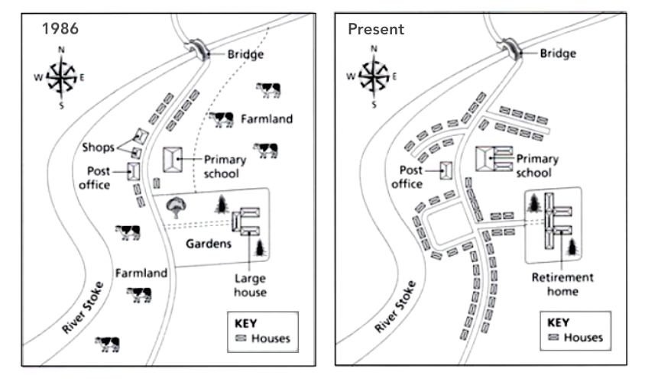

Summarize the information by selecting and reporting the main features and make comparisons where relevant

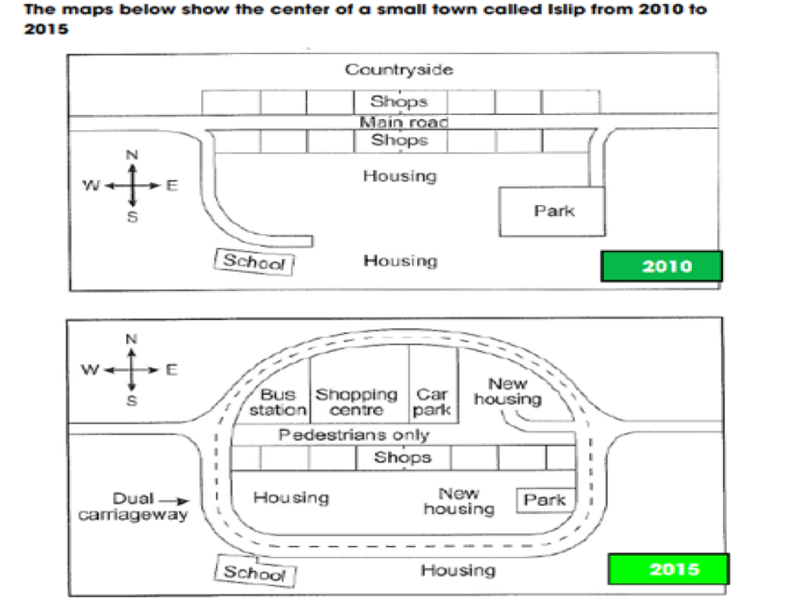

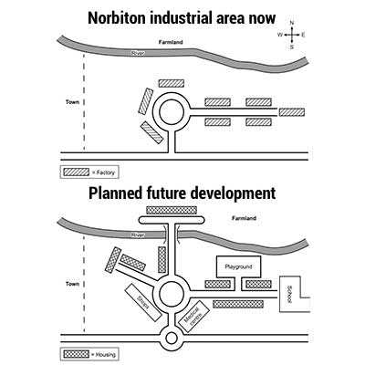 Summarize the information by selecting and reporting the main features and make comparisons where relevant.

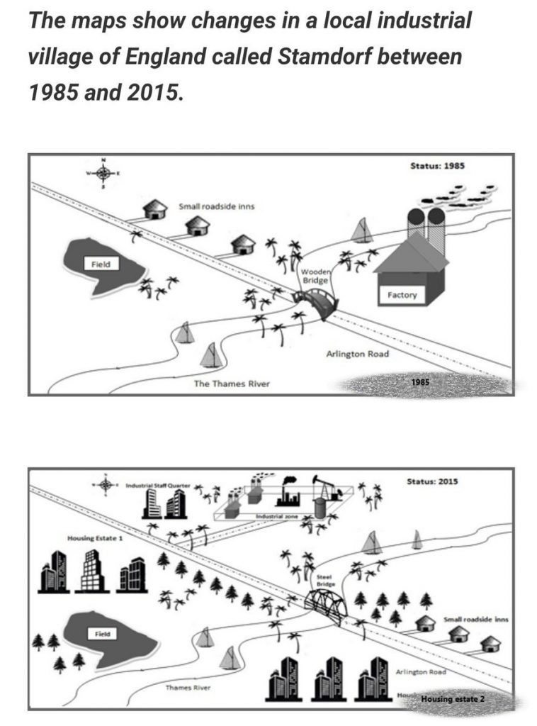

## model sample Report Plan

Paraphrase: show>compare; before and after construction of some tourist facilities >before and after developments carried out for tourism purposes

Overview: The maps compare a small island before and after the developments carried out for tourism purposes.

Paragraph 2: (1) Talk about the overall information. Explain briefly.

Paragraph 3: (1) Compare the before and after scenarios. Give explanation.

Paragraph 4: (1) Compare the before and after scenarios. Give explanation.

The maps show a small island before and after various tourist-related projects.

Overall, it is evident that hotels and other tourist-related amenities were built, and a pier was built to enable boat access to the island.

The island was initially wholly uninhabited. The northern and southern halves were covered in a lot of trees. Two distinct residential districts were constructed in the island's center, each consisting of a circle of modest huts. In the middle of these two spaces, there was a restaurant and reception room. Another road was built, leading to the beach on the island's western side and a swimming facility for visitors.

The construction of a pier allowed visitors to arrive on the island in safety by boat. The path to the restaurant was later covered by a car track that went from the pier to the reception area.

**Sample answer 2**

The map shows how an island has changed since tourism facilities were built there. The island appeared to be abandoned and devoid of any important tourist facilities prior to this transformed scenario. To make the island more tourist-friendly, numerous tourist amenities were added during the remodeling, such as roads, island-wide reception, a selection of lodging options, a restaurant, a pier, and more.

Save for a few trees, the initial map depicts the island as being empty. The second one, however, shows all of the modifications made after construction. It was possible to observe a pier that was built for boats. A car track that leads to the restaurant and the reception area may be seen from there. Near the restaurant, it appears that the car track ends. There is also a footpath that takes visitors from the accommodation sections to the beach. With linked pathways, the residential portions are located on either side of the reception.

The residential portion and the beach are connected by a pathway that runs to the left of the reception. Swimming pools are easily accessible. Although trees are visible on both maps, it is important to note that no timber was chopped.

In conclusion, the map depicts how a barren island was transformed into a handy tourist destination for the entertainment and leisure of people without causing harm to the environment.

**Band 9 Sample Report**

The two maps offered are meant to demonstrate the various building modifications done on a desolate island. The development of mentioned facilities is being done to boost tourism.

The first structure of the island shows the barren surroundings with a few strewn clusters of trees. Nonetheless, the image of the island after the renovations shows all the steps done to promote tourism. They include building a dock so that people may travel to the island by boat and creating roads so that visitors can drive their cars up to the reception. There are just trails leading to the residential areas constructed on either side of the island.

Furthermore, a restaurant has been built on the edge of the island with a view of the water and is accessible by cars. The existing beach has been renovated for swimming activities.

In conclusion, the project to rebuild the island for tourist proved successful. Another admirable finding is that the natural surroundings, including the island's plant life, were not affected throughout the rebuilding process.



The images depict the alterations that took place in Stokeford between 1930 and 2010.

In general, Stokeford grew considerably during this time, with areas of farmland being replaced by housing.

On the east bank of the River Stoke is where Stokeford is located. The town had a single main route that ran through it from north to south in 1930. There were a few houses, a few shops, a post office, and an elementary school on either side of the street. The post office was still there in 2010, but more homes had taken the place of the stores. To link the new homes to the main road, additional roads were also constructed. Additionally, even more homes had been constructed to the west and the elementary school had been expanded.

A big house and some public gardens were located to the southeast of the town, but at some point in the past, this house was turned into a retirement community. Finally, a new housing area was created on the farmland that had previously been to the south of the village.

**Sample answer 2**

The maps provide a comparison of the state of the town of Stokeford in 1930 and 2010.

Over the 80-year period depicted in the maps, Stokeford underwent some major changes, with a dramatic increase in residential areas and a corresponding reduction in farmland being the most noticeable.

Stokeford, which lies on the eastern bank of the River Stoke, was surrounded by farmland to the south and northeast in 1930. However, by 2010, this agricultural land had been converted into new housing with new roads providing access. The shops that stood on the single road that used to run through Stokeford from north to south were demolished and replaced by housing sometime between 1930 and 2010, although the original post office still remained. Similarly, while the old primary school still stood where it had in 1930, it had been extended to cater for the rising population.

Another prominent feature of Stokeford in 1930 was a sizeable area of gardens to the south of the town that also contained a large estate house. Nevertheless, eight decades later, this area had been converted into a retirement home with extensions to the original house being made. (184 words)

**Map 3**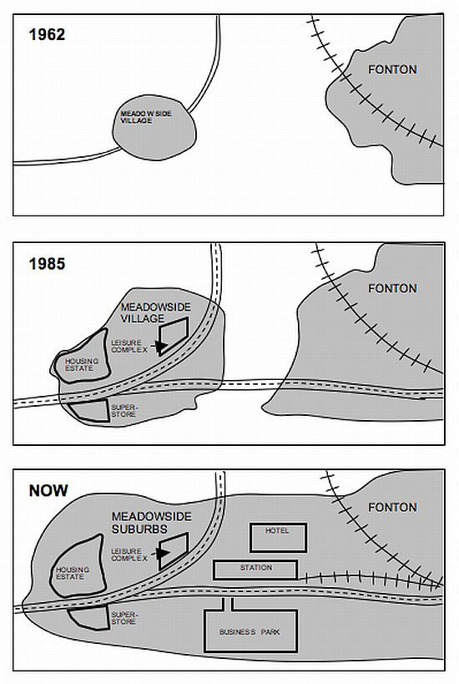

***The maps show changes in the village of Meadowside and the town of Fonton from 1962 to now. Write a report of at least 150 words describing the main features and making comparisons where relevant.***

The maps show the changes that occurred in Meadowside and the nearby community of Fonton. Three time periods are depicted on the maps: 1962, 1985, and the present.

Overall, both locations experienced significant growth and development of structures and amenities over the time period, and they have now fused into a single, sizable area, with Meadowside village now serving as a suburb of the town of Fonton.

The villages were totally cut off from one another in 1962. Meadowside had a road running through it from the southwest to the northeast, while Fonton had a rail route passing through from the southeast to the northwest.

Both areas had considerably grown by 1985. The old road had also been widened to match the size of the new one, and a road now connected the hamlet and the town. In Meadowside, a home development, a recreation area, and a large retailer had been constructed next to the main street.

A business park is now located to the south of the road and a hotel is located to the north in the area that used to separate Meadowside from Fonton. Additionally, a train station with a new line connecting to the old one has been added next to the road.

**Sample answer 2 Advanced**

The maps **provide a broad outline** of the **expansion** of a village called Meadowside and a town called Fonton over three periods of time: 1962, 1985, and the present day.

Overall, both areas **experienced significant growth**, and by the end of the period Meadowside had been **absorbed** into Fonton and was now **referred to** as the suburb of Meadowside.

In 1962, Meadowside and Fonton were **separated by a strip** of empty land with no **transport links** between them.**Access to** Meadowside was provided by a road running through the village from the southwest to the northeast, while Fonton was **serviced by** a railway that passed through the town from the southeast to the northwest.

Just over two decades later, the two areas had **spread out noticeably** and had also been joined by a new road running east-west. In Meadowside, a leisure center and housing estate had been built to the north of the original road, while a superstore now stood to the south of the housing estate and the old road.

Presently, the two areas **have become one** and a large amount of new **infrastructure** has been built in the empty area that used to lie between the two. A business park has been**established** to the south of the connecting road, while on the **opposite side** of the road to this a train station with a line joining the **original one** has been constructed. Finally, sometime between 1985 and now a hotel was opened just to the north of the railway station. (249 words)

**Map 4**

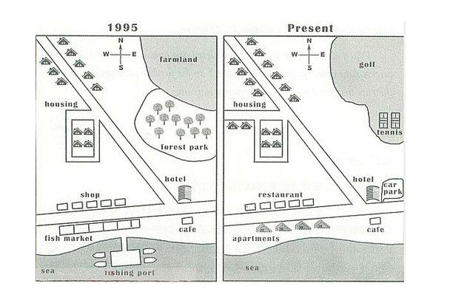

The maps show the community of Seatown and the changes it has undergone between 1995 and the present.

Since 1995, Seatown has undergone significant change, and the town today hardly resembles what it was in the past.

The town's east and northeastern farmland and forest park, which have been cleared to make room for a golf course and some tennis courts, is one significant development to be aware of. Another notable distinction is that the former fishing port on the town's south shore has been destroyed and not replaced. The shops and fish market that once stood just above the ancient fishing port have been replaced by rows of restaurants and apartments.

In addition, a parking lot has been built to the eastern side of the hotel to the east of this. Finally, a new road has been built to provide access, and the residential region in the west and northwest has been enlarged.

After comparing the two maps, it is obvious that Seatown has changed from a sleepy fishing hamlet to a popular tourist and entertainment hub.

**Map 5**

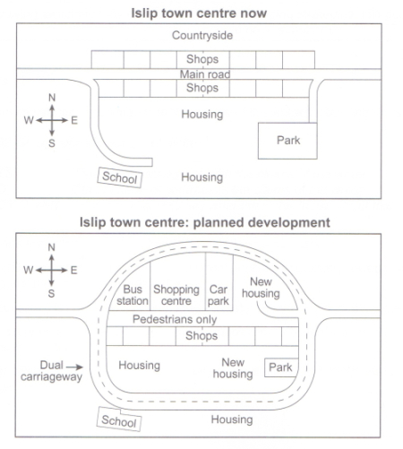

The diagrams show a few modifications that have been suggested for Islip's town center.

The development of a ring road around the town's center will undoubtedly be the most significant change. Along with the construction of this road, numerous other developments in terms of retail and housing will take place.

On the current map of Islip, we can see that a major road cuts through the middle of the city from east to west. The second map depicts the road's proposed pedestrianization. A dual carriageway will be used as a detour for traffic, forming a ring around the town center.

The schematics show a few modifications that have been suggested for Islip's town center.

Currently, the major road is surrounded by a row of stores on either side. However, it appears that the businesses along the new pedestrian street's north side will be destroyed to make room for a bus stop, a retail center, a parking lot, and new housing. The stores on the south side of the street will stay open, but it appears that the town park will be shrunk to allow for the construction of more new homes inside the circular road.

# DIAGRAM & FLOW CHART - PROCESS

**The meaning of the word "diagram" in Uzbek is "diagramma" and "process"”jarayon. The processes are mainly of two types, they are "natural process" or "man-made" process.**

**Natural processes are necessary to describe the processes that occur in a natural state. For example, it can be about the life of a butterfly, the process of pregnancy, the water cycle, and the process of rain. These are certainly some examples of natural processes.**

**Man-made processes, on the other hand, are processes involving the human factor. For example, you may be asked to describe in words the process of how coffee, tea or wine is produced, the process of making cement or bricks, or the process of how an ATM or the Internet works.**

**But regardless of the type of process, you can respond using the same type of skills and system. When answering the chart, it will be very helpful if you use a 5-step plan.**

**Part 1 (Understand the process)**

* + The first thing you should do is look at the process and understand what it is all about.
  + Find the opening and closing speeches of the process
  + Determine how many stages there are and what each stage does
  + Understand how each stage is related to the stages before and after it. To do this, find the answers to the following questions in the process.
    - Where does the process begin and end?
    - Is it a human-induced or natural process?
    - Is it a cyclical process or a linear process with one start and one end?
    - How many stages does the process consist of?
    - Are there any additional materials that should be added to the process?
    - What is the function of each stage of the process?
    - Try to find answers to these questions in the given question below.

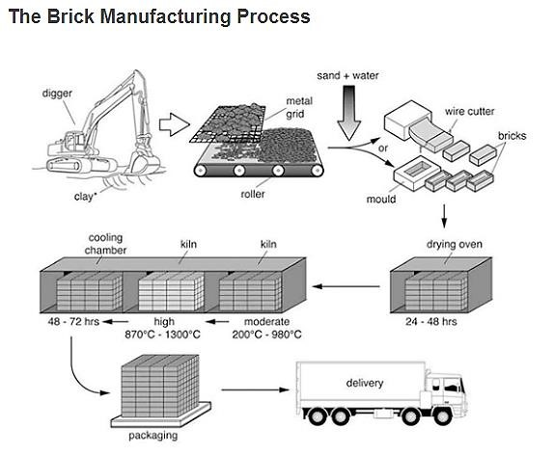

The diagram above illustrates the process that is used to manufacture bricks for the building industry.

* + It si clear thet , it is a "man-made" process, i.e. a process involving the human factor. This is because the brick product does not appear by itself. Of course, bricks are produced by human hands and using the necessary technologies.
  + The beginning of the process begins with the excavation of the mud by the earthmoving equipment and ends with the loading of the finished products into the delivery machine.

Processes are usually of 2 types, i.e. cyclical continuous process or linear with one beginning and one end. This process is considered linear because the process does not repeat itself. A brick does not return to the form of clay!

* + As you can see, the process consists of 8 steps.
  + Information is provided for use in the process. For example, stage names, product names, and display marks**.**
  + **Part 2 (Paraphrasing the question)**

|  |
| --- |
| The diagram above illustrates the process that is used to manufacture bricks for the building industry. |

Just like we did in the other questions, you rewrite the given question in your own words without changing its meaning.

Question: *The given diagram provides information regarding the way in which bricks are made for the construction industry.*

Paraphrased: *The provided diagram depicts how the bricks are produced for construction field.*

* + **Part 3 (Overview)**

Generalization in process questions is quite different from other types of questions. In your general opinion on the process, you must provide the following information.

* + The process is about the "natural" or "man-made" league.
  + The process is about "cyclical - circular" or "linear - has a beginning and an end speech".
  + How many stages the process consists of and what it starts and ends with.
  + Example: The entire production of bricks is a man-made linear manufacturing process that includes eight stages in succession, beginning with the excavation of the clay from the earth and finishing with the loading of the finished bricks into the delivery truck.



* + Example: The entire manufacturing process for bricks has eight sequential steps from beginning to end and has man-made characteristics associated with a linear manner of production.
  + **Part 4 (Body Paragraphs)**

Writing the rest of the essay is also different from previous question types. As you can see here, the times are not given, the numbers are not given to rise and fall. The information consists only of steps. When writing these parts, we will divide the steps that we have identified into two. That is, if the whole process consists of 8 stages, we will divide these stages into 2 parts of 4, and in body paragraph 1 we will give information about the first 4, and in body paragraph 2 about the remaining 4.

As for vocabulary and required sentences, usually all the necessary words are given to describe these types of processes, you just need to know the words that are usually used to describe the process sequence. Pay attention to the given words below and do exercises with them.

*Firstly – birinchidan Initially – birinchidan*

*Primarily – birinchidan First of all – birinchidan*

*Secondly – ikkinchidan Furthermore - ikkinchidan*

*After that – undan keyin Subsequently – undan keyin*

*Next – undan keyin Afterwards – undan keyin*

*Then – keyin Thereafter – undan keyin*

Body Paragraph 1

A big digger is first used to remove the clay from the earth that will be utilized to create the bricks. The clay is then spread out on a metal grid to be broken up into smaller pieces. A roller helps with this procedure. After that, the clay is combined with sand and water, and the product is either pressed into a mold or cut into bricks using a wire saw. The next step is to dry the bricks in an oven for 24 to 48 hours.

Body Paragraph 2

The bricks then undergo a heating and chilling procedure in the following stage. They undergo a two- to three-day cooling procedure in a chamber after being heated in a kiln at temperatures ranging from 200°C to 1300°C at first a moderate, then a high temperature. The bricks are then delivered to their final destinations after being packaged.

 **5 – Qism (Check your work)**

**In the last fourth part, we will check the essay we just wrote. As mentioned above, this is a very important speech. This is because you can correct grammar, spelling, or punctuation errors by proofreading your essay.**

**Plan – Process & Diagram**



**Introduction**

**Paraphrasing the question**

**Overview**

* *type – man made*
* *process style – linear*
* *stages – 8*

**Body Paragraph 1**

* *- first 4 stages of 8* **Body Paragraph 2**
* *- last 4 stages of 8*

*The given diagram provides details on how bricks are manufactured for the construction sector.*

*The entire production of bricks is a man-made linear manufacturing process that includes eight stages in succession, beginning with the excavation of the clay from the earth and finishing with the loading of the finished bricks into the delivery truck.*

*A big digger is first used to remove the clay from the earth that will be utilized to create the bricks. The clay is then spread out on a metal grid to be broken up into smaller pieces. A roller helps with this procedure. After that, the clay is combined with sand and water, and the product is either pressed into a mold or cut into bricks using a wire saw. The next step is to dry the bricks in an oven for 24 to 48 hours.*

*The bricks then undergo a heating and chilling procedure in the following stage. They undergo a two- to three-day cooling procedure in a chamber after being heated in a kiln at temperatures ranging from 200°C to 1300°C at first a moderate, then a high temperature. The bricks are then delivered to their final destinations after being packaged.*

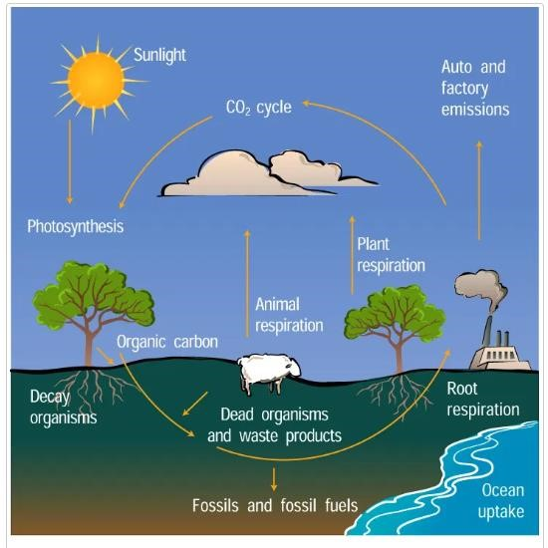**Plan – Process & Diagram**

Introduction

Paraphrasing the question

Overview

* *type – natural*
* *process style – cyclical*
* *stages – 6*

Body Paragraph 1

* *- first 3 stages of 6* Body Paragraph 2
* *- last 3 stages of 6*

**Question:** The diagram below illustrates the carbon cycle in nature.

*The figure illustrates the numerous processes that carbon goes through to build a full cycle. Ultimately, it is evident that the entire process is organic, cyclical in nature, and comprises six distinct stages that occur in order from beginning to conclusion.*

*First off, it is undeniable that plants use a process called photosynthesis to convert solar energy into organic carbon. When plants and the animals that eat them perish and decay, this organic carbon is subsequently released underground. A portion of this carbon is buried and preserved as fossils and fossil fuels.*

*Nonetheless, a variety of processes result in the release of carbon back into the atmosphere. One is when plants and animals breathe, and the other is when people consume fossil fuels in their factories and automobiles. All of this carbon is released into the air as CO2. Plants then take it up again, and the cycle repeats.*

**Brick manufacturing process**

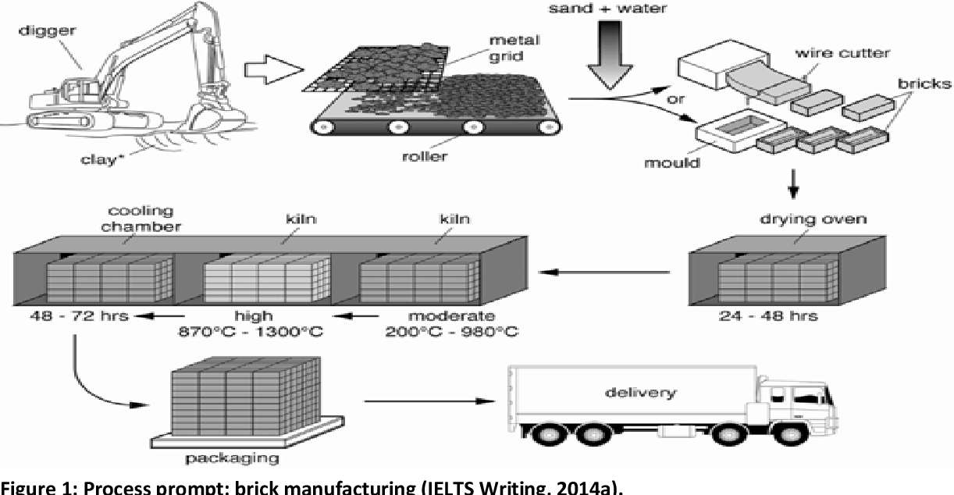

The process of making bricks for the building industry is shown in the diagram. This linear process has a total of seven steps, starting with the excavation of the clay and finishing with the delivery of the finished bricks.

A big digger first excavates the clay from the earth to be used in the bricks. The clay is then spread out on a metal grid to be broken up into smaller pieces. A roller helps with this procedure.

After that, the clay is combined with sand and water, and the product is either pressed into a mold or cut into bricks using a wire saw.

An oven and kilns are used in the next two steps (a type of oven). After 24 to 48 hours, the bricks are placed in an oven to dry. The bricks then undergo a heating and chilling procedure in the following stage. They undergo a two- to three-day cooling procedure in a chamber after being heated in a kiln at temperatures ranging from

200°C to 1300°C at first a moderate, then a high temperature. Each of these phases need a lot of time. The bricks are then delivered to their final destinations after being packaged.

The diagram shows the process of photosynthesis

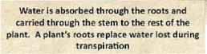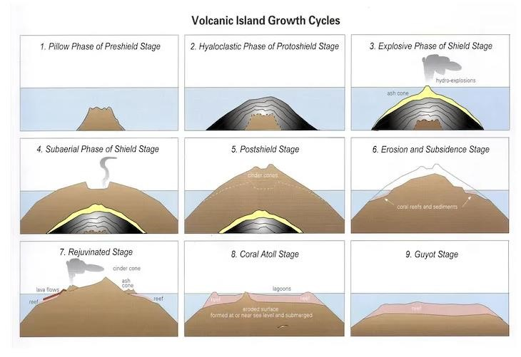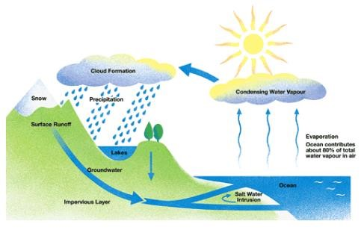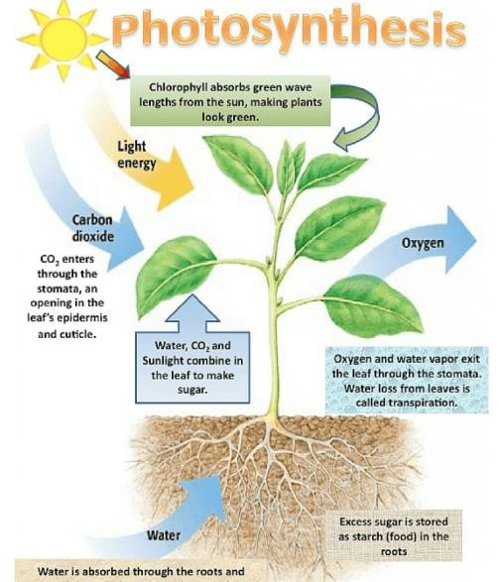

Summarize the information by selecting and reporting the main features and make comparisons where relevant .

# MULTIPLE GRAPH

**The** **T** The direct meaning of the word multiple graph in Uzbek is several graphs. This type of question is considered more difficult than other types of questions. This is because during the exam you may be given two or more graphs to describe.

When these types of questions come, students who do not have enough knowledge make more mistakes.

The reason for this is related to some problems. Below are the problems related to this question and their solutions. Pay close attention and try not to repeat the following problems during trainings.

**Problem and solution**

1. **Problem 1: Too much typing**

Because there are several sources of information, students try to write too much, and these two problems are not enough time for 20 minutes and writing unnecessary information. Because the student forgets to write the main task of the question, i.e. the main features.

**Solution 1:**

Take 2 separate main sections from each graph and limit yourself to writing only about these sections. Don't worry about leaving out information: the examiner will actually look for your ability to leave out irrelevant information because it shows that you are summarizing the main features and only reporting them .

**Problem 2: unable to find key pieces**

Because of the large amount of information presented in the graphs, it may not be easy to identify key segments. It is often difficult for many students to determine which information is the most important.

**Solution 2:**

As a rule, the main features are usually distinguished in the graphs. I mean, you can figure out the main features just by looking at it. Look for extreme highs and lows, major trends, big swings, and any clear comparisons that can be seen on both charts and within a single chart.

**Problem 3: not grouping data into paragraphs**

One of the biggest mistakes is not to divide the information into groups, but instead to write them in one paragraph. Separation of information is very important, and paragraphs should be logical and have one main idea.

**3 - solution: -** Do not put the main parts and additional information you found in both graphs in one paragraph. In the structure of the essay, 2 main paragraphs (body paragraphs) should be written, and you know it well. Therefore, place the information in the first column in one of the paragraphs, and the information in the second column in the next paragraph.

This structure can be used for any question where you are given two different graphs. By constantly working on yourself, you can increase your experience in working with this step-by-step system.

But regardless of the type of graph, you can answer using the same type of skills and system. When answering the chart, it will be very helpful if you use a 4-step plan.

**Part 1 – (Paraphrase the question)**

In these types of questions, there will be two clauses in their own right, and you must combine them into a single sentence with the words 'and' or 'while'. It allows you to create complex sentences and earn points for grammatical range and accuracy.

Question:

*The* ***charts*** *below give information about the interests of people living in the UK in 2016*

Paraphrased:

*The bar graph gives information about the interest of people living in the UK by age range* ***while*** *the pie charts provides the same interest by gender in 2016*.

Question:

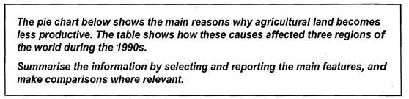

Paraphrased:

The table shows how these issues influenced three parts of the world in the 1990s, and the pie graph shows the main reasons why farming land deteriorates.

**Part 2 Overview**

If you pay attention to the question, there is 1 piece of pie chart (pizza quality table) and 1 piece of table (table). Break the main parts of these graphs into separate sentences when you write about the main features. That is, in the first sentence, write about the 2 main features of the pie chart. In your second sentence, write about 2 main features of the table. If you find information that needs to be checked, then write your third sentence about it.

**Please note: The pie chart shows the reasons for the infertility of the world's lands. The biggest reason is over-grazing (35%), followed by deforestation (30%) and over-cultivation (28%). You can group this information into the first paragraph.**

The table provides information about the places affected by these causes. If you notice that there are a lot of numbers, but if you look at the end of the table, the sum of these numbers is given in the total land degraded line. Europe 23%, Oceania 13% and North America 5%.

You can group this information into the second paragraph.

*The pie graphic makes it evident that there are three main factors that contribute to the degradation of farmland, with overgrazing being the main one. The table demonstrates that, in comparison to the other two areas throughout this time, Europe had a significantly higher percentage of unproductive land.*

**Part 4 First body paragraph**

***Now, in the first paragraph, you only need to elaborate on the 2 key features you selected from Chart 1.***

*Four causes are represented by the pie graphic, with overgrazing accounting for little over a third of them. Both the over usage of crops and the widespread clearance of trees account for little over a quarter of the problem.*

**Second body paragraph**

***In the second paragraph, you will need to provide information about the 2 main characteristics that you selected from the 2nd graph.***

*The table reveals that about 25 percent of Europe's surface had experienced deterioration. Just 5% of North America's entire land area lost productiveness, and Oceania's value was slightly greater at 13%.*

**Plan – Multiple Graph**

*over cultivation*

Introduction

-

Paraphrase the question

- Overview

*2 main features of pie chart*

*-*

*- 2 main features of table*

**First Body Paragraph**

-

*main features of pie chart*

*2*

**Second Body Paragraph**

-

*2*

*main features of table*

**Pie chart**

-

*main feature 1*

*–*

*over grazing*

-

*main feature 2*

*–*

*deforestation &*

**Table**

-

*main feature 1*

*–*

*Europe*

-

*main feature 2*

*–*

*North America & Oceania*

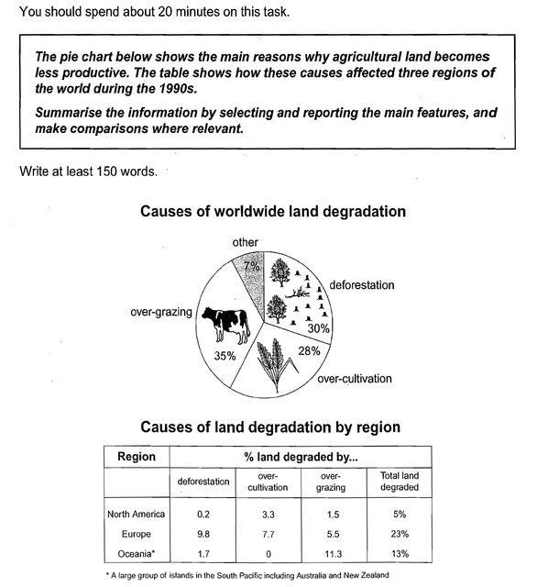

*The table shows how these issues influenced three parts of the world in the 1990s, and the pie graph shows the main reasons why farming land deteriorates.*

*The pie graphic makes it evident that there are three main factors that contribute to the degradation of farmland, with overgrazing being the main one. The table demonstrates that, in comparison to the other two areas throughout this time, Europe had a significantly higher percentage of unproductive land.*

*Four causes are represented by the pie graphic, with overgrazing accounting for little over a third of them. Both the over usage of crops and the widespread clearance of trees account for little over a quarter of the problem.*

*The table reveals that about 25 percent of Europe's surface had experienced deterioration. Just 5% of North America's entire land area lost productiveness, and Oceania's value was slightly greater at 13%.*

**Practice**

**–**

**Multiple graph**

The charts give information

about the interests of people

living in the UK in 2016.

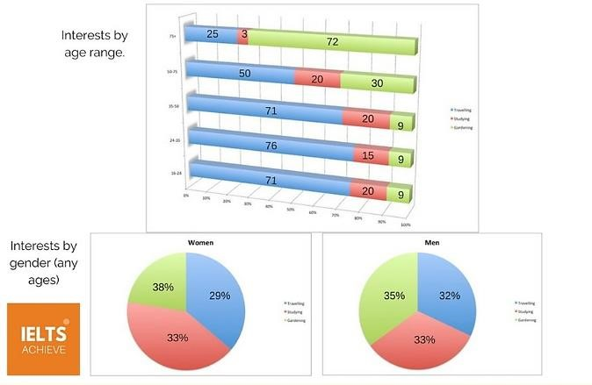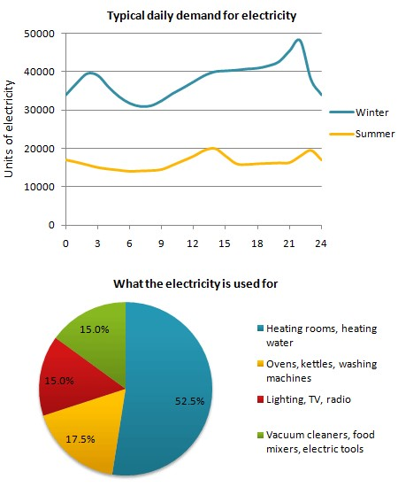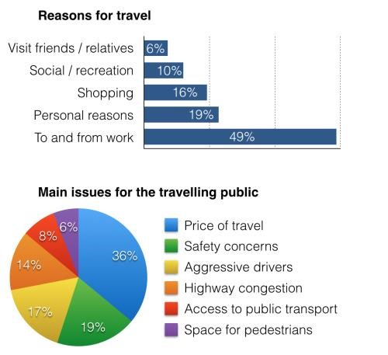

The graph below shows the demand for

electricity in England during typical days in

Figure 3The charts below show reasons for travel

and the main issues for the travelling public in the

US in 2009.

winter and summer. The pie chart shows how electricity is used in an average English home.

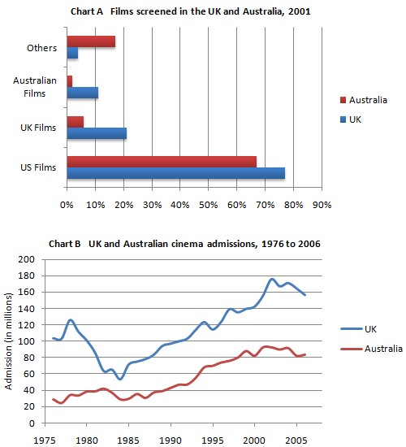

The graph shows cinema admission in the UK

and Australia from 1976 to 2006.



The pie chart below shows the frequency of U.S.

Adults’ online purchasing habits in

2015, while the

bar chart shows a further classification denoting online purchasing preferences.

The first chart shows in which countries adolescents do the most homework in terms of hours per week. The second chart shows the nations that scored the best on an international science test.

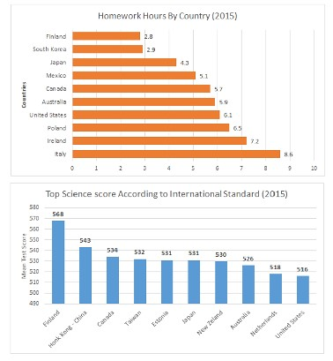

# PIE - CHART

Pie chart - when translated into Uzbek, pie means "pirog" and chart means "table", i.e. pie is a qualitative table, and it is considered one of the easiest tasks in the series of questions. To answer such a question, we use the usual 3-step structure.

A pie chart is a visual representation of data that looks like a pie with the slices representing the size of the data. To show data as a pie chart, a list of numerical variables and categorical variables are required. Each slice in a pie chart has an arc that is proportionate to the quantity it depicts, and as a result, the area and central angle it generates are also proportional.

What is pie chart?

A form of chart called a pie chart uses a circular graph to visually display data. It is one of the most popular graphs used to depict data because it uses the characteristics of spheres, circles, and angular data to represent information from the actual world. A pie chart has a circular shape, with the pie representing the total amount of data and the slices representing its component elements, which are separately recorded.

Pie chart definition

A pie chart is a form of graph that uses circular data recording and then divides the data into sectors to portray each sector's data as a percentage of the total data. These segments or slices each represent a proportionate percentage of the entire. Pie charts, sometimes referred to as pie diagrams, aid in more easily understanding and presenting the data. The given data is also compared using it.

Part **1 – (Paraphrasing the question)**

In this section, you usually provide information about two things:

• what the graphs provide information about

• about years

Question: The percentages of each industry sector's contribution to Turkey's GDP in 2000 and 2016 are depicted in the two pie charts below.

Paraphrased: *The two pie charts show the percentage contributions of several industry sectors to Turkey's economy in 2000 and 2016.*

**Part 2**

**–**

**(Overview)**

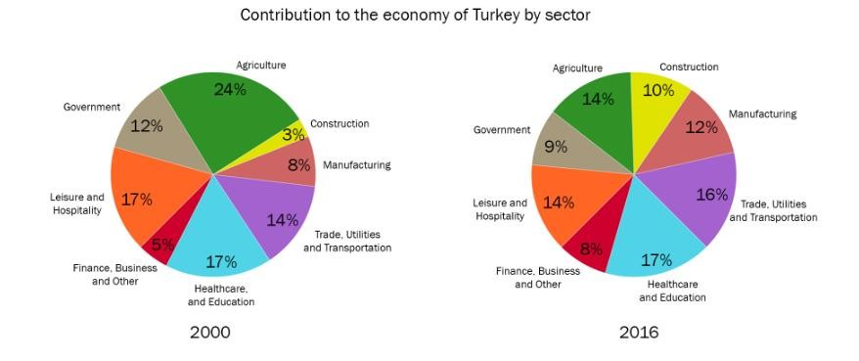

In this section, you should give a brief description of the main parts of each pie chart. That is, the main parts of the first pie chart in your first sentence, and the main parts of the second pie chart in your second sentence. To provide information about the main sections, you need to find the following information, namely:

• find the largest and smallest pieces of the pie chart

• find which fraction has increased, decreased or not changed at all

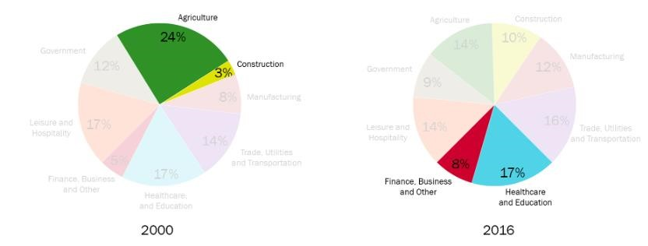

*Example : Construction made the least economic contribution to Turkey overall at the time, with agriculture being the most important industry. By contrast, by the conclusion of the decade, healthcare and education had overtaken business, financial, and other services as the major economic sectors.*

**Part 3 (Body Paragraphs)**

In this part of the essay, you need to group the information. Grouping can usually be done in a number of ways, and one of the easiest ways is as follows:

• sectors that have experienced growth over the years

• sectors that have declined or remained unchanged over the years

Example:

*Turkey's economy's share of the construction sector increased from 3% in 2000 to 10% in 2016, a more than threefold growth. In 2000, economic income from trade, utilities, and transportation was 14%; in 2016, it increased 2% marginally. Manufacturing and finance, business, and other services made up 8% and 5% of Turkey's GDP at the beginning of the period, but these percentages increased to 12% and 8% in 2016.*

*Turkey's economy's share of agriculture, which was almost a quarter in 2000, dropped to 14% in 2016. Government and leisure and hospitality sectors' respective economic outputs in 2000 were at 12% and 17%, and both had fallen by 3% during the previous 16 years. The contribution from the healthcare and education sectors, however, remained constant at 17% in both years.*



The two pie charts below show the percentages of industry sectors’

contribution to the economy

of Turkey in 2000 and 2016

*The two pie charts show the percentage contributions of several industry sectors to Turkey's economy in 2000 and 2016.*

*Construction made the least economic contribution to Turkey overall at the time, with agriculture being the most important industry. By contrast, by the conclusion of the decade, healthcare and education had overtaken business, financial, and other services as the major economic sectors.*

Turkey's economy's share of the construction sector increased from 3% in 2000 to 10% in 2016, a more than threefold growth. In 2000, economic income from trade, utilities, and transportation was 14%; in 2016, it increased 2% marginally. Manufacturing and finance, business, and other services made up 8% and 5% of Turkey's GDP at the beginning of the period, but these percentages increased to 12% and 8% in 2016.

Turkey's economy's share of agriculture, which was almost a quarter in 2000, dropped to 14% in 2016. Government and leisure and hospitality sectors' respective economic outputs in 2000 were at 12% and 17%, and both had fallen by 3% during the previous 16 years. The contribution from the healthcare and education sectors, however, stayed the same in both years.

**Practice**

**–**

**Pie Chart**

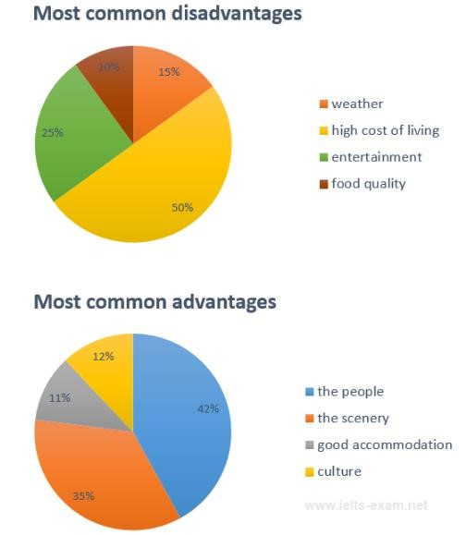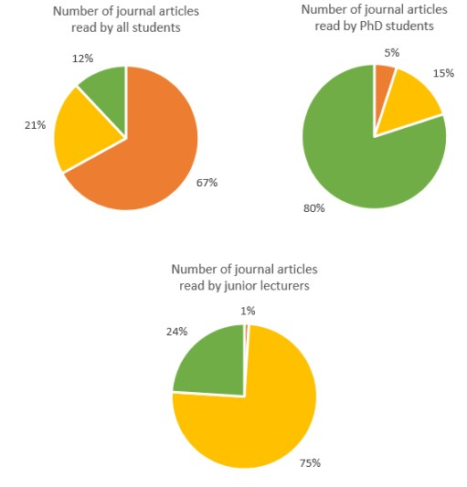

The pie charts below show the most common journal articles read per week by all students, advantages and disadvantages of Bowen Island, PhD students, and junior lecturers at an according to a survey of visitors.Australian university.

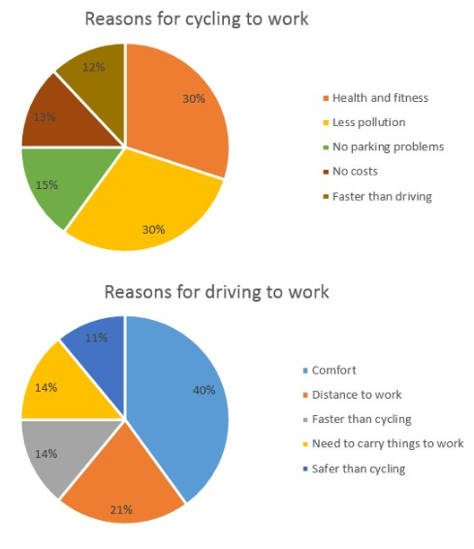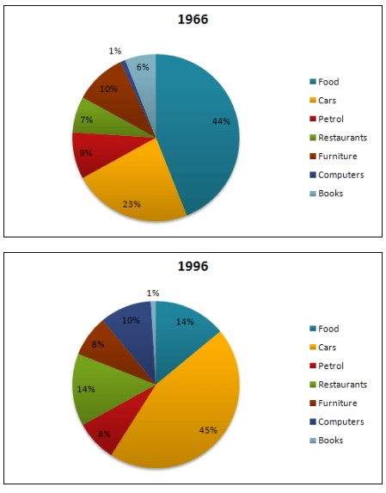

The charts below show the reasons why people The charts below show US spending patterns travel to work by bicycle or by car.between 1966 and 1996.

**Sample answers.**

You should spend about 20 minutes on this task.

**The pie chart shows the amount of money that a children's charity located in the USA spent and received in one year, 2016.**

**Summarize the information by selecting and reporting the main features and make comparisons where relevant.**

Write at least 150 words.

#### Revenue Sources and Expenditures of a USA Charity in one year, 2016.

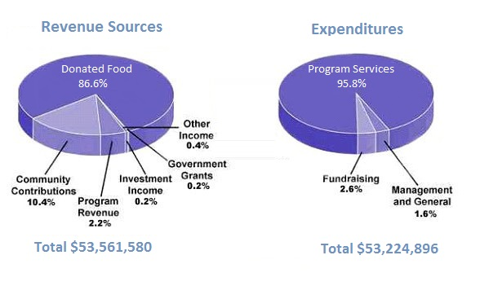

The earnings and expenditures for a children's charity in the USA are depicted in pie charts for 2016.

Overall, it is clear that program services accounted for the majority of the outlay while donated food made for the majority of income. Just barely more money came in than went out overall.

In specifics, 86% of the charity's earnings came from donated food. The same is true of expenditures, where one category—program services—accounted for 95.8% of total outlays.The other groups were somewhat more compact. Community contributions, the second-largest source of income, contributed 10.4% to the total, and were followed by program revenue, which contributed 2.2%. Only 0.8% of the total revenue came from investment income, grants from the government, and other sources of income.

Only two other spending categories, management and general and fundraising, accounted for 2.6% and 1.6% of the total. The total income of $53,561,580 was just enough to pay for the $53,224,896 in expenses.

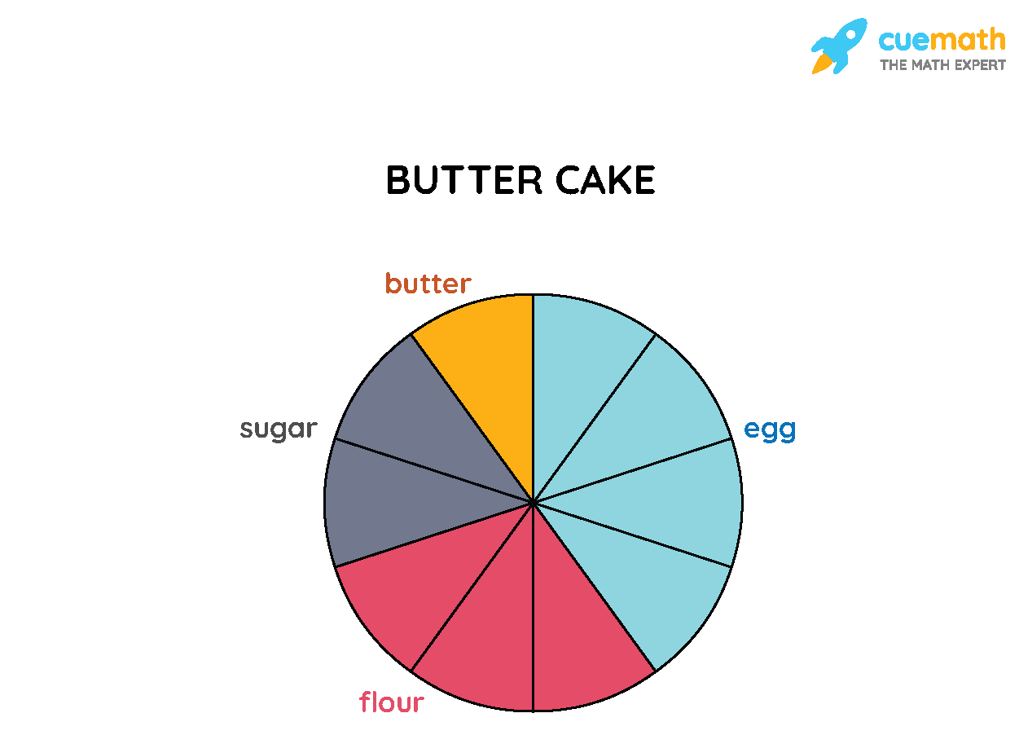

Example:

A value of 100 is represented by the entire pie. There are ten slices or sections in it. The cake's ingredients are represented by its many colors. What would be the precise percentage of each ingredient in the pie chart below that is depicted in a particular color?

Solution:

The pie is divided into 10 pieces, or sectors, as can be seen. We divide the value of the entire sector, 100, by the number of sectors to determine the precise amount of components to be added to the cake. So, 100 ÷ 10 = 10. In light of the pie chart's color-coded divisions, we can therefore deduce that:

|  |  |
| --- | --- |
| Quantity of Flour | 30 |
| Quantity of Sugar | 20 |
| Quantity of Egg | 40 |
| Quantity of Butter | 10 |

Pie Chart Formula

We are aware that the pie's overall worth is always 100%. Another well-known fact is that a circle encompasses a 360° angle. As a result, 360 degrees is equal to the sum of all the data. This lead to the two primary formulas used in pie charts:

* To calculate the percentage of the given data, we use the formula: (Frequency ÷ Total Frequency) × 100
* To convert the data into degrees we use the formula: (Given Data ÷ Total value of Data) × 360°

We can work out the percentage for a given pie chart using the steps given below,

* Categorize the given data and calculate the total
* Divide the different categories
* Convert the data into percentages
* Calculate the degrees

Let's use an example to understand the aforementioned stages.

Check out the pie chart below, which shows how much money Ana spent during the fair. The color shown indicates how much was spent in each category. The data have a 20-point total value, and the following is how much money was spent on each category:

* Ice Cream - 4
* Toffees - 4
* Popcorn - 2
* Rides - 10

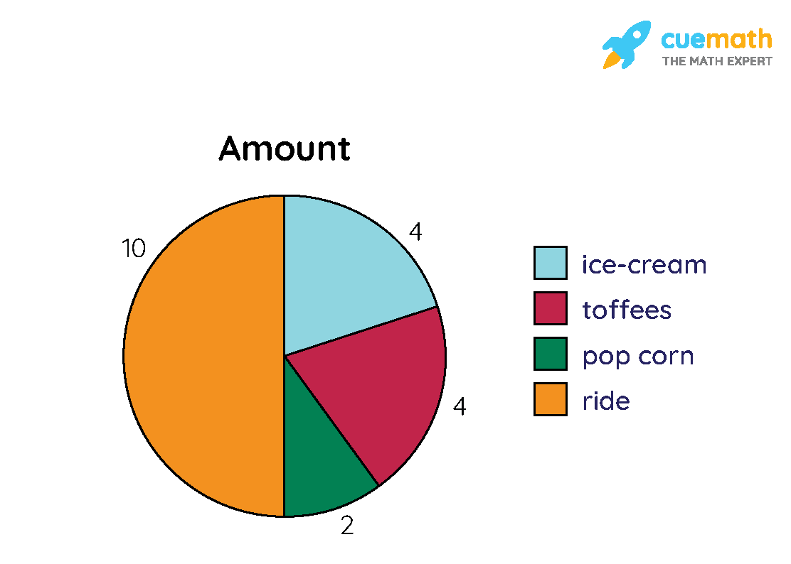

**To convert this into pie chart percentage, we apply the formula: (Frequency ÷ Total Frequency) × 100**

Let us convert the above data into a [percentage](https://www.cuemath.com/commercial-math/percentages/):

Amount spent on rides: (10/20)× 100 = 50%

Amount spent on toffees: (4/20)× 100 = 20%

Amount spent on popcorn: (2/20)× 100 = 10%

Amount spent on ice-cream: (4/20)× 100 = 20%

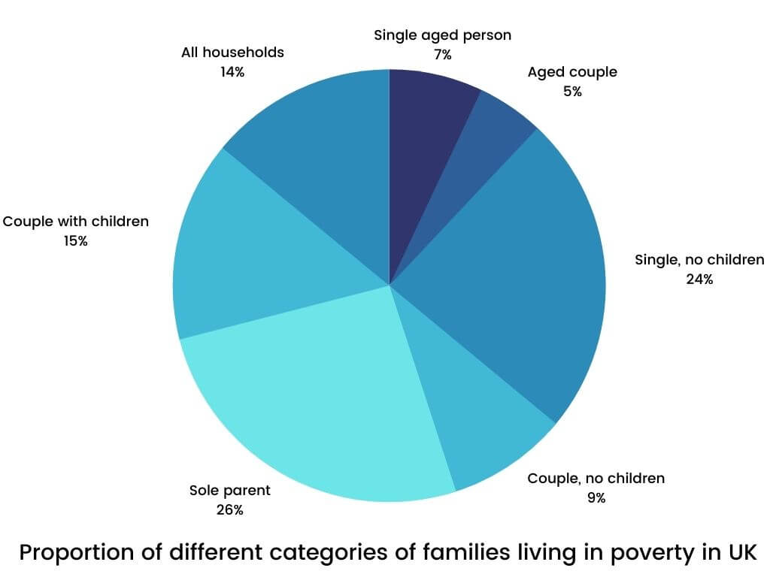

The pie chart examines the various family groups that were living in substandard housing in the UK in 2002.

On the surface, the given year saw 14% of all households in the nation living in poverty. Couples had it easier than singles, who had it harder. For those with children, couples with children reported a relatively lower rate of 15%, while single parents reported the highest percentage of 26% among all the listed categories.

Single persons made up a sizable portion of those without children—24%—and are virtually as numerous as single people with children. On the other hand, in 2002, just 9% of couples without children suffered from poverty. Regarding the elderly, individuals made up a slightly higher percentage than married couples. Just 7% and 5% of the elderly population experienced housing challenges.

**Task 2**

**Basic information:**

- It is important that you write 250 words or more.

- Task 2 corresponds to 3/2 of the general IELTS writing section

- given time is 40 minutes

- there are 5 types of essays

**How to write an accurate and powerful essay?**

To write a strong essay, you must first understand what type of essay question is being asked, and of course planning ahead is required. An essay that begins without a plan will not produce the results you expect. Here, I will show you how to determine the type of essay and also how to structure your essay.

**1 – Opinion Essay or (Agree or Disagree)**

*This type of essay is considered to be the essay given in the most questions, and it is very different from other types of essays in terms of writing and requires a lot of attention. In this essay, the IELTS examiners want you to make a clear point, so it's important that you make up your own mind when reading the question.*

**How do you know if it is an opinion essay?**

*You can learn from the following questions under topic*

Do you agree or disagree?

To what extent do you agree or disagree?

What is your opinion?

***Structure***

*Many students do not do well in this type of essay, and the main reason for this is that they do not know which essay structure to use. It is important to note that there is no one-size-fits-all structure for each type of essay .*

***Structure for opinion essays.***

***Introduction***

-

-

Thesis statement

Outline statement

-

***Body 1***

Topic sentence

-

Explain topic sentence

-

Example

-

***Body 2***

-

Topic sentence

-

Explain topic sentence

-

Example

***Conclusion***

-

Summary and reiteration of your

opinion.

***Note: You don't have to use this build and other builds can get you higher scores. However, this structure has been approved by IELTS examiners, allowing you to write a clear and coherent essay. This structure allows you to generate ideas and then focus on writing an effective essay.***

## Structural information

## **Now we will learn with you what each section of the essay means and consider some questions as examples.**

## Introduction

* ***Introduction -*** *mainly includes three sections, and they are paraphrasing the question, thesis statement and outline statement.*

***- Paraphrasing the question -*** *this was mentioned a lot in task 1, and the same direction works for task 2. It means that you should rewrite the question with other words or sentences without changing the meaning of the question.*

***Question:*** As a result of consuming too much fast food, a rising number of people in several nations are experiencing health issues. Governments must consequently levy a greater tax on this kind of food.

***Paraphrased*:** Because there are more health concerns linked with consuming junk food, it is argued that governments should impose a tax on it.

*As you can see, the meaning of the question has not changed and the general idea has been expressed differently with other sentences.*

***- Thesis statement*** *is your personal opinion on the question, that is, whether you agree or disagree with the given opinion. If you agree with the above opinion, your answer will be as follows*

***Example:*** This essay concurs that fast food businesses ought to pay a higher rate of tax.

***Outline statement -*** *this section gives information about what you will now write about in the body parts of the essay. The main purpose of writing this section is to give the examiner a preview of what will be written in the rest of the essay. The key to writing this section is to link the introduction and body paragraphs together. Of course, this style will earn you big points. So, what will the continuation of the essay look like after the outline statement is written .*

***Example:*** This essay will first describe the higher taxes that producers of alcohol and tobacco already pay, and then it will discuss how greater taxes can increase costs and decrease usage.

*By writing the word firstly, in the first part of the essay (body paragraph 1), you said that you will write about the fact that alcohol and tobacco products are already taxed at a high rate, and by secondly, in the second part of the essay (in body paragraph 2, how high tax rates increase the price and demand You said you will write about the reduction of goods.*

*Now our introduction is completely ready. In the example we can see:*

## ***As there are more health concerns linked with consuming junk food, it is argued that governments should impose a tax on it. This essay concurs that fast food businesses ought to pay a higher rate of tax. This article will first explore the fact that corporations that produce alcohol and tobacco already pay higher taxes, and then it will discuss how greater taxes would increase prices and decrease use.***

## Body Paragraph 1 - the first part of the essay

## ***-*** Topic sentence **- the topic sentence is considered as the first written sentence of the essay parts. In other words, the topic sentence tells you what your essay is going to be about in this section. Let's see how the topic sentence should be in the example.**

## Example: ***Increased taxes on cigarettes and liqueur have been shown to be effective in reducing the harm these substances cause.***

***Explanation -*** *in this section, you will now have to explain the idea that started in the topic sentence in more depth. A good way to do this is to assume that the examinee has no knowledge of the subject and explain exactly what you mean. This might look like this :*

***Example:*** The money generated from these sales has gone toward treating health issues linked to these goods and has helped fund public awareness efforts about the risks of abusing alcohol and cigarettes. The same could be done with fast food taxes .

***Example -*** we need to think of an example to confirm our point. Think of the latest news, research or advertising. If you can't think of one, make it up. The validator does not check whether it is valid or not .

***Example:*** A prime example is the United Kingdom, where smokers' money is invested in health programs in schools to educate kids about the risks of smoking while also being used to treat lung cancer and heart disease.

*Now body paragraph 1, the first part of the essay, is completely ready. In the example we can see:*

Increased taxes on cigarettes and liqueur have been shown to be effective in reducing the harm these substances cause. The money generated from these sales has gone toward treating health issues linked to these goods and has helped fund public awareness efforts about the risks of abusing alcohol and cigarettes. The same could be done with fast food taxes. A prime example is the United Kingdom, where money collected from smokers is utilized to treat heart disease and lung cancer.

## Body Paragraph 2 – second part of the essay

*Now we repeat the same formula, the second part of our essay.*

* ***Topic sentence***

***Example:*** Tax increases would result in higher costs and decreased demand.

Explanation

***Example:*** These levies would be passed on to customers by fast food chains in the form of higher costs, which would prevent individuals from affording junk food because it is so expensive. Junk food would quickly turn into a luxury item and would only be seldom consumed, posing less of a threat to public health.

***Example:*** For instance, most individuals find the cost of organic food to be prohibitively expensive, which explains why a relatively small proportion of people buy it frequently.

## Conclusion

***The best type of summary is a summary of the main points and your personal opinion.***

***Note: Never write about new ideas in this section.***

***Example:***In conclusion, junk food should be taxed more heavily due to the positive examples of alcohol and tobacco, as well as the fact that the higher price should cause fewer individuals to purchase fast food.

## SAMPLE ESSAY

***Question:* As a result of consuming too much fast food, a rising number of people in several nations are experiencing health issues. Governments must consequently levy a greater tax on this kind of food.**

**How much do you concur or disagree?**

There is a claim that governments should impose a tax on junk food due to the growing number of health concerns connected to its consumption. This essay concurs that fast food chains should be subject to a higher tax rate. This essay will first talk about how alcohol and tobacco corporations currently pay greater taxes, and then it will talk about how increased taxes would increase costs and decrease use .

Increased taxes on cigarettes and liqueur have been shown to be effective in reducing the harm these substances cause. The money generated from these sales has gone toward treating health issues linked to these goods and has helped fund public awareness efforts about the risks of abusing alcohol and cigarettes. The same could be done with fast food taxes. A prime example is the United Kingdom, where money collected from smokers is utilized to treat heart disease and lung cancer.

Tax increases would result in higher costs and decreased demand. These levies would be passed on to customers by fast food chains in the form of higher costs, which would prevent individuals from affording junk food because it is so expensive. Junk food would quickly turn into a luxury item and would only be seldom consumed, posing less of a threat to public health. For instance, most individuals find the cost of organic food to be prohibitively expensive, which explains why a relatively small proportion of people buy it frequently .

In conclusion, junk food should be taxed more heavily due to the positive examples of alcohol and tobacco, as well as the fact that the higher price should cause fewer individuals to purchase fast food

***Question: Some people contend that unpaid community service initiatives (such volunteering for a nonprofit, enhancing the neighborhood, or instructing young children in sports) ought to be a requirement for enrollment in school programs. Affirmative or negative?***

It is believed that volunteering ought to be taught in schools. This article wholeheartedly concurs with that opinion due to the advantages it provides students. The essay will first examine how volunteer work can aid in the development of soft skills in students before going through how universities and businesses regard these extracurricular activities .

Education should not only focus on academic subjects; students should also learn life skills like teamwork, empathy, and self-discipline. Community service is one of the finest ways to develop these talents. Helping others who are less fortunate than we are teaches us many things, such as how to get along with individuals from different backgrounds and the importance of working hard. For instance, when I returned to my studies after spending six weeks teaching underprivileged children in Africa as a volunteer, I had a significantly better work ethic .

These kinds of experiences are increasingly sought after by many institutions and employers. While most graduates have similar grades, doing good deeds can help you stand out from the crowd. For instance, Cambridge and Oxford only accept a small portion of the hundreds of applications from straight-A students each year. The thing that sets you apart from the competition and secures you that desired slot is frequently what you have accomplished outside of the classroom .

In conclusion, teens should be required to perform unpaid work as part of their education since doing so will enable them to obtain skills and knowledge that they might not otherwise learn from their teachers and will increase their likelihood of enrolling in further education.

***Question: Job contentment is not as crucial as a high wage.***

***Do you concur or disagree?***

It is frequently suggested that choosing a job with a large salary is preferable, even if you have no interest in doing so. I vehemently disagree with this viewpoint and believe that pay is not the most essential factor.

First of all, I think that having a fulfilling career provides people a sense of purpose that money cannot buy. Even if a person has a big income but feels stressed out and compromises with his morals, he or she won't enjoy life. While following one's passions will always be enjoyable and satisfying. For instance, many well-known researchers chose their professions because they were excited about science rather than because of the attractive pay. Because of this, choosing a line of employment that makes you happy is more significant than focusing simply on a large salary.

Second, doing what you enjoy keeps you motivated, which advances your career. In other words, there is a significant link between productivity and job satisfaction. Individuals who enjoy their work are more likely to flourish in their fields and provide superior results than those who prioritize their salaries. For instance, Henry Miller chose to pursue writing instead of staying at his regular job while earning a high salary. He eventually overcame years of ups and downs to become one of the most well-known and wealthy novelists of the 20th century. So, from a long-term viewpoint, the benefits of occupations that keep you content exceed the disadvantage of a low wage .

*In conclusion, I firmly believe that a large pay is not always better than a job that makes people happy and driven.*

***Question: Investments made by the government in the performing arts are a waste of funds. Governments ought to use this money to fund public services instead.***

***Do you agree or disagree, and to what extent?***

It is frequently suggested that the government should fund public services rather than allocating funds to the performing arts. I believe that sufficient support for the arts sector is also essential for the society, even though I agree that government investments in public services play a very vital role.

On the one hand, the government must allocate a significant portion of its budget to public services. The entire quality of life is determined by this economic sector, which makes sure that all citizens, regardless of their social standing or level of income, have access to some fundamental amenities like schools, hospitals, and roads. Since public services meet the majority of societal demands, they must receive adequate money, whereas artists and musicians do not treat illnesses or construct homes, they play a supporting function in society. A nation may survive without music festivals, but without access to healthcare, serious issues will arise. To begin with, the government ought to sufficiently fund public services .

On the one hand, the government must allocate a significant portion of its budget to public services. The entire quality of life is determined by this economic sector, which makes sure that all citizens, regardless of their social standing or level of income, have access to some fundamental amenities like schools, hospitals, and roads. Since public services meet the majority of societal demands, they must receive adequate money, whereas artists and musicians do not treat illnesses or construct homes, they play a supporting function in society. A nation may survive without music festivals, but without access to healthcare, serious issues will arise. To begin with, the government ought to sufficiently fund public services.

I agree that the government should spend a significant portion of its money on pressing societal requirements like public services, but I also believe that the arts, music, and theater should be supported because they are crucial for the growth and entertainment of society.

**Some individuals think that technology has increased human socialization. How much do you concur or disagree with this viewpoint?**

Whether the introduction of sophisticated contemporary technology, such as mobile phones, computers, and iPads, has served to enhance and improve people's social life or whether the opposite has become the case is a topic of controversy among experts in both the developing and developed worlds.

**Some individuals think that technology has increased human socialization. How much do you concur or disagree with this viewpoint?**

I strongly support the former point of view. In order to illustrate ideas and support claims, this essay will explore both perspectives while using examples from the UK government and Oxford University.

On the one hand, there is a wealth of compelling research that shows how harmful such technology can be, especially for the younger generation who are more susceptible to its addictive qualities and which can make people feel more separated from society.

The main causes of this are twofold. First, the development of online social media platforms and applications like Twitter and Facebook has drastically decreased the amount of necessary face-to-face encounters. Those who utilize these alluring and alluring mediums feel in touch and connected yet lack essential social skills and communication abilities.

Second, it's shockingly simple to develop a dependent on such devices, which could be bad for mental health and promote a sedentary lifestyle. For instance, a recent study by the UK government found that 90% of people in their 30s spend more than 20 hours per week chatting with their pals on Messenger and similar apps rather than getting together and spending meaningful time together or engaging in sports. It is therefore undeniably true that these technological advances have lessened and weakened our real-world interactions.

On the other hand, despite the fact that technology advancements have some substantial drawbacks, its numerous benefits are undeniable. This is largely due to the ease with which individuals may connect today thanks to technology like cellphones, which removes all geographical restrictions. Individuals may communicate with their loved ones anytime and wherever they choose, which maintains a sense of proximity and closeness. They can exchange any news, information, images, and thoughts. For instance, a thorough investigation by Oxford University revealed that those who use Face time and WhatsApp to communicate with their family while working or studying abroad are less likely to feel isolated and lonely than those who do not.

This line of reasoning is supported by the fact that businesspeople may surely profit from these developments by organizing virtual real-time meetings utilizing Skype, which may enhance the likelihood of sealing transactions without having to fly.

The arguments and examples provided have convinced me that despite some potentially serious health consequences that governments must address, overall communication and human sociability have advanced significantly as a result of the enormous technological advancement of the past 20 years. It is also predicted that its popularity will continue to soar in the future.

**Due to the prevalence of firearms in homes, shootings have increased in several nations. How much do you concur or disagree? Provide precise justifications and illustrations to back up your claim.**

Many people own guns for self-defense and entertainment all across the world. Particularly when gun-related home fatalities occur, the morality of such private gun ownership comes into stark focus. I will utilize crime statistics to support my claim that having a gun in the home significantly increases the danger of being shot. future.

First off, it should go without saying that keeping a gun in the home puts kids and teenagers at danger. This is due to the fact that young people lack the skills and maturity needed to wield weapons responsibly. For instance, according to figures recently released by the US Department of Justice, 150 American children and teenagers pass away each year in incidents involving domestic guns. Hence, it is undeniable that having access to guns at home increases the likelihood of shootings.

Second, when spouses get into heated confrontations, domestic guns become very hazardous. This is due to the fact that male sexual wrath, in particular, frequently leads to lethal aggressiveness. For instance, the International Crime Bureau has revealed statistical proof that a man is twice as likely to kill his wife in a fit of jealous rage if there is a gun in the home if he finds out she is having an affair. Once more, home firearms are positively correlated with more shootings.

In conclusion, there is indisputable proof that having a gun in the home increases the likelihood of shootings. Given the gravity of this evidence, additional legislation restricting private gun ownership will need to be put in place in the future.

**Throughout the past century, developments in medicine, biology, and other societal fields have changed how we live and postponed the day of death. There is no period greater than this one to be alive. How much do you concur or disagree with this viewpoint?**

Due to its direct connection to survival and health, biology is one of the most significant branches of science. It has been suggested that the present is the best moment to be alive given the remarkable advancements made. For two reasons—first, lives have been made better, and second, risks have decreased—I firmly concur with this assertion.

First, it is conceivable to enumerate new advantages compared to life a century ago, including hospitals, physicians, medications, diagnoses, donors, and transplants—all of which were highly uncommon before. The quality of life has significantly increased as a result of scientific advancements.

As an illustration, think of a procedure performed in France a few years ago during which a woman had her entire face transplanted. Her life has clearly improved as a result of science because this would have been unimaginable before 1910.

Second, health hazards have drastically decreased, making it possible to go to tropical areas that previously posed serious risks. This is due to the lack of prophylactic measures including vaccinations, immunizations, and prescription medications in the past.

Also, their prices have decreased over the past thirty years, making exotic travel accessible to practically everyone with the money. Thus, there has never been a time in history where contemporary science has expanded opportunities and decreased risks associated with travel.

To sum up, I wholeheartedly concur that advances in biology and science have improved people's well-being and prospects for global exploration. Without a doubt, this is the first time in history that such circumstances have existed.

## ***Many governments in the world spend large amounts of money on art, which helps to improve the quality of people’s lives. However, governments should spend money on other things rather than art. Do you agree or disagree? Give your opinion.***

Cultures having a history of "arts" have long been regarded as smart and progressed culturally. But, in light of the recent financial crisis, this extravagant spending should be called into question. Using taxpayer money for practical purposes rather than cultural endeavors is required. First of all, not everyone in society is an art enthusiast, and secondly, work should come first.

If you're interested, art can improve your life. Those who enjoy art are often in the minority in society; people who enjoy other pursuits, like sports, are more prevalent. Take football as an illustration. It is evident that more people watch sporting events in stadiums than look at sculptures or other works of art. This makes it impossible for art to improve a community if there is minimal interest in the galleries.

Second, the public should profit from the use of the funds diverted to such projects because they are public funds. Taxpayers who experience high unemployment, like those in Newcastle, UK, should not be insulted by commissioning or purchasing art. Despite the city's historically high unemployment rate, "The Angel of the North," a sizable sculpture, was commissioned by the council. Indeed, it would have been more beneficial for the neighborhood to fund a project that would have created jobs.

To sum up, I think it is unfair to claim that art improves one's quality of life, and I concur that the money would be better used elsewhere. This is because, first, only a small minority benefits from spending money on the arts, and second, the money spent on the arts should benefit everyone. In the future, governments should realize that a person's quality of life is derived from having acceptable opportunities in life, not from a sculpture.

# 2 – Advantages and Disadvantages

## In the advantages and disadvantages essay type, you are usually given a statement and asked to comment on the advantages and disadvantages of that statement.

## The problem is that there are 3 different types of pros and cons essay writing and each requires a different approach. If you answer them incorrectly, you risk losing a lot of points.

## This lesson will look at each of the three question types. There are sample answers for each of the three questions to compare the three approaches and make it easier for you to understand.

## Question 1

***Topic:*** Some nations encourage young people to take a year off from education after high school before beginning their university studies.

***Question:*** Discuss the advantages and disadvantages for young people who decided to do this

***Topic:*** *In some countries, young people are recommended to work or travel for a year before finishing high school and continuing their studies at university.*

***Question:*** *Discuss the advantages and disadvantages of young people deciding to do this.*

*This type of question is not asking you for your personal opinion on which side is better or which side is worse, it is only asking for the advantages or disadvantages of the given topic.*

### Structure for Question 1 Introduction

*Sentence 1- Paraphrase question*

*Sentence 2- Outline sentence*

### Body 1 (Advantages)

*Sentence 3- Topic sentence (Advantage 1)*

*Sentence 4- Explain how this is an advantage*

*Sentence 5- Example*

### Body 2 (Disadvantages)

*Sentence 6- Topic sentence (Disadvantage 1)*

*Sentence 7- Explain how this is a disadvantage Sentence 8- Example*

[***Conclusion***](https://www.ieltsadvantage.com/2015/06/14/ielts-writing-conclusions/)

*Sentence 9- Summary of main points*

## Question 1 Sample Answer

**Some nations encourage young people to take a year off from education after high school before beginning their university studies.**

Talk about the benefits and drawbacks for young individuals who made this decision.

Many young people are told that spending a year working or traveling before starting college is a good idea. This essay will argue that the largest benefit of doing this is saving money, while the biggest drawback is having less drive to learn .

Due to the high cost of a third level education, many students opt to work for a year in order to save money before starting their studies. Instead of struggling financially or having to take a second job on top of their schoolwork, this enables students to cover their living expenses, tuition, and housing charges while concentrating on their academics. According to a recent article in The Times, the average UK university student needs over $12,000 year merely to subsist, and many students leave because they are unable to continue .

Despite these benefits, many students find that after a year away from school they become accustomed to working or traveling and don't want to go back. Because of their short-term perspective, some people may forego attending college completely and instead begin working in a position that is under their skill level or may not provide the same opportunities as a future career. According to a recent British Government poll, 26% of students who take a gap year never enroll in university education.

In summary, taking a hiatus from studies can be beneficial if it enables people to save money, but they should also be careful that it does not result in a generalized disillusionment with education.

## Question 2

***Topic:*** Some experts believe that it is better for children to begin learning a foreign language at primary schools rather than secondary school. ***Question:***Do the advantages of this outweigh the disadvantages?

***Topic:*** *Some experts believe that it is better for children to start learning a foreign language in elementary schools than in high school.*

***Q:*** *Do the pros outweigh the cons?*

*This type of question is now different because we are asking whether the advantages outweigh the disadvantages. If you have noticed, there is a question, "if the advantages of starting foreign language learning in primary schools rather than secondary schools outweigh the disadvantages."*

*In this type of essay, you have to show whether the advantages are really more. The question doesn't ask you to talk about numbers, but preferences or comment on the overall severity of the deficiencies.*

### Structure for Question 2 Introduction

*Sentence 1- Paraphrase question*

*Sentence 2- Thesis statement (state which one outweighs the other) Sentence 3- Outline sentence*

### Body 1 (Stronger Side)

*Sentence 4- Topic Sentence*

*Sentence 5- Explain why it is strong*

*Sentence 6- Example*

*Sentence 7- Topic Sentence*

*Sentence 8- Explain why it is strong*

*Sentence 9- Example*

### Body 2 (Weaker Side)

*Sentence 10- Topic Sentence*

*Sentence 11- Explain why it is not strong*

*Sentence 12- Example*

### Conclusion

*Sentence 13- Summary of main points and restate position.*

## Question 2 Sample Answer

***Some experts believe that it is better for children to begin learning a foreign language at primary schools rather than secondary school.***

***Do the advantages of this outweigh the disadvantages?***

Some experts believe that starting language learning in primary school rather than high school is better for students. This essay will contend that this has more benefits than disadvantages. The essay will first show that learning a second language early increases a person's likelihood of mastering it and has extra cognitive advantages. This will be followed by a discussion of how the main drawback, being confused with their original tongue, is unfounded .

Early exposure to foreign languages boosts children's chances of becoming fluent speakers as adults, which is the main justification for doing so. This means that kids will have a lot more time to hone their abilities and that speaking two languages will seem completely natural to them. For instance, almost 95% of adults speak English at an advanced level in nations like Holland and Norway where it is taught to children at a very young age. Developing one's general cognitive capacities is another benefit of learning a second language. In other words, it helps a child's brain develop in general. Children who learned a new language before the age of five had a considerably better chance of performing well on tests, according to a recent Cambridge University study.

## **Others who are against it claim that doing so will confuse the child between their mother tongue and the other language. The truth is that there is no evidence to back up this theory, and multilingual youngsters perform as well in both languages. The majority of his classmates are outperformed in both Vietnamese and English by my own kid, who was up speaking both languages.**

## **Overall, the faulty claim that early foreign language learning hinders the acquisition of native languages is strongly outweighed by the reality that it increases fluency and improves brain function .**

## Question 3

***Topic:*** Computers are becoming an essential part of school lessons. **Question:** Discuss the advantages and disadvantages and give your own opinion.

This type is different from each other. It's like a discussion and a personal opinion essay at the same time. For this type of essay, you must write the advantages and disadvantages of the topic, and in addition to it, your personal opinion, that is, in your opinion, whether computers are more useful or harmful in school classes.

***Structure for Essay 3***

### Introduction

*Sentence 1- Paraphrase question*

*Sentence 2- Thesis statement (your opinion)*

*Sentence 3- Outline sentence*

### Main Body Paragraph 1 (Advantages)

*Sentence 4- Topic Sentence*

*Sentence 5- Explain*

*Sentence 6- Example*

### Main Body Paragraph 2 (Disadvantages)

*Sentence 7- Topic Sentence*

*Sentence 8- Explain*

*Sentence 9- Example*

### Main Body Paragraph 3 (Opinion)

*Sentence 10- Explain opinion*

*Sentence 11- Explain or give example*

***Conclusion***

*Sentence 12 – Summary of main points*

# 3 – Problem and Solution

* ***The problem and solution essay type is one of the most common IELTS Task 2 essays in the exam. Despite being very common, many students are unable to answer these questions. The following page will give you step-by-step information on how to write this essay for a high score.***
* *What are the most common problems?*

***One of the most common problems*** *is that the student gives too much information about a problem or a solution to it based on his own thoughts. Or even worse is to give countless problems and countless solutions to those problems. The examiner does not want this kind of essay from you*

* *The essay response expected from you will include 1 or 2 problems and solutions, and only about this will you explain your thoughts through explanation and examples.*

***A second common problem*** *is writing about problems and solutions that are not directly related to the question. You should be like a sniper when answering questions and give specific ideas rather than general ideas.*

*Too many students write lots of good ideas about problems but fail to come up with solutions to those problems. Every problem should have a solution that is directly related to it, or in other words, it should solve a real problem.*

*Finally, some students think of very good problems and solutions that answer the question correctly and then expand their answers with explanations and examples, but they answer with general ideas. Instead, you should give a specific problem and a specific solution to your written problem*

* *In order to avoid these problems, you need to prepare well and start writing your essay after studying the given structures well. The first thing you need to do is to understand the question clearly and completely. For this, you need to think about the following 3 things and analyze the question*
* Keywords (kalit so’zlar)
* Micro-keywords (mikro kalit so’zlar)
* Action words (harakat so’zlari)

***Keywords*** *are words that basically tell us what the general topic is about*

***Micro-keywords -*** *micro-keywords, and the examiner determines what you will discuss about the general topic. Micro keywords usually give an idea or break down sub-sections of a general topic.*

***Action words*** *give information about what the examiner wants us to do.*

***Topic:*** *One of the greatest challenges to humanity in the twenty-first century is global warming, and the rate at which sea levels are rising is worrying.*

*What issues are related to this, and what are some potential remedies.*

*If you notice, the keyword here is global warming, and that's our general theme. We will write an essay about this. But we cannot write about any problems related to global warming (climate warming). If we did, we would have answered the question incorrectly.*

*For this we need to find micro-keywords. The micro keyword here is "humans" and "sea level rise". So instead of writing about global warming and all the problems associated with it (such as hurricanes, extinction of certain animals, soil erosion), how sea level rise affects people we need to talk about the effect. For example, if we talk about problems related to "the planet" or "animals" or "atmosphere", we do not answer the question.*

*The last thing we need to define is action words. In this essay, we should write about the problems and solutions of rising water levels. These types of essays are not asking you about the reasons why your water level is rising. He is only asking what problems this situation creates for people and the solutions to it .*

***Topic:*** *One of the greatest challenges to humanity in the twenty-first century is global warming, and the rate at which sea levels are rising is worrying.*

***Question:*** What problems are associated with this and what are some possible solutions.

***Structure***

|  |
| --- |
| ***Introduction***  *Sentence 1- Paraphrase question*  *Sentence 2- Outline sentence (say what you*  *will discuss in the rest of the essay)*  ***Body 1 - Problem***  *Sentence 3- State problem*  *Sentence 4- Explain what problem is*  *Sentence 5- What is the result of this problem*  *Sentence 6- Example*  ***Body 2 - Solution***  *Sentence 7- State solution*  *Sentence 8- Explain how the solution will solve the problem Sentence 9- Example*  ***Conclusion***  *Sentence 10- Summary of main points in paragraphs 2 and 3*  *Sentence 11- Prediction or recommendation* |

***SAMPLE ESSAY***

***Global warming is one of the biggest threats humans face in the 21st Century and sea levels are continuing to rise at alarming rates.***

***What problems are associated with this and what are some possible solutions.***

## Introduction

***-*** ***Introduction - includes paraphrasing the question and outline statement******Paraphrased -*** Climate change is among the principal dangers facing people this century and ocean levels are increasing dramatically.

***Outline Statement –*** This essay will first suggest that the biggest problem caused by this phenomenon is the flooding of homes and then submit building flood protection as the most viable solution.

***Full paragraph example:***

Climate change is among the principal dangers facing people this century and ocean levels are increasing dramatically.This essay will first suggest that the biggest problem caused by this phenomenon is the flooding of homes and then submit building flood protection as the most viable solution.

***For use:***

## Body 1– Problem

***-Topic Sentence -*** The foremost problem caused by climbing sea levels is the flooding of peoples’ residences.

***-Explanation*** *Millions of people live along coastlines around the world, and if the sea level increases by just a few feet, they will be engulfed in water and lose their possessions. One of the most fundamental human needs is shelter, and widespread flooding would make millions of people homeless and force them to lose all of their things.*

-***Example-*** *Floods have recently affected many people around the world. Everyone could clearly observe the destruction caused by extensive flooding during the 2011 Tsunami in Japan, which resulted in millions of people being displaced.*

***Full paragraph example:***

## **The flooding of people's homes is the main issue brought on by the water levels gradually rising. Millions of people live along coastlines around the world, and if the sea level increases by just a few feet, they will be engulfed in water and lose their possessions. One of the most fundamental human needs is shelter, and widespread flooding would make millions of people homeless and force them to lose all of their things. Millions of people were displaced as a result of the 2011 tsunami in Japan, which made obvious the destruction caused by this .**

## Body 2 – Solution

***-Topic Sentence -*** A possible solution to this problem would be to build flood barriers.

***-Explanation -*** Flood defenses, such as dikes, dams, and floodgates, could be built along coasts and waterways, thereby stopping the water reaching populated areas.

-***Example-*** One of the most populous and flood-prone countries in the world is the Netherlands, which has successfully implemented a number of flood protection measures.

***Full paragraph example:***

## ***Building flood barriers could be a solution to this issue. Dikes, dams, and floodgates, among other flood defenses, could be constructed beside waterways and coastlines to prevent flooding of populous areas. One of the most populous and flood-prone countries in the world is the Netherlands, which has successfully implemented a number of flood protection measures .***

## Conclusion – Summary & Prediction or Recommendation

***-Summary –*** In conclusion, controlling the rising tides brought on by rising global temperatures is one of the biggest issues we have and will eventually cause many towns to become submerged. Nevertheless, there may be a solution if we adopt the flood prevention methods already employed by nations like Holland.

***-Prediction-*** It is anticipated that more and more nations will be compelled to implement these measures in order to prevent a water-related catastrophe.

***Full paragraph example:***

In conclusion, controlling the rising tides brought on by rising global temperatures is one of the biggest issues we face and may eventually cause many towns to become submerged. Nevertheless, there may be a solution in using the flood prevention methods already employed by nations like Holland. It is anticipated that more and more nations will be compelled to implement these measures in order to prevent a water-related catastrophe .

***For use:***

## SAMPLE ESSAY

***Question:*** One of the greatest challenges to humanity in the twenty-first century is global warming, and the rate at which sea levels are rising is worrying.

What issues are raised by this, and what solutions might be found.

Ocean levels are rising fast, and climate change is one of the main threats to humanity this century. This essay will first indicate that the flooding of dwellings is the main issue brought on by this phenomena, and it will then present flood protection built into buildings as the most practical remedy.

The flooding of people's homes is the main issue brought on by the water levels gradually rising. Millions of people live along coastlines around the world, and if the sea level increases by just a few feet, they will be engulfed in water and lose their possessions. One of the most fundamental human needs is shelter, and widespread flooding would make millions of people homeless and force them to lose all of their things. Millions of people were displaced as a result of the 2011 tsunami in Japan, which made obvious the destruction caused by this.

Building flood barriers could be a solution to this issue. Dikes, dams, and floodgates, among other flood defenses, could be constructed along waterways and coastlines to prevent flooding of populous areas. One of the most populous and flood-prone countries in the world is the Netherlands, which has successfully implemented a number of flood protection measures .

## ***In conclusion, controlling the rising tides brought on by rising global temperatures is one of the biggest challenges we face and will eventually cause many cities around the world to become submerged. However, there may be a solution in using the flood prevention strategies already employed by nations like Holland. It is anticipated that more and more nations will be compelled to implement these measures in order to prevent a water-related catastrophe .***

## SAMPLE ESSAY

***Question Students are using computers more and more frequently.***

***What are some of the drawbacks of being dependent on computers, and what are some potential remedies?***

Technology like the Internet and mobile devices are being used by learners more and more frequently. This essay will go through one of the key issues with computer reliance and offer a workable solution.

Plagiarism is the main issue with an excessive reliance on technology, including tablets and PCs. Instead of considering the question, students frequently utilize search engines to find the solution to a question and simply copy the information from a website. In addition to being against the law in schools and universities, this practice also inhibits a student's intellectual growth. For instance, many professors lament the fact that their students simply copy entire web pages verbatim from Wikipedia rather than responding to questions in a logical manner. Asking students to email their answers to teachers and teachers utilizing anti-plagiarism software to detect copying are two solutions to this troubling issue. Students would also be made aware of this approach, which would encourage them to respond to inquiries in their own words as opposed to others'. For instance, many institutions already use this type of software to check course work for plagiarism, and students in secondary and tertiary education might expand its use to check all homework.

In conclusion, plagiarism is one of the primary issues with the excessive use of technology in education, and this issue can be resolved by using plagiarism detection software. It is anticipated that an increasing number of students will send their assignments to their teachers, who will then check them for plagiarism.

**The internet has transformed the way information is shared and consumed, but it has also created problems that did not exist before.**

**What are the most serious problems associated with the internet and what solutions can you suggest?**

*The massive increase in internet usage over the past ten years has resulted in significant changes to how information is consumed and distributed. Despite the fact that this has led to significant issues, there are remedies.*

*One of the first issues with the internet is how simple it is for kids to access potentially harmful websites. For instance, because kids may register with a site and make the claim that they are adults, they have easy access to pornography websites. There is no question that this has a bad effect on the children and society as a whole, as it impacts their thoughts and development. The rise of internet fraud and hacking is a significant issue as well. Nowadays, there are frequently reported incidents of sensitive information being obtained by thieves when government and business websites were compromised.*

*It is crucial that steps are taken to address these issues. Governments should make sure that sufficient laws and regulations are in place to stop children from accessing risky websites, such as demanding more than just confirming your age to see a website. Parents play a role as well. They must actively watch their children's actions and limit their access to particular websites, both of which can now be done via a variety of computer tools. In order to make fraud and hacking considerably more challenging, businesses must also strengthen their onsite IT security systems by conducting in-depth inspections of their current systems for flaws.*

*To sum up, the internet is a phenomenal technological advancement that has revolutionized people's lives, but not without drawbacks. But, it is possible to make it a safe environment for everyone with the proper action by people, governments, and corporations.*

***Problem 1:***children can access potentially dangerous sites

* ***Explanation / Example:*****Pornography sites**
* ***Result:***Affects thought & development - negative for children & society

***Problem 2:***growth of online fraud and hacking

* ***Explanation / Example:*****Evident from the constant news stories**
* ***Result:***Criminals get sensitive information

***Solution 2:***Parents

* ***Idea:*****Monitor children and restrict access**
* ***How:***Use a computer program

***Solution 3:***Companies

* ***Idea:*** **Improve IT security systems**
* ***How:***Review current systems in place

***Despite a large number of gyms, a sedentary lifestyle is gaining popularity in the contemporary world.***

* ***What problems are associated with this?***
* ***What solutions can you suggest?***

*How to answer the question?*

*Before starting to write your answer, you should think of 1-2 problems and 1-2 solutions, so you know what to write about. In our case:*

***Problems associated with sedentary lifestyle****:*

**

* *obesity*
* *problems with backbone (osteoporosis, scoliosis)*

***Solutions****:*

* *promote walking and cycling as safe and attractive alternatives to motorized transport*
* *promote visiting gyms and doing exercises*

*Now,*after we’ve generated some ideas for our essay, it’s time to use them in our writing*.*

***Remember****: it’s not enough to simply state these facts, you should also extend the ideas in your writing.*

Despite the abundance of sport facilities nowadays, a sedentary lifestyle is growing in popularity. The primary issues surrounding this epidemic will be covered in this article, along with some potential fixes.

Obesity and numerous spine ailments are the main issues brought on by an inactive lifestyle. A increasing amount of evidence suggests that prolonged periods of inactivity increase the risk of becoming overweight. People easily gain weight and burn less calories as a result. Furthermore, numerous studies demonstrate that the so-called "sitting illness" frequently causes posture and backbone issues. Due to prolonged sitting, a person loses muscular mass, their spine curves, and they get many spinal illnesses. For instance, it has been demonstrated that back pain affects roughly 80% of adults at least once every week.

Promoting an active lifestyle is, in my opinion, the best solution to these issues. First off, because they drive instead than walk, millions of individuals are less physically active. Consequently, promoting walking and cycling as secure and appealing alternatives to motorized transportation is a successful strategy for encouraging people to be more active. Also, a lot of individuals these days like passive relaxation to gym activities, which is why an inactive lifestyle is becoming more and more popular. The greatest method to protect yourself from the risks of unhealthy living is to engage in regular physical activity. Hence, encouraging gym use and consistent exercise would boost activity.

In conclusion, a sedentary lifestyle contributes to a wide range of health issues, such as obesity and spinal illnesses. The best course of action is to promote physical exercise and raise society's level of fitness.

***In many developing countries, there is a problem with declining quality of air and water from both industry and construction.***

***What are the effects of this problem?***

***What measures could be taken to prevent this?***

Poor air and water quality caused by industry and construction is a major problem in some countries of the world. I believe this issue can lead to further problems if governments and local communities there do not take an active part in addressing this problem.

To begin with, a fall in air and water quality can trigger two interconnected problems. The first one is most likely to be a decline in the quality of people’s lives. People breathing polluted air and consuming contaminated water are bound to experience health problems at some point in their lives, which in turn, will eventually have a negative effect on their wellbeing. The second effect, stemming mainly from the first one, is excess spending from the government to provide healthcare to those who will suffer from health conditions due to diminishing air and water quality. Once people are exposed to contaminated air and water, it is just a matter of time before they report such health issues as respiratory disorders and organ failure to seek financial support from the government. If there are many people turning to governmental aid, it might create a burden on public budget.

In response to the problem and its effects, governments and individuals should be equally involved. The governments of the countries suffering the problem of bad air and water quality could implement laws limiting industrial and construction practices that can be detrimental to the environment, especially to water tables and air quality. This proposition could be further reinforced by imposing heavier taxes on heavy polluters like factories that burn fossil fuel and discard industrial waste into rivers. On an individual level, local communities can also play their part by boycotting the products and services of those industries that pollute the environment. This solution has proved itself quite effective as it can be seen in the more developed countries of the world where environmentally-conscious individuals make more responsible purchasing choices as a way to express their concern towards the environment.

In conclusion, while falling living quality and financial burden on public budget are the main consequences of declining air and water quality, I believe that imposing stricter laws and more environmentally-friendly habits on individuals’ part can be cited as possible solutions.

***In the developed world, average life expectancy is increasing. What problems will this cause for individuals and society? Suggest some measures that could be taken to reduce the impact of ageing***

***populations.***

It is true that citizens in developed countries can anticipate living longer than ever. Although this tendency will likely have some negative effects, societies can take measures to lessen these possible issues.

Many linked issues can be expected as populations in wealthy nations age and people live longer. The biggest problem is that there will undoubtedly be more people who are eligible for retirement and so entitled for a pension. Because there would be a decreased percentage of young, working adults, governments will collect less tax revenue relative to the size of the population. In other words, an aging population will result in higher taxes for people in the workforce. Further pressures will come from the growing need for healthcare as well as the fact that young adults will increasingly have to care for their older relatives.

Governments could adopt a variety of steps to address the issues raised above. First and foremost, a straightforward answer would be to raise the retirement age for working persons, maybe from 65 to 70. These days, most persons of this age are still in good enough condition to work. In order to boost the number of working adults who pay taxes, governments could also promote immigration. Last but not least, funds from the national budgets will need to be pulled from other areas in order to spend on the essential healthcare, housing, and transportation facilities for the growing population of older individuals.

In conclusion, a variety of actions can be made to address the issues that will unavoidably develop as nations' populations age.

# 4 – Discuss both views essays

***This type of essay is similar to an opinion essay. But instead of arguing in favor of one side like in an opinion essay, you discuss both sides. This type of essay is much easier to answer. The most important thing is that you understand what the question is about and what you will be writing about.***

***The questions asked in this type of essay basically ask about 2 different situations at once and it is very easy to understand .***

***Topic:***Computers are being used more and more in education. Some people say that this is a positive trend, while others argue that it is leading to negative consequences. ***Question:***Discuss both sides of this argument and then give your own opinion.

*It is clear from this question that a two-pronged approach to the same topic is given. The answer expected from you will be a discussion of both ideas and of course your own personal opinion. You may want to consider some of these types of essay questions .*

***Topic:*** Blood sports have become a hot topic for debate in recent years. As society develops it is increasingly seen as an uncivilized activity and cruel to the helpless animals that are killed. All blood sports should be banned.

***Question:***Discuss the main arguments for this statement and give your own opinion.

***Topic:***Some people think that the best way to reduce crime is to give longer prison sentences.

Others, however, believe there are better alternative ways of reducing crime.

***Question:***Discuss both views and give your opinion.

***Topic:***A growing number of people feel that animals should not be exploited by people and that they should have the same rights as humans, while others argue that humans must employ animals to satisfy their various needs, including uses for food and research.

***Question:***Discuss both views and give your opinion.

*As you can see, these types of essays usually state two points and then you are asked to discuss the two and give your opinion. Make sure you do these things in the essay. If you discuss both points and do not express your opinion, you lose points .*

*Structure*

[***Introduction***](https://www.ieltsadvantage.com/2015/03/05/how-to-write-introduction-ielts-writing-task-2/)

*Sentence 1-* [*Paraphrase Question*](https://www.ieltsadvantage.com/2015/03/31/paraphrase-ielts/)

*Sentence 2- State Both Points of View*

*Sentence 2- Thesis Statement*

*Sentence 3- Outline Sentence*

## Body 1 – first viewpoint

*Sentence 1- State first viewpoint*

*Sentence 2- Discuss first viewpoint*

*Sentence 3- Reason why you agree or disagree with viewpoint*

*Sentence 4- Example to support your view*

## Body 2 – second viewpoint

*Sentence 1- State second viewpoint*

*Sentence 2- Discuss second viewpoint Sentence 3- Reason why you agree or disagree with viewpoint*

*Sentence 4- Example to support your view*

[***Conclusion***](https://www.ieltsadvantage.com/2015/06/14/ielts-writing-conclusions/)

*Sentence 1- Summary*

*Sentence 2- State which one is better or more important*

## Introduction - includes paraphrasing the question and outline statement Question: Computers are being used more and more in education. Some people say that this is a positive trend, while others argue that it is leading to negative consequences.

***Paraphrased -*** Technology in the classroom is being used more and more, including tablets and computers. It is frequently maintained that this is a positive development, but others don't agree and believe it will have negative effects.

***Thesis Statement:***This essay agrees that an increase in technology is beneficial to students and teachers.

***Outline Statement –*** This essay will discuss both points of view.

***Full paragraph example:***

## ***Technology in the classroom is being used more and more, including tablets and computers. It is frequently maintained that this is a positive development, but others don't agree and believe it will have negative effects. This argument concurs that more technology is advantageous for both students and teachers. Both perspectives will be discussed in this essay .***

## Body 1– First viewpoint

***-Topic Sentence* -** It is obvious that kids now have access to more information than ever before because to the internet.

***-Explanation* -** Also, students can easily conduct research on any topic and learn more about it. Therefore, it is acknowledged that technology is a very valuable instrument for education.

-***Example* -** A good example is Wikipedia, where students may quickly and readily obtain in-depth knowledge by simply typing in any keyword**.**

***Full paragraph example:***

## ***It is obvious that kids now have access to more information than ever before because to the internet. Also, students can easily conduct research on any topic and learn more about it. Therefore, it is acknowledged that technology is a very valuable instrument for education. A good example is Wikipedia, where students may quickly and readily obtain in-depth knowledge by simply typing in any keyword .***

## Body 2 – Second viewpoint

***-Topic Sentence -*** Several people, on the other hand, disagree and believe that technology robs people of true personal interaction.

***-Explanation -*** People learn useful skills from other individuals, like conversation, argument, and empathy. Internet access still allows for human engagement, hence this essay disagrees that technology should be disregarded for this reason.

-***Example-*** People can engage in ways that were never before feasible, for example, thanks to Skype and Facebook.

***Full paragraph example:***

Several people, on the other hand, disagree and believe that technology robs people of true personal interaction. People learn useful skills from other individuals, like conversation, argument, and empathy. Internet access still allows for human engagement, hence this essay disagrees that technology should be disregarded for this reason. People can engage in ways that were never before feasible, for example, thanks to Skype and Facebook.

## Conclusion – Summary & Prediction or Recommendation

***-Summary* –** In conclusion, while the benefits of technology, particularly the internet, allow students to tap in to limitless sources of information, some still feel that people should be wary of this new phenomenon and not allow it to curb face to face interaction.

***-Personal opinion*-** However, as long as we are careful to keep in mind the importance of human interaction in education, the educational benefits are clearly positive.

***Full paragraph example:***

In conclusion, while the benefits of technology, particularly the internet, allow students to tap in to limitless sources of information, some still feel that people should be wary of this new phenomenon and not allow it to curb face to face interaction. However, as long as we are careful to keep in mind the importance of human interaction in education, the educational benefits are clearly positive.

***For use:***

## SAMPLE ESSAY

***Question:*** *Computers are being used more and more in education. Some people say that this is a positive trend, while others argue that it is leading to negative consequences.*

*Discuss both sides of this argument and then give your own opinion.*

Technology in the classroom is being used more and more, including tablets and computers. It is frequently maintained that this is a positive development, but others don't agree and believe it will have negative effects. This argument concurs that more technology is advantageous for both students and teachers. Both perspectives will be discussed in this essay.

It is obvious that kids now have access to more information than ever before because to the internet. Also, students can easily conduct research on any topic and learn more about it. Therefore, it is acknowledged that technology is a very valuable instrument for education. A good example is Wikipedia, where students may quickly and readily obtain in-depth knowledge by simply typing in any keyword.

Several people, on the other hand, disagree and believe that technology robs people of true personal interaction. People learn useful skills from other individuals, like conversation, argument, and empathy. Internet access still allows for human engagement, hence this essay disagrees that technology should be disregarded for this reason. People can engage in ways that were never before feasible, for example, thanks to Skype and Facebook.

## ***In conclusion, although while technology, especially the internet, has many advantages and enables students to access an endless supply of information, some individuals believe that people should be cautious of this new development and not let it discourage face-to-face interaction. Nonetheless, the educational benefits are undeniably advantageous as long as we are mindful to remember the significance of human connection in education .***

## SAMPLE ESSAY

***Question:*** *Some people say that industrial growth is necessary to solve poverty, but some other people argue that industrial growth is creating environmental problems and it should be stopped.*

*Discuss both views and give your opinion.*

The relationship between economic growth and poverty has come under scrutiny because of the continuous issue of poverty in the developing nations. Some people believe that poverty decreases as the economy grows and the industrial sector expands. Some think that poverty results from economic prosperity. This essay aims to evaluate both viewpoints. I do, however, support the earlier viewpoint.

First off, even if not equally, industrial progress benefits almost all citizens of a nation, which lowers poverty. For instance, the majority of the poor work in agriculture in rural areas. Such a nation gains economic growth via agricultural exports, which helps both its poor farmers and the even poorer laborers they hire. Similar to this, rapid growth in the manufacturing sector as a result of higher demand generates a large number of new jobs and eventually results in higher salaries, which further reduces poverty . Historical documents are the basis of my second argument. About 1820, Western nations discovered the link between economic expansion and poverty reduction, and throughout the following years, living standards in Europe and the United States significantly increased. As a result, widespread poverty was eradicated in what is now regarded as the developed world. Even a short-term perspective shows that, when measured in the same way, poverty has decreased as a result of many developing countries' recent acceleration of growth.

Opponents of this perspective assert that inequality between the rich and the poor is a result of economic development. They claim that as the poor are being pushed to the brink, a small group of wealthy people are getting richer. Results, however, have shown that this inequality is just temporary and that everyone has gained in the long run. It appears that economic expansion is causing poverty because of the substantial beginning inequality.

In conclusion, poverty decreases as a result of industrial development. In the early stages of economic development, wealth distribution might occasionally be uneven. But, finally everyone wins. Opponents of this perspective assert that inequality between the rich and the poor is a result of economic development. They claim that as the poor are being pushed to the brink, a small group of wealthy people are getting richer. Results, however, have shown that this inequality is just temporary and that everyone has gained in the long run. It appears that economic expansion is causing poverty because of the substantial beginning inequality.

In conclusion, poverty decreases as a result of industrial development. In the early stages of economic development, wealth distribution might occasionally be uneven. But, finally everyone wins.

# 5 – Two questions essay

***This type of essay is the easiest of all types of essays and does not require much from you. In this type of essay, basically one general topic is given, but 2 different questions are asked based on the topic. You are expected to answer each question separately .***

***Topic:***As most people spend a major part of their adult life at work, job satisfaction is an important element of individual wellbeing.

***Question 1:***What factors contribute to job satisfaction?

***Question 2:***How realistic is the expectation of job satisfaction for all workers?

*Structure:*

## Introduction

*Sentence 1- Paraphrase Question*

*Sentence 2- Outline Sentence*

*(mention both questions)*

## Body 1: 1st question

*Sentence 1- Answer first question*

*directly*

*Sentence 2- Explain why*

*Sentence 3- Further explain*

*Sentence 4- Example*

## Body 2: 2nd question

*Sentence 1- Answer second question directly*

*Sentence 2- Explain why*

*Sentence 3- Further explain*

*Sentence 4- Example*

***Conclusion***

*Sentence 1- Summary*

## Introduction

***-Introduction – includes paraphrasing the question and outline statement***

***Question* -**Job satisfaction is a crucial component of personal wellbeing given that the majority of adults spend a significant portion of their adult lives at work.

***Paraphrased* -** Since the majority of individuals spend the majority of their waking hours at work, having a fulfilling profession is essential to one's health and happiness.

***Outline Statement –*** *This essay will first go over the factors that contribute to job happiness before addressing the likelihood that everyone will be content with their jobs.*

***Full paragraph example:***

## ***Since the majority of individuals spend the majority of their waking hours at work, having a fulfilling profession is essential to one's health and happiness. This essay will first go over the factors that contribute to job happiness before addressing the likelihood that everyone will be content with their jobs .***

## Body 1– 1st question

*-* ***Answer first question directly***-Being treated with respect by management and receiving fair compensation are the two factors that have the biggest impact on an individual's level of job satisfaction.

***-Explain why -*** You feel appreciated if others in positions of authority regard you personally and for the work you do.

***-Explain further* -** Benefits and a fair wage are other crucial factors to take into account because, if you feel you are being underpaid, you will either resent your bosses or look for another position.

-***Example* -** These two elements ranked highest in a recent Monster.com survey on work happiness, which indicated that 72% of respondents were satisfied with their present position if their superiors consistently expressed their appreciation for them.

***For use:***

***Full paragraph example:Being treated with respect by management and receiving fair compensation are the two factors that have the biggest impact on an individual's level of job satisfaction. You feel appreciated if others in positions of authority regard you personally and for the work you do. Benefits and a fair wage are other crucial factors***

***to take into account because, if you feel you are being underpaid, you will either resent your bosses or look for another position. These two elements ranked highest in a recent Monster.com survey on work happiness, which indicated that 72% of respondents were satisfied with their present position if their superiors consistently expressed their appreciation for them .***

## *Body 2 – 2nd question*

*-* ***Answer second question directly***-With regards to the question of happiness for all workers, I think this is and always will be highly unlikely. ***-Explain why -*** The vast majority of people fail to reach their goals and end up working in a post they don’t really care about in return for a salary.

***-Explain further* -** This money is just enough to pay their living expenses which often means they are trapped in a cycle of disenchantment. -***Example* -** For example, The Times recently reported that 89% of office workers would leave their jobs if they did not need the money.

***Full paragraph example:***

With regards to the question of happiness for all workers, I think this is and always will be highly unlikely. The vast majority of people fail to reach their goals and end up working in a post they don’t really care about in return for a salary. This money is just enough to pay their living expenses which often means they are trapped in a cycle of disenchantment. For example, The Times recently reported that 89% of office workers would leave their jobs if they did not need the money.

### Conclusion – Summary

***-Summary* –** In conclusion, being satisfied with your trade or profession is an important part of one’s well-being and respect from one’s colleagues and fair pay can improve your level of happiness; however, job satisfaction of all workers is an unrealistic prospect.

***Full paragraph example:***

In conclusion, being satisfied with your trade or profession is an important part of one’s wellbeing and respect from one’s colleagues and fair pay can improve your level of happiness; however, job satisfaction of all workers is an unrealistic prospect*.*

## SAMPLE ESSAY

***Question:*** *As most people spend a major part of their adult life at work, job satisfaction is an important element of individual wellbeing.*

***Question 1:*** *What factors contribute to job satisfaction?*

***Question 2:*** *How realistic is the expectation of job satisfaction for all workers?*

As the majority of adults spend most of their time at work, being content with your career is a crucial part of a person’s health and happiness. This essay will first discuss which elements lead to job satisfaction and it will then address the question of how likely it is that everyone can be happy with their job.

The two most important things that lead to someone being satisfied at work are being treated with respect by managers and being compensated fairly. If those more senior than you respect you as a person and the job you are doing then you feel like you are valued. A fair salary and benefits are also important considerations because if you feel you are being underpaid you will either resent your bosses or look for another job. These two factors came top of a recent job satisfaction survey conducted by Monster.com, that found that 72% of people were pleased with their current role if their superiors regularly told them they were appreciated.

With regards to the question of happiness for all workers, I think this is and always will be highly unlikely. The vast majority of people fail to reach their goals and end up working in a post they don’t really care about in return for a salary. This money is just enough to pay their living expenses which often means they are trapped in a cycle of disenchantment. For example, The Times recently reported that 89% of office workers would leave their jobs if they did not need the money.

In conclusion, being satisfied with your trade or profession is an important part of one’s wellbeing and respect from one’s colleagues and fair pay can improve your level of happiness;

however, job satisfaction of all workers is an unrealistic prospect.

**Car ownership has increased so rapidly over the past thirty years that in many cities around the world there are constant traffic jams.**

**How true do you think this statement is?**

**What measures can governments take to discourage people from owning cars?**

In recent years, it has grown more frequent for cities to be overrun by cars, which has led to higher levels of traffic. I believe this to be a very genuine occurrence, and that governments could do more to promote alternative forms of transportation.

There is little question that the proliferation of cars in cities is the primary contributor to traffic. An increase in car ownership is a logical result of a growing middle class around the world. This is evident in statistics as well as in the daily lives of millions of people who reside in crowded cities like Los Angeles, Beijing, and London. The typical resident in those cities must decide between sitting in traffic, taking public transportation, or living close to their place of employment. There is little likelihood that this trend will alter in the future because many individuals associate car ownership with social status and general prosperity.

The greatest way to reduce traffic is to encourage alternate forms of transportation because most automobile owners won't be deterred by price increases. Governments only need to commit to preserving and enhancing the current public transit choices, which are currently present in the majority of cities in the shape of buses and subways. The London

Underground, which has numerous lines and is well-maintained, would be a prime example of this. The promotion of bicycle and motorcycle use is another practical solution. Many European nations accomplish this by offering free bicycles for quick trips. Urban planners in Southeast Asian nations like Vietnam designate lanes particularly for small motorbikes where there is far less traffic than in the lanes for big cars.

The state can reverse this trend by establishing laws that encourage the use of bicycles and motorbikes in urban areas. There is no doubt that cities are becoming more crowded than they have ever been. This reform is essential for both the impact on the environment and the quality of life.

**Some children spend hours every day on their smartphones.**

**Why is this the case?**

**Do you think this is a positive or a negative development?**

Today, many would contend that kids spend too much time on their devices. This is a natural outcome of the conveniences cell phones provide, in my opinion, and it is unquestionably bad because it negatively affects health.

Parents' perception of smartphones as a practical tool is the main cause of children using them excessively today. First, this is just a matter of common sense. Smartphones are one of the simplest ways for parents to keep their kids active and entertained when they get home from work because most parents are busy and exhausted. In restaurants and airports, it's typical to see kids using their phones while their parents are elsewhere. Also, parents may readily defend cellphones by arguing that they help their kids become more tech-savvy. The claim that young children would be able to comprehend applications and how to use websites like YouTube and Google search is self-serving, but there is some truth to it.

I believe that excessive smartphone use seriously harms children's physical and mental

development. Using a smartphone supports a more sedentary lifestyle on a physical level. Nowadays, many kids would rather stay inside after school and play video games, communicate with family members, or browse Tik Tok or YouTube than go outdoors and play with friends. They develop into ingrained habits over time and endanger their long-term physical fitness. In terms of intellect, using a phone reduces attention span. Online media, particularly those programs that support shorter video formats, triggers dopamine reactions in the brain that need for repeated stimulation. Children can only learn these emotions via their digital devices, not from a book.

In conclusion, despite their practical applications, smartphones impede kids' cognitive and physical growth. Screen time should be restricted for kids by their parents.

**Some youn*g people like to copy the behavio*r and clothes of famous people today.**

**Why might this be the case?**

**What problems can it cause?**

The practice of many younger people copying the style and demeanor of superstars has become more widespread. This, in my opinion, is due to the celebrity lifestyles being commercialized, which might cause polarization in society.

Today's youth can follow influencers in ways that weren't previously conceivable. The rise of social media, which allows celebrities to publish without the traditional media's filter and update their fans on their thoughts, style preferences, and lifestyle, has made it feasible for them to have more impact. Businesses have taken use of the media's widespread presence to market their goods and services. For instance, the Kardashians are well known for endorsing numerous goods and fusing business interests into their everyday routines. Hence, copying of these role models is a normal human attraction to the counsel of

successful, alluring people combined with a worldwide consumerist society. The resulting

issues are related to social divisions. In previous generations, local residents had a greater

effect on citizens than persons from other countries or the media. Today, there is a higher likelihood that any given community will contain people who are drawn to sports stars, K-Pop superstars, American movie stars, well-known businesspeople, etc. Even if this diversity offers advantages, it can also cause rifts in the social order. For instance, a teenager who finds it difficult to make friends can be drawn to extremist viewpoints online. If they find acceptance with racist, contentious, or other groups that prey on their weaknesses and emulate the famous people, they may eventually become estranged from traditional or mainstream society.

In conclusion, the expansion of media and business globalization make it simple for the general public to emulate famous persons today. Although if this isn't always bad, it might cause younger generations to behave in risky and divisive ways.

**Advanced technology has brought many beneficial changes to the world. However, some old people today struggle with the use of technologies such as mobile phones and the Internet.**

**How can the elderly benefit from using advanced technologies?**

**How can the elderly be encouraged to use consumer electronics more often?**

Not all age groups reap the benefits of technological advancements equally. I believe that enterprises switching to primarily online business models could benefit customers, especially the elderly, more in terms of ease.

Better consumer electronics skills lead to a more convenient living. When buying online, this improvement would be immediately noticeable. Many senior citizens first learned how to obtain meals and other requirements online during the recent Covid-19 outbreak. Many people still utilize these applications to search for the greatest deals while being at home

and being sure of the quality of their goods now that the pandemic restrictions have been loosened. Furthermore, keeping in touch with one's family today requires a smartphone in particular. Most elderly people place a high importance on family relationships and, if they were more tech aware, could video call and contact their kids and grandchildren. Companies should keep enticing consumers to interact online in order to reach this degree of convenience. The advantages of technology alone may not persuade older people because many of them may be resistant. Another instructive example is the Coronavirus pandemic, which showed that older individuals didn't start learning how to use their phones to their full potential until they were forced to adapt. The elderly will be forced to adopt modern comforts as businesses today place an increasing emphasis on internet orders and phase out in-person discounts and physical locations. For instance, in order to book flights these days, aspiring travelers essentially need to learn how to navigate an airline's website.

In conclusion, if older people take use of technological advancements that businesses have already started to adopt, they can live easier lives. Children should naturally assist in educating their elderly parents about these advantages.

***VOCABULARY FOR ESSAYS***

|  |  |
| --- | --- |
| ***Introduction*** | ***Kirish qism*** |
| Many/some people claim/opine/believe that | Ko'pchilik / ba'zi odamlar da'vo qiladilar / ishonishadi / ishonishadi |
| There is no denying that | Buni rad etib bo'lmaydiki |
| It is often said that |  |
| These days.../ Nowadays.../ In this day and age | Bu kunlar ... / Hozir ... / Shu kun va yoshda  ... |
|  |  |
|  | Odamlar bu borada har xil fikrda ... |
| .... is one of the most important issues... | ... eng muhim masalalardan biri ... |
| Whether .... or .... is a controversial issue... | ... yoki .... bu munozarali masala ... |
| Let us examine both views before reaching a concrete decision. | Aniq bir qarorga kelishdan oldin ikkala fikrni ham ko'rib chiqaylik. |
| The following paragraphs discuss whether ...... or ...... and reach a reasonable conclusion. | Quyidagi paragraflarda ...... yoki ...... muhokama qilinadi va oqilona xulosaga keladi. |
| The following essay takes a look at both sides of the argument. | Quyidagi insho dalilning ikkala tomonini ham ko'rib chiqadi. |
|  |  |
| I oppose the view and my reasons will be explained in the following paragraphs. | Men bu qarashga qarshiman va mening sabablarim quyidagi paragraflarda tushuntiriladi. |
| I will support this view with arguments in the following paragraphs. | Men ushbu fikrni quyidagi paragraflardagi dalillar bilan qo'llab-quvvatlayman. |
| I personally believe that... | Men shaxsan bunga ishonaman ... |
| Thus the advantages far outweigh the disadvantages... | Shunday qilib, afzalliklar kamchiliklardan ancha ustundir ... |
| I wholeheartedly believe that this trend should be changed. | Ushbu tendentsiyani o'zgartirish kerakligiga chin dildan ishonaman. |
| In my opinion... | Meni fikrimcha... |
| I strongly opine that... | Men bunga qat'iyan ishonaman ... |
| I strongly agree with the idea that... | Men bu fikrga qat'iy qo'shilaman ... |
| I strongly disagree with the given topic... | Men ushbu mavzu bilan qat'iyan rozi emasman ... |
| I think... | Menimcha... |
| My opinion is that... | Menimcha, bu ... |
| Personally speaking... | Shaxsan gapiradigan ... |
| In my view... | Mening fikrimcha... |
| I believe... | Men ishonaman... |
| Apparently... | Aftidan ... |
| Personally speaking... | Shaxsan gapiradigan ... |
| According to me... | Menga ko'ra ... |
| From my point of view... (Not 'In my point of view') | Mening nuqtai nazarimdan ... ("Mening nuqtai nazarimdan emas") |

|  |  |  |  |  |
| --- | --- | --- | --- | --- |
| As far as I am concerned... | | | Menga kelsak ... | |
| From my perspective... | | | Mening nuqtai nazarimdan ... | |
| I realize... | | | Men angladim ... | |
| To my way of thinking... | | | Mening fikrlash tarzimga ... | |
| It seems to me that... | | | Menimcha ... | |
| To me... | | | Menga... | |
| To my mind... | | | Xayolimga... | |
| My own view on the matter is... | | | Ushbu masala bo'yicha mening nuqtai nazarim - bu ... | |
| It appears that... | | | Aftidan ... | |
| I feel that... | | | Men buni his qilyapman ... | |
| I understand... | | | Tushundim... | |
| I suppose... | | | Nazarimda... | |
| ***Body Paragraph 2*** | ***Tana qism 2*** | ***Body Paragraph 2*** | | ***Tana qism 2*** |
| It is true that... | To'g'ri, ... | Second(ly)... | | Ikkinchi (ly) … |
| First... | Avval ... | Third(ly)... | | Uchinchi (ly) ... |
| First of all... | Birinchidan... | Then... | | Keyin ... |
| Firstly... | Birinchidan ... | Next... | | Keyingi... |
| First and foremost... | Birinchi navbatda ... | After that... | | Undan keyin... |
| Initially... | Dastlab ... | And... | | Va ... |
| To begin with... | Bilan boshlamoq... | Again... | | Yana ... |
| To start with... | Bilan boshlash... | Also... | | Shuningdek... |
| Let us take a look at... | Keling, ko'rib chiqamiz  ... | Besides... | | Bundan tashqari  ... |
| It is worth considering... | Buni ko'rib chiqishga arziydi ... | Likewise... | | Xuddi shunday ... |
| In the first place... | Birinchi navbatda... | In addition... | | Qo'shimcha... |
| Though it is true that... | Bu haqiqat bo'lsa-da ... | Consequently... | | Binobarin ... |
| Some people believe that... | Ba'zi odamlar bunga ishonishadi ... | What’s more... | | Yana ... |
| Many people think that... | Ko'pchilik buni ... | Furthermore... | | Bundan tashqari  ... |
| According to many... | Ko'pchilikka ko'ra ... | Moreover... | | Bundan tashqari  ... |
| Some people believe that... | Ba'zi odamlar bunga ishonishadi ... | Other people think that... | | Boshqa odamlar shunday deb o'ylashadi ... |
| Many support the view that... | Ko'pchilik bu fikrni qo'llab-quvvatlaydi ... | Other people believe that... | | Boshqa odamlar  bunga ishonishadi  ... |
| On the one hand... | Bir tomondan... | On the other hand... | | Boshqa tarafdan... |

|  |  |  |  |
| --- | --- | --- | --- |
| ***Vocabulary to show contrast:*** | ***Kontrastni ko'rsatish uchun lug'at:*** | ***Vocabulary to show an example:*** | ***Misol ko'rsatish uchun lug'at:*** |
| On the other hand... | Boshqa tarafdan... | As an example... | Misol sifatida ... |
| On the contrary... | Aksincha... | For instance... | Masalan... |
| However... | Ammo ... | For example... | Masalan... |
| Nevertheless.../ Nonetheless... | Shunga qaramay ... / Shunga qaramay ... | Like... | Shunga o'xshash |
| But... | Ammo ... | As... | ... sifatida |
| Nonetheless/ Nevertheless... | Shunga qaramay / Ammo ... | Among others... | Boshqalar orasida... |
| Oppositely... | Aksincha ... | Such as... | Kabi... |
| Alternatively... | Shu bilan bir qatorda ... | Particularly... | Xususan ... |
| Unlike... | Undan farqli o'laroq ... | Regarding... | Haqiqatan ... |
| While... | Mobaynida | In particular... | Jumladan... |
| Whilst... | Qachonki ... | Namely... | Aynan ... |
| Although... | Garchi ... | With respect to... | Munosabat bilan... |
| Though... | Garchi... | As far .... is concerned... | Hozircha .... haqida |
| Even though... | Garchi; .. bo'lsa ham... | To show an example... | Misol ko'rsatish uchun  ... |
| Despite... / In spite of... | ... / qaramay ... | To give an example... | Misol keltiring ... |
| In spite of the fact that... | Shunga qaramay ... | To cite an example... | Misol keltiring ... |
| Alternatively... | Shu bilan bir qatorda ... | As an evidence... | Dalil sifatida ... |
| In contrast to this... | Buning aksi ... | To illustrate... | Tasavvur qilish uchun  ... |
| Then again... | Keyin yana ... | To paraphrase... | Qisqartirish uchun ... |
| On the other hand... | Boshqa tarafdan... | An example is... | Bunga misol ... |

|  |  |  |  |
| --- | --- | --- | --- |
| ***Vocabulary to make a point***  ***stronger/ Adding emphasis:*** | ***Bir fikrni kuchaytirish uchun lug'at / Ta'kid qo'shish:*** | ***Vocabulary to show consequence, effects or result:*** | ***Natija, ta'sir yoki natijani ko'rsatish uchun lug'at:*** |
| It goes without saying that... | Aytishlarsiz ketadi ... | As a result... | Natijada... |
| Obviously... | Shubhasiz ... | Consequently... | Binobarin ... |
| Needless to say... | Aytishga arzimaydi... | As a consequent... | Natijada ... |
| There is little doubt that... | Bunga shubha yo'q ... | As an effect... | Effekt sifatida ... |
| Although... | Garchi ... | Thus... | Shunday qilib ... |
| Thought... | Fikrlar ... | So... | Shunday qilib ... |
| Nonetheless... | Shunga qaramay ... | The reason why... | Sababi ... |
| Nevertheless... | Shunga qaramay ... | Therefore... | Shuning uchun ... |
| Still... | Hali ... | On account of... | Hisobiga... |
| Yet... | Ammo ... | Because of... | Tufayli... |

***Vocabulary for Tushuntirish yoki Other transitional Boshqa o'tish so'zlari clarifying or qaytarish uchun words/connective / biriktiruvchi rephrasing: lug'at: words: so'zlar:***

1. To put it simply... Oddiy qilib aytganda ...
2. Then... Keyin ...
3. To put in another Boshqacha qilib
4. That is to say... Demak...
5. Otherwise... Aks holda ...
6. Boshqa so'z bilan
7. Besides...
8. In other words... aytganda...
9. Bundan tashqari ...
10. As soon as... Bo'lishi bilanoq...
11. As much as..... Qadar.....

***Vocabulary for the conclusion part: Xulosa qismi uchun lug'at:***

1. In conclusion... Xulosa...
2. In summary... Qisqa bayoni; yakunida...
3. To conclude... Xulosa qilmoq...
4. To conclude with... Bilan tugatish ...
5. To sum up... Xulosa qilmoq...
6. In general... Umuman...
7. To summarise... Xulosa qilish uchun ...
8. In short... Qisqasi...
9. All in all... Yakunida, yakunlab; Umuman...
10. Overall... Umumiy ...
11. On the whole... Umuman olganda...
12. To draw the conclusion... Xulosa chiqarish uchun ...
13. In a nutshell... Qisqasini etkanda...
14. All things considered... Ko'rib chiqilgan barcha narsalar ...
15. By and large... Umuman olganda ...
16. Taking everything into consideration... Hammasini hisobga olgan holda ...
17. Taking everything into account... Hammasini hisobga olgan holda ...
18. Weighing up both sides of the argument... Dalilning ikkala tomonini tortish ...

**REFERENCES**

* 1. Zafar Sobitov (2004). Writing task 1 and task 2.
  2. https://ieltsmaterial.com/