Analysis of published scientific publications for solar desalination plants

Askarov M.N¹., Yuldosheva N.Y²., Jo’rayev A.R³., Nazarova S.M³.

¹Mamun University Urgench, Uzbekistan
²Bukhara Innovative Education and Medical University, Bukhara, Uzbekistan
³Bukhara State Pedagogical Institute, Bukhara, Uzbekistan
Bukhara State University, Bukhara, Uzbekistan

Abstract
By using renewable energy to create freshwater, solar desalination has become a key tool in the fight against worldwide water scarcity. Using information from Web of Science and Scopus, this study provides a thorough overview of published scientific articles on solar desalination from 2010 to 2024. The study highlights developments and research needs while identifying publishing patterns, important journals, and topic areas. Peer-reviewed publications make up 68.1% of the documents, with journals like Applied Energy, Solar Energy, and Desalination contributing significantly. As a reflection of the multidisciplinary character of the sector, engineering (20.7%), energy (19.9%), and environmental science (17.2%) dominate the subject areas. Recent peaks in research activity show that combining solar energy and desalination technology is becoming more and more popular worldwide. This study highlights the necessity of ongoing innovation in sustainable designs, hybrid systems, and materials to improve the viability and efficiency of solar desalination systems worldwide.

Keywords: Solar desalination, Scientific publications, Renewable energy, Water treatment, Desalination technologies, Literature review

1. Introduction

Using renewable energy to turn salty water into fresh, solar desalination technology has become a key answer to the world's water shortage. Sustainable solutions like solar desalination are essential to guaranteeing access to clean water while the world's freshwater resources are under growing strain from industrial activity, population development, and climate change [1-14]. Because solar desalination combines renewable energy with water treatment, it is especially well-suited for arid and semi-arid areas with high levels of sunshine and acute water shortages [15,16]. The demand for ecologically friendly desalination solutions and improvements in solar energy systems have fueled an increase in scholarly interest in this area in recent years [17]. Numerous sun desalination solutions have been investigated by researchers, including as hybrid systems that combine thermal and photovoltaic energy, multi-effect distillation, and solar stills [18,19]. Additionally, the area has made great progress because to the creation of novel materials and designs that improve water production and energy efficiency [20]. Conducting a thorough examination of existing scholarly literature on solar desalination facilities is the aim of this work. This review seeks to offer important insights into the development of this discipline and identify areas for further research by looking at trends, research areas, and knowledge gaps in the literature [21]. Finding important topics, scientific advancements, and regional contributions to the advancement of solar desalination technology is the main goal of this work. Publications from 2010 to 2024 that were gathered from reputable scientific sources like Web of Science and Scopus are included in the review's scope. With an emphasis on how they advance solar desalination technology, the analysis covers a range of publication genres, including journal articles, conference proceedings, and reviews. This methodical strategy guarantees a comprehensive but in-depth comprehension of the advancements and difficulties in the sector [22,23]. This study aims to close important gaps in the current body of knowledge and promote the global shift to sustainable water solutions by laying the groundwork for future research and development in solar desalination.

2. Methodology

Data Collection
This study used Web of Science and Scopus, two prestigious academic databases, to do a thorough examination of published scientific literature on solar desalination facilities. These databases were chosen because they include a wide range of peer-reviewed research in the fields of desalination and renewable energy, including reviews, conference proceedings, and papers.
Boolean operators and targeted keywords were used in the search strategy to guarantee that pertinent publications were found. Keywords like "renewable energy desalination," "solar desalination," "solar water purification," "solar stills," and "hybrid desalination systems" were used. In order to ensure thorough coverage of papers within the purview of solar desalination research, the search keywords were further narrowed using Boolean operators (AND, OR) to combine phrases [3].

3. Results and Discussion

Figure 1 displays the distribution of research publications and contributions by nationality using the search keywords "Solar" and "Desalination" from the Scopus database under the heading "Devices."
The yellow bar graph illustrates the temporal development in the quantity of publications on solar desalination from 2010 to 2024. Publications have steadily increased between the early 2010s and 2020, suggesting that academic interest in solar desalination techniques is expanding. Publication production has increased significantly after 2020, reaching a high in 2022–2024.
Advances in solar desalination technology and the growing attention being paid to renewable energy options worldwide are probably the causes of this time of tremendous increase. The pie chart displays the publications' geographic distribution. China is the biggest contributor to the literature on solar desalination, accounting for 17% of all articles. The nation's substantial research on renewable energy technology, particularly in light of the ensuing problems with rural water scarcity, explains this high percentage. With 12%, the USA comes in second, demonstrating the significant level of investment the nation makes in solar energy research. With 9% each, India and Iran demonstrate a keen interest in this area, particularly with regard to energy efficiency and environmental sustainability.

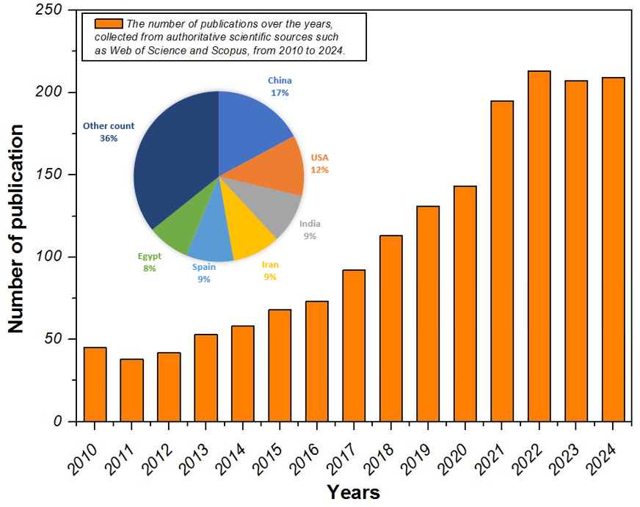
Fig. 1. The number of publications and the percentage of countries coresponding to these publication (2010-2024).

Spain (9%), Egypt (8%), Saudi Arabia (7%) and the U.K. (5%) are among the other notable contributors, indicating that there is growing interest in solar desalination research in these countries as well.
On the other hand, Germany (3.7%) and Italy (4%) both made significant contributions, albeit lesser ones.
These trends show that solar drying technologies are becoming increasingly popular across the world. Poor nations are particularly interested in solar desalination facilities since they are crucial for enhancing sustainability, energy efficiency, and food security.
A search of the Scopus database using the terms “Solar” and “Desalination” provides a comprehensive overview of the number of research papers published annually in various academic sources from 2010 to 2024.
Overall patterns: Over time, research on solar desalination has expanded quickly, with notable variations in publications from various sources.
Because it focuses on water-related research, the Desalination Journal dominates in some years and rises dramatically in 2018.
Growth in specialized publications: Since 2015, Applied Thermal Engineering and Renewable Energy has consistently published, suggesting that there is growing interest in integrating desalination with thermal engineering and renewable energy.
The interdisciplinary focus of the Energy Conversion and Management and Renewable and Sustainable Energy Reviews is seen in their consistent contributions.
Peaks and troughs: The number of desalination papers rose sharply in 2018 before declining. Journals like Applied Energy and Solar Energy started to produce more in recent years (2023–2024), probably due to advancements in technology and increased interest in renewable energy sources around the world.
Variations in other journals point to changes in emphasis or new directions in the study of solar desalination.

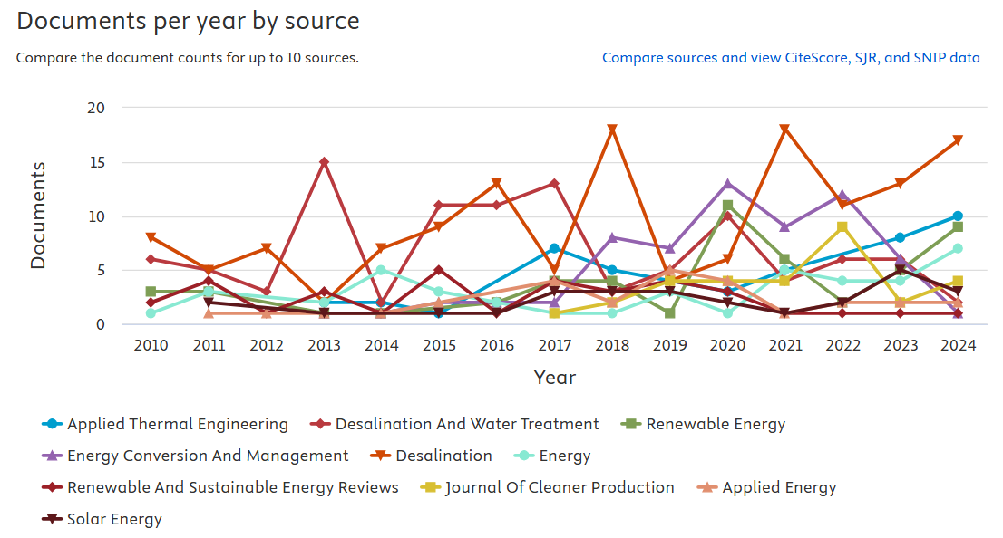
Fig. 2. Documents per year by source (2000-2024).

Recent years (2023–2024): Advances in solar thermal and photovoltaic technology for salt desalination are reflected in a substantial rise in publications in applied energy and solar energy.
Results: Contributions to solar desalination have been published in engineering, energy, and environmental publications, indicating a rising and dynamic interest in the process.
Rising water scarcity and the growth of renewable technology are two examples of global variables that may be reflected in the publishing peaks around 2018 and 2023–2024.
Journal information:
Applied Thermal Engineering: Shows steady growth, reflecting its role in research on desalination based on heat and power systems.
Desalination and Water Treatment: Experiences cyclical fluctuations but remains stable in publishing research on water-related topics.
Renewable Energy and Renewable and Sustainable Energy Reviews: Both journals show steady growth, reflecting the increasing focus on sustainable and renewable energy-based desalination.
Solar Energy: Publications in this journal show significant growth in recent years, especially in 2023 and 2024, reflecting the increasing use of solar-powered desalination solutions.
Energy Conversion and Management: Shows steady production with significant growth in publications after 2020, likely due to advances in hybrid systems.
Trends by year:
2018: The sharp increase in desalination highlights the major breakthroughs or events that catalysed this year’s research.
2023–2024: The increase in publications in Applied Energy, Solar Energy, and Renewable Energy highlights the growing importance of integrating solar energy into desalination.
Dominant journals:
Journals such as Desalination, Applied Energy, and Renewable Energy are leading the way, highlighting their focus on solar desalination technologies.
The rise in publications is indicative of solar desalination's increasing significance as a long-term remedy for the world's water shortage.
Multidisciplinary research in engineering, energy systems, and environmental sciences is highlighted by the journals' variety.
Innovative solar desalination methods are becoming more and more popular, as seen by the recent rise in solar energy and applied energy.
Directions for future research:
Advanced materials, energy efficiency enhancements, and hybrid solar desalination systems might all be investigated by researchers.
Future research seems to be headed in a favorable route by combining solar desalination with energy storage devices and intelligent control systems.
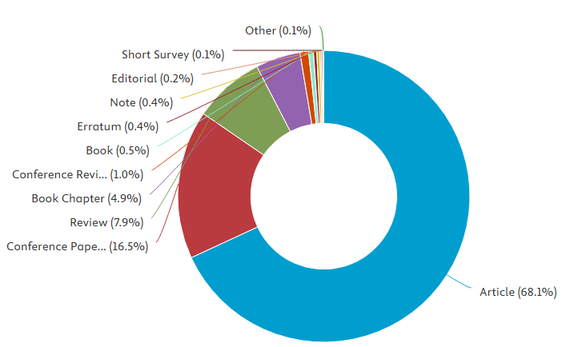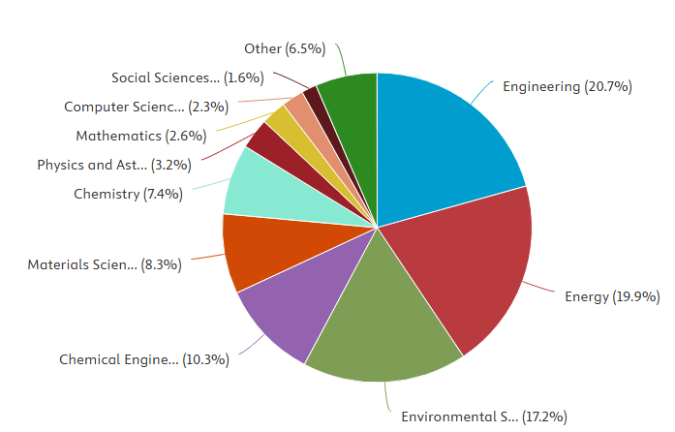

Fig. 3. Documents by type and subject area (2010-2024).

Two donut charts that group materials pertaining to solar desalination research by kind and topic area from 2010 to 2024 are shown in the figure.
Articles (68.1%): Peer-reviewed articles make up the bulk of the publications, demonstrating the high level of academic journal documentation of solar desalination research. This highlights the need of conducting thorough, high-caliber research.
Conference Papers: A sizable percentage of the publications are conference papers, emphasizing the function of conferences in debating innovations or sharing preliminary discoveries.
Reviews (7.9%): The existence of review papers indicates that there are continuous attempts to compile and examine the corpus of information already available on solar desalination systems.

Conclusion
The analysis of scientific publications related to solar desalination from 2010 to 2024 reveals several key trends and insights that underscore the significance of this field in addressing global water scarcity through sustainable solutions.

Publication Trends:
Research on solar desalination has shown a consistent upward trend, with significant growth in publications in recent years. Journals such as Desalination, Solar Energy, and Applied Energy are major contributors, reflecting the increasing focus on renewable energy-driven desalination systems.

Document Types:
The dominance of peer-reviewed articles (68.1%) and conference papers (16.5%) indicates a robust and dynamic research landscape. The presence of review articles (7.9%) highlights efforts to synthesize and analyze existing knowledge, while book chapters (4.9%) suggest its integration into broader discussions on renewable energy and water treatment.

Subject Areas:
Solar desalination research is inherently multidisciplinary, with engineering (20.7%), energy (19.9%), and environmental science (17.2%) forming the core. Contributions from chemical engineering (10.3%) and materials science (8.3%) reflect advancements in system design and materials. Chemistry, physics, and computational disciplines are also contributing to improving process efficiency and modeling capabilities.

Research Gaps and Opportunities:
While the field is maturing, opportunities exist for further exploration in underrepresented areas such as computer science (e.g., AI-driven optimization), mathematics (e.g., advanced modeling), and social sciences (e.g., policy and economic feasibility studies).
The increasing focus on integrating solar energy with hybrid systems, advanced materials, and sustainable designs presents exciting prospects for future innovations.

Implications for Sustainability:
The rising interest in solar desalination technologies reflects their critical role in providing sustainable water solutions for arid and water-stressed regions. The integration of renewable energy, coupled with advancements in materials and system design, underscores the potential of solar desalination to address global water and energy challenges.

Final Remarks
This comprehensive analysis highlights the dynamic growth and interdisciplinary nature of solar desalination research. By leveraging insights from existing studies, researchers and policymakers can identify critical knowledge gaps and foster innovations that contribute to a more sustainable and water-secure future. The continued collaboration across disciplines and integration of advanced technologies will be essential in driving this field forward.
Acknowledgments
The authors would like to thank the conference organizers.
References
- United Nations. Sustainable Development Goals: Clean Water and Sanitation. (2022).
- Iskandarov Z.S. The efficiency of solar drying plants with flow-type solar collectors (1999) Applied Solar Energy (English translation of Geliotekhnika), 35 (1), pp. 24-27.
- Iskandarov Z.S. Engineering calculation method of the energy-saving effect of spent drying agent partial regeneration in drying chambers (1997) Applied Solar Energy (English translation of Geliotekhnika), 33 (2), pp. 27-29.
- Iskandarov Z.S. Condition of efficiency of application of regenerative heat accumulators in solar-fuel dryers (2003) Geliotekhnika, (2), pp. 89-96.
- Iskandarov Z.S., Rakhmatov, O., Salomov M.N., Akhmedov Sh.K., Rashidov A.S. Double chamber solar and fuel drying unit for agricultural products (2011) Applied Solar Energy (English translation of Geliotekhnika), 47 (1), pp. 24-26. Doi.10.3103/S0003701X11010087.
- Akhatov J.S, Ahmadov K.S. Extraction of Hydrogen from Water Using CeO2 in a Solar Reactor Using a Concentrated Flux of Solar Radiation. Applied Solar Energy (English translation of Geliotekhnika), 2022, 58(6), pp. 889–894.
- Rakhimov N, Akhmadov Kh, Komilov A, Rashidov K, Aliyarova, L. Analysis of thermophysical parameters of solar water desalination plant with an external camera. E3S Web of Conferences, 2024, 498, 01012.
- Nazarova, N.M., Saidov, D.Sh., Karimov, M.K., ...Kurbanov, M.K., Feruzbek, M.K. Solar Dryer with Recovery Heat Exchanger: Production Test Proceedings of the 2023 IEEE 16th International Scientific and Technical Conference Actual Problems of Electronic Instrument Engineering, APEIE 2023, 2023, страницы 1660–1664.
- Boltaev S.A, Akhmadov K.S, Gapparov U.R, Kurbanov, M.K, Saidov, D.S. Thermotechnical and Adsorption Characteristics of the SrCl2 Adsorbent for Ammonia Vapors in Solar Absorption Cycles. Applied Solar Energy (English translation of Geliotekhnika), 2022, 58(1), pp. 116–120.
- J.S. Akhatov, Kh.S. Akhmadov, N.I. Juraboyev, Thermal performance enhancement in the receiver part of solar parabolic trough collectors, UNEC J. Eng. Appl. Sci. 3(2) (2023) 5-13 https://doi.org/10.61640/ujeas.2023.1201.
- Juraboev N.I., Akhmadov Kh. S., Kuchkarov A.A. A Comparative Study on Thermal Analysis of Latent Heat Energy Storage Systems Using Phase Change Materials. International Conference on Thermal Engineering, Volume 1, Issue 12024 15th International Conference on Thermal Engineering: Theory and Applications, ICTEA 2024 Tashkent 28 May 2024 through 1 June 2024, Code 314379. https://www.scopus.com/record/display.uri?eid=2-s2.0-85199170053&origin=resultslist.
- Juraboev, N., Akhmadov, K., 2024. Enhancing Thermal Performance of Solar Parabolic Through Collector by using Corrugated Absorber Tube. Presented at the ICTEA: International Conference on Thermal Engineering.Khushdil S. Akhmadov, Nodir I. Juraboev, Sanat A. Boltaev, Jasurjon S. Akhatov. CFD Analysis for Receiver Tube of Solar Parabolic Through Collector. (under review). https://10.21203/rs.3.rs-4617576/v1
- Akhmadov K.S., Boltaev S.A., Hojiev T.S., Hamraev J.H., Dustova S.H., Safarov T.T. Advancements in Solar Thermochemical Reactors: Integrating Experimental Validation and Modelling Techniques for Enhanced Performance and Scalability. Vol. 1 No. 1 (2024): ICTEA: International Conference on Thermal Engineering. https://journals.library.torontomu.ca/index.php/ictea/article/view/2295/1914.
- Hojiev T.S., Akhmadov Kh. S., Halimov A.S., Akhatov J.S. Advancements in Solar Thermochemical Reactors for Sustainable Hydrogen Production. International Conference on Thermal Engineering, Volume 1, Issue 12024 15th International Conference on Thermal Engineering: Theory and Applications, ICTEA 2024Tashkent28 May 2024through 1 June 2024Code 314379. https://www.scopus.com/record/display.uri?eid=2-s2.085199177910&origin=resultslist.
- Kalogirou, S. A. Solar Energy Engineering: Processes and Systems. Academic Press, 2014.
- Ghaffour, N., et al. "Solar desalination for future sustainable water solutions." Renewable and Sustainable Energy Reviews, 2019.
- Elimelech, M., and Phillip, W. A. "The future of seawater desalination: Energy, technology, and the environment." Science, 2011.
- Shahzad, M. W., et al. "An innovative design of solar desalination for efficient freshwater production." Desalination, 2020.
- Abdullahi, Y. A., et al. "Emerging trends in solar desalination technologies." Renewable Energy, 2022.
- Patel, K., et al. "Advancements in solar thermal materials for desalination." Materials Today, 2021.
- Kalidindi, S. R., and Basu, S. "Bibliometric analysis of solar desalination research." Journal of Cleaner Production, 2018.
- Scopus database, Accessed 2023.
- Web of Science database, Accessed 2023.

