O‘zbekiston Respublikasi
Oliy ta’lim, fan va innovatsiyalar vazirligi
Buxoro davlat universiteti

Vaxidova Fotima Saidovna

“Gapirish va tinglab tushunish ko’nikmalari” fanidan 2-bosqich (kechki) bakalavr talabalari uchun tayyorlangan

LISTENING AND SPEAKING SKILLS

O‘QUV QO‘LLANMA

UO’K
A 45
KBK
F.S.Vaxidova
“Gapirish va tinglab tushunish ko’nikmalari” fanidan 2-bosqich talabalari uchun tayyorlangan “Listening and Speaking Skills ” nomli o’quv qo’llanma [Matn] Buxoro: “” nashriyoti, 2025. -156 b.

Ushbu o‘quv qo‘llanma Oliy o‘quv yurtlarining 60230100 – Filologiya va tilarni o’qitish (ingliz tili) ta’lim yo’nalishi talabalari uchun mo’ljallangan. Mazkur qo'llanma gapirish va tinglab tushunish ko’nikmalarini kommunikativ metod asosida o'rgatuvchi va mustahkamlovchi mashqlarga tayanadi. O'quv qo'llanmadan joy olgan mashqlar talabalarning dunyoqarashini oshiradi. Mazkur o’quv qo’llanma mavzuga doir matnlar, gapirish va tinglab tushunish ko’nikmalarini rivojlantirishga bag’ishlangan turli-tuman mashqlar, testlar bilan boyitilgan. Shuningdek, muallif o’quv qo’llanmani tuzishda chet el adabiyotlaridan unumli foydalangan. Manba va o’quv materiallar talabalarning yoshi, til darajasi, qiziqishlari inobatga olib yaratilgan.

MAS’UL MUHARRIR: Z.I.Rasulov – Buxoro davlat
universiteti Ingliz tilshunosligi
kafedrasi mudiri, f.f.d.(DSc),
professor

TAQRIZCHILAR: M.U.Saidova – Buxoro davlat
universiteti Ingliz tilshunosligi
kafedrasi f.f.f.d.(PhD), dotsent G.H.Hamdamova – Buxoro
davlat Pedagogika instituti
Ingliz tili va adabiyot kafedrasi
dotsenti, f.f.f.d.(PhD)

O‘quv qo‘llanma, O’zbekiston Respublikasi Oliy ta’lim, fan va innovatsiyalar vazirligi Buxoro davlat universitetining 2025-yil dagi -sonli buyrug’iga asosan nashr etishga ruxsat berilgan. Ro’yxatga olish raqami №

ISBN

Contents:

 | Theme1 Who Are You? Let’s Talk! | 6
 | Theme 2 About Youth | 10
 | Theme 3 Education | 15
 | Theme 4 How Does Health Shape our Lives? | 20
 | Theme 5 Change and Consequences | 26
 | Theme 6 The concept of family in different cultures | 37
 | Theme 7 Relaxation and well-being | 42
 | Theme 8 How technology has changed language use | 48
 | Theme 9 Change and consequences: Challenge and  Implications | 54
 | Theme 10 City and Country: Urbanization | 60
 | Theme 11 Recalling the Past | 67
 | Theme 12 Work | 73
 | Theme 13 Life experiences | 80
 | Theme 14 Extreme news | 85
 | Theme 15 Volunteering | 91
 | Glossary | 96

Mundarija:

 | 1-mavzu Siz Kimsiz? Keling suhbatlashamiz | 6
 | 2-mavzu Yoshlik haqida | 10
 | 3-mavzu Ta’lim | 15
 | 4-mavzu Sog’liq hayotimizni qanday shakllantiradi? | 20
 | 5-mavzu O’zgarish va oqibatlar | 26
 | 6-mavzu Turli xil madaniyatlarda oila tushunchasi | 37
 | 7-mavzu Dam olish va farovonlik | 42
 | 8-mavzu Texnologiyalarning tilga ta’siri | 48
 | 9-mavzu O’zgarish va oqibatlar: Qiyinchiliklar va ularning natijalari | 54
 | 10-mavzu: Shahar va qishloq: Urbanizatsiya | 60
 | 11-mavzu: O‘tmishni eslash | 67
 | 12-mavzu: Ish | 73
 | 13-mavzu: Hayotiy tajribalar | 80
 | 14-mavzu: Ekstremal yangiliklar | 85
 | 15-mavzu: Ko‘ngillilik | 91
 | Lug‘at | 96

Содержание:

1 | Тема 1: Кто ты? Давай поговорим! | 6
2 | Тема 2: О молодежи | 10
3 | Тема 3: Образование | 15
4 | Тема 4: Как здоровье формирует нашу жизнь? | 20
5 | Тема 5: Изменения и последствия | 26
6 | Тема 6: Понятие семьи в разных культурах | 37
7 | Тема 7: Отдых и благополучие | 42
8 | Тема 8: Как технологии изменили использование языка | 48
9 | Тема 9: Изменения и последствия: вызовы и значение | 54
10 | Тема 10: Город и деревня: урбанизация | 60
11 | Тема 11: Воспоминания о прошлом | 67
12 | Тема 12: Работа | 73
13 | Тема 13: Жизненный опыт | 80
14 | Тема 14: Экстремальные новости | 85
15 | Тема 15: Волонтёрство | 91
16 | Глоссарий | 96

Introduction

Dear Reader,
Welcome to this Listening and Speaking book, designed to enhance your communication skills in a variety of real-life contexts. Whether you are learning English for academic purposes, professional development, or personal growth, this book offers you valuable tools to develop both your listening comprehension and speaking abilities.
Listening and speaking are interconnected skills, and mastering them together can significantly improve your confidence and fluency. We believe that practice is key to success. Therefore, each section provides opportunities for you to listen actively, reflect on what you hear, and speak with clarity and purpose. Whether you're preparing for an exam, a job interview, or simply aiming to communicate better in your day-to-day life, this book is designed to support you every step of the way.Let’s embark on this exciting journey to becoming a more confident and skilled listener and speaker.

Author

Theme 1. Who Are You? Let’s talk!

A. Predict
Look at the picture and discuss in pairs:
"How would you describe yourself in three words?"
"What personality traits do you admire in others?"
B. Share information
Work in pairs and ask questions about personality.
 | Questions | Answers
1 | How would your friends describe you in three words?
2 | What qualities do you look for in a good friend?
3 | Do you think people can change their personality over time?
4 | Which personality trait do you think is the most important for success?

C. Vocabulary
Match the words with its definitons.
1.Someone who is kind and easy to talk to.
2.A person who puts a lot of effort into their work or studies.
3.Feeling sure about your own abilities or decisions.
4.Nervous or uncomfortable with meeting and talking to people.
5. Someone who likes to give and share with others.
6.Showing good manners and respect to others.
7. A person who enjoys talking a lot.
8.Someone who always tells the truth and does not cheat.
9.A person who has many new and original ideas.
10.Someone who does not often joke and takes things importantly.
Serious
Friendly
Creative
Honest
Hardworking
Confident
Talkative
Shy
Polite
Generous
D. Role-Play Activity
Student A: Pretend to be a famous person (e.g., an athlete, artist, or historical figure).
Student B: Ask at least 5 questions to learn about their appearance, personality, and achievements.
Switch roles and repeat.
Share one interesting thing you learned from your partner’s description or role-play.
Listening.

Pre-listening activity
Questions 1-4
Write ONE WORD ONLY for each answer.
The 'weak-tie' theory: how friends-of-friends influence us
In 1973, Mark Granovetter claimed that the influence of 'weak-ties' can affect the
behavior of populations in the fields of information science, politics and
1 ………………… Although friends-of-friends may be unlike us, they have similar
enough 2 ………………… to have a beneficial effect on our lives. An example of this
influence is when we hear about 3 ………………………. because information about
them is provided by weak-ties. Since Granovetter proposed his theory, other studies
have shown that weak-tie networks also benefit our 4 ……………….….
While-listening activity
Questions 5 and 6
Choose TWO letters, A-E.
Which does the speaker believe are TWO real benefits of online social networking?
A. people can gain higher self-esteem
B. people can access useful medical information
C. people can form relationships more quickly
D. people can improve academic performance
E. people can be reliably informed about current affairs
Questions 7 and 8
Choose TWO letters, A-E.
Which TWO problems related to online social networking will increase, according
to the speaker?
A criminal activity
B poorer grades at school
C a decline in physical fitness
D less work done by employees
E loss of career prospects
Questions 9 and 10
Choose TWO letters, A-E.
Which TWO claims are made by Robin Dunbar about social networking sites?
A They are not helpful for developing certain social skills.
B They cannot fully reveal a person's real character.
C They are not a good starting point for building new relationships.
D They do not encourage people to widen their social circle.
E They will not retain their popularity with the young generation

Post-listening activity.
a) Relisten characters and people mentioned in the listening task and vote on which character you would like to meet, work or be friend with.
b) Listen and choose answer to the questions
11. PS Camping has been organising holidays for
A 15 years.
B 20 years.
C 25 years.
12. The company has most camping sites in
A France.
B Italy.
C Switzerland.
13. Which organised activity can children do every day of the week?
A football
B drama
C model making
14. Some areas of the sites have a ‘no noise’ rule after
A 9.30 p.m.
B 10.00 p.m.
C 10.30 p.m.
15. The holiday insurance that is offered by PS Camping
A can be charged on an annual basis.
B is included in the price of the holiday.
C must be taken out at the time of booking.
16. Customers who recommend PS Camping to friends will receive
A a free gift.
B an upgrade to a luxury tent.
C a discount

Listening Tip
Focus on keywords in the question and options.
Before the audio starts, carefully read the question and underline or mentally note key words, such as dates, names, places, or specific details. This will help you stay focused on relevant parts of the audio. Often, distractors (incorrect options) are mentioned but subtly contradicted later in the recording, so listen for clarification or emphasis.

Theme 2 About Youth

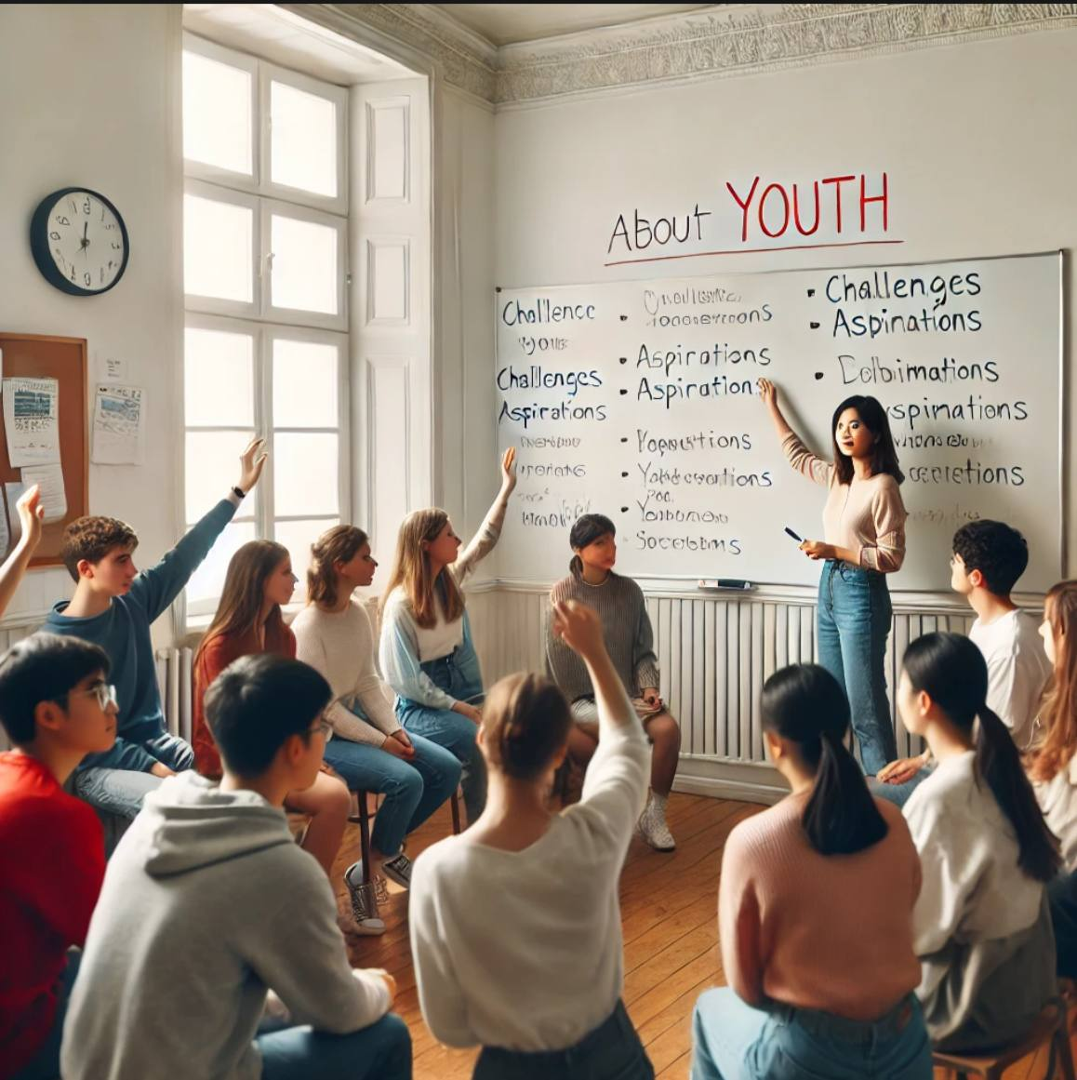
A.Predict
What are the biggest challenges young people face in our country?
How can youth make a positive impact on society?
What role should older generations play in supporting young people?
B. Share information
Make a debate as youth activists and community leaders about creating opportunities for young people.
Your roles:
Youth activists: advocate for more opportunities and independence.
Community leaders: emphasize the importance of tradition and guidance.
Students prepare arguments in pairs and present them.
C. Vocabulary
Fill in the blanks with the appropriate words from the word bank. Then, discuss your answers with a partner.
Many young people today look to their_for inspiration and guidance.
In today's world, ______ plays a huge role in shaping youth opinions and behaviors.
A major ______ that teenagers face is the constant pressure to fit in with their friends.
This new fashion ______ has become extremely popular among teenagers worldwide.
Growing up, I always had big ______, like becoming a doctor and helping others.
The younger ______ is often characterized by rapid changes in technology and culture.
Youth should learn to balance their personal goals with their ______ as a member of the family or society.
One of the biggest ______ young people face is balancing school, hobbies, and social life.

Ambition
Generation
Trend
Peer pressure
Independence
Social media
Responsibility
Aspirations
Challenge
Role models
Questions for discussions
What kind of role models do you think are most important for young people today? How do you think social media impacts youth in both positive and negative ways? What is the biggest challenge you think young people face today?
Listening 
Pre-listening. Listen carefully and discuss the meanings of the words in pairs. "identity," "peer pressure," "social media," "activism," and "self-expression."
While-listening
a) Complete the notes below.
Write NO MORE THAN TWO WORDS AND/OR A NUMBER for each answer.
Hilary Lodge Retirement Home
Example
The name of the manager is Cathy
Activities program involving volunteers
Monday evenings: computer training
• Training needed in how to produce 1 ………………
Tuesday afternoons: singing
• The home has a 2 ……………… and someone to play it
Thursday mornings: growing 3 ………………..
• The home doesn’t have many 4 ……………… for gardening
Once a month: meeting for volunteers and staff
Interview
• Go in on 5 ……………….., any time
• Interview with assistant called 6 ……………..
• Address of home: 73 7 ………………. Road
'Open house' days
• Agreed to help on 8 ………………..
• Will show visitors where to 9 …………………..
• Possibility of talking to a 10 ……………. reporter

b) Listen carefully and match the answers.
What is currently the main area of work of each of the following people?
Choose FIVE answers from the box and write the correct letter, A-H, next to questions 1-5.
Area of work
A advertising
B animal care
C building
D educational links
E engine maintenance
F food and drink
G sales
H staffing
People
1. Simon (the speaker) ……
2. Liz ……………………
3. Sarah ………………….
4. Duncan ………………
5. Judith
Post-listening activity.
Questions 1-6
Choose the correct letter, A, B or C.
1 Dave Hedley says that the computer system has
A too many users.
B never worked well.
C become outdated.
2 The main problem with the computer system is that it
A is too slow.
B stops working.
C displays incorrect data.
3 Timetabling has become an issue because
A there is not enough time for anyone to do it.
B the system does not handle course options.
C the courses are constantly changing.
4 To solve the timetabling issues, Randhir suggests that
A students should create their own timetables.
B Dave should have someone to assist him.
C the number of courses should be reduced.
5 Randhir says that a new system may
A need to be trialled.
B still have problems.
C be more economical.
6 Improving the existing system will take
A a few weeks.
B four or five months.
C nine months.


Theme 3. Education


A. Predict
Look at the picture of a classroom or a group of students. Discuss in pairs:
"How would you describe your experience in school in three words?"
"What qualities do you admire in a good teacher or classmate?"

B. Share Information
Work in pairs and ask questions about education and learning experiences.
Questions
Answers
1. What was your favorite subject in school and why?

2. Who was your most memorable teacher, and what made them special?

3. What skills do you think are most important for success in education?

4. Do you believe learning styles (like visual or auditory) affect success?

C. Vocabulary
Match the words with their definitions.
1. A person who is eager and determined to achieve something.  2. Someone who is eager to learn and ask questions.  3. Willing to work with others in a helpful way.  4. Having the ability to control yourself and work hard.  5. Having a lot of information and understanding about a subject.  6. Being able to adjust to new situations easily.  7. Asking many questions and showing interest in learning.  8. Staying calm and understanding while teaching or learning.  9. Able to think of new and original ideas.  10.Paying attention and concentrating on tasks. | Curious  Motivated  Disciplined  Cooperative  Knowledgeable  Inquisitive  Adaptable  Patient  Creative  Focused

D. Role-Play Activity
Student A: Pretend to be a famous educator (e.g., Maria Montessori, Albert Einstein, or Malala Yousafzai).
Student B: Ask at least 5 questions about their teaching philosophy, achievements, and educational background.
Switch roles and repeat.
Share one interesting thing you learned from your partner's role-play.

E. Fill in the blanks
Carefully read the passage about education in Uzbekistan.
Use the provided word bank to complete the missing information in the text. Choose the most appropriate word for each blank based on the context.
Education in Uzbekistan plays a crucial role in the country's development. The education system consists of three main levels: primary, secondary, and (1). Children typically begin school at the age of (2), and basic education lasts for nine years. After completing secondary education, students can choose to continue their studies in (3) institutions, such as colleges or lyceums.
Higher education is offered at universities and (4) institutions. The government has introduced reforms to improve the quality of education and promote (5) learning. Additionally, more emphasis is being placed on learning foreign (6), especially English, to meet global demands.
Teachers play a vital role in shaping students' futures, and there are ongoing efforts to provide better (7) for educators. As Uzbekistan continues to modernize its education system, the focus remains on fostering creativity, critical thinking, and practical skills for a (8) future.

seven
higher
educational
vocational
languages
lifelong
prosperous
training

Structure your points using "PAST and PRESENT" Past: Start by briefly discussing how education was different in the past .Example: "In the past, education heavily relied on traditional methods like lectures and textbooks. "Present: Transition to how education functions today. Example: "Nowadays, technology plays a major role in education, with online learning becoming common."

Listening
Pre-listening activity
Listen carefully the speech about “The Future of Education” and predict:
What will the speaker say about education trends?
Will the speaker discuss technology in education?
How do you think education will change in the next 10 years?
While-listening
a) Choose the correct letter, A, B or C.
1.One reason why Spiros felt happy about his marketing presentation was that
A he was not nervous.
B his style was good.
C the presentation was the best in his group.
2. What surprised Hiroko about the other students' presentations?
A Their presentations were not interesting.
B They found their presentations stressful.
C They didn’t look at the audience enough.
3. A delighted.
B dissatisfied.
After she gave her presentation, Hiroko felt
C embarrassed.
4. How does Spiros feel about his performance in tutorials?
A not very happy
B really pleased
C fairly confident
5.Why can the other students participate so easily in discussions?
A They are polite to each other.
B They agree to take turns in speaking.
C They know each other well.
b) Complete the questions below.
Write NO MORE THAN THREE WORDS for each answer.
Sea Life Centre – information
1. What was the Sea Life Centre previously called? ……………………
2.What is the newest attraction called? ……………………………
3. When is the main feeding time? …………………………………….
4. What can you do with a VIP ticket? ………………………………..
5.What special event will the Sea Life Centre arrange for you? ……………………
6. Where will the petition for animal conservation be sent to?
7. What can you use to test what you have learnt? …



Post-listening activity

Complete the notes below.
Write ONE WORD ONLY for each answer.
New Caledonian crows and the use of tools
Examples of animals using tools
• some chimpanzees use stones to break nuts
• Betty (New Caledonian crow) made a 1 ………….. out of wire to move a bucket of
food
New Zealand and Oxford experiment
• Three stages: crows needed to move a 2………………….. in order to reach a short
stick; then use the short stick to reach a long stick; then use the long stick to reach
food
Oxford research
• crows used sticks to investigate whether there was any 3 …………….. from an
object
• research was inspired by seeing crows using tools on a piece of cloth to investigate
a spider design
• Barney used a stick to investigate a snake made of 4 ………………….
• Pierre used a stick to investigate a 5 ………………
• Corbeau used a stick to investigate a metal toad
• the crows only used sticks for the first contact



Theme 4. "How Does Health Shape Our Lives?"



A. Predict
Look at the picture of a healthy family or a group of people exercising together. Discuss in pairs:
"How would you describe a healthy lifestyle in three words?"
"What habits do you think contribute to good health?"

B. Share Information
Work in pairs and ask questions about health and wellness experiences.
Questions
1. What is your favorite way to stay healthy? Why?
2. Who inspires you to live a healthier lifestyle?
3. What do you think is more important: exercise or a healthy diet?
4. How do you manage stress and maintain mental health?

C. Vocabulary
Match the words with their definitions:
- Having a healthy combination of nutrients in the diet.
- Frequently moving and engaging in physical activities.
- A substance in food that helps the body grow and stay healthy.
- Having enough water in your body.
- Being able to recover quickly from stress or illness.
- Being aware of your thoughts, feelings, and actions.
- The ability to sustain physical activity for a long period.
- Taking steps to avoid disease or health problems.
- The ability to keep going despite fatigue.
- The state of being in good physical and mental health.

- Wellness
- Endurance
- Stamina
- Preventive
- Mindful
- Resilient
- Nutrient
- Hydrated
- Active
- Balanced

D. Role-Play Activity
Student A: Pretend to be a health expert (e.g., a nutritionist, a fitness trainer, or a mental health counselor). Student B: Ask at least 5 questions about their advice on staying healthy, diet recommendations, and exercise tips. Switch roles and repeat.Share one interesting health tip you learned from your partner’s role-play.

E.Gap-Filling Exercise: Health and Well-being
Complete the sentences by filling in the gaps with appropriate words:
Eating a ______ diet provides the body with essential nutrients.
Regular ______ helps to maintain a healthy weight and improve mental well-being.
Drinking enough ______ is essential to keep the body hydrated.
A lack of ______ can lead to stress, fatigue, and poor concentration.
Smoking is one of the leading causes of ______ diseases.
To strengthen your immune system, it is important to eat ______ rich in vitamins and minerals.
Practicing good ______ hygiene helps to prevent the spread of germs.
Too much ______ in your diet can increase the risk of diabetes and obesity.
Regular medical ______ can help detect health problems early.
Mental health is just as important as ______ health for overall well-being.
Exercise,balanced
Sleep, water
Foods,respiratory
Sugar, hand
Physical,check-ups
Speaking tips:
Use Clear and Simple Language. Avoid complicated medical terms unless necessary. Explain concepts in simple words that everyone can understand. Example: Instead of "hypertension," say "high blood pressure."

Listening. Pre-listening activity
Listen to the audio. Choose the correct letter, A, B or C.
1. A champion athlete will be in the shop
A on Saturday morning only.
B all day Saturday.
C for the whole weekend.
2. The first person to answer 20 quiz questions correctly will win
A gym membership.
B a video.
C a calendar.
Questions 3 and 4Choose TWO letters A-E
Which TWO pieces of information does the speaker give about the fitness test?
A You need to reserve a place.
B It is free to account holders.
C You get advice on how to improve your health.
D It takes place in a special clinic.
E It is cheaper this month.



While-listening activity
Questions 1-4
Complete the notes below.
Write ONE WORD ONLY for each answer.

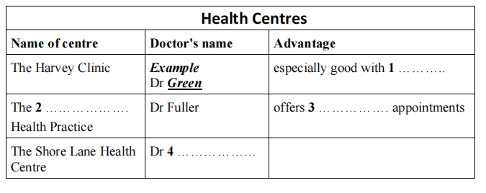

Questions 5-6
Choose TWO letters, A-E.
Which TWO of the following are offered free of change at Shore Lane Health Centre?
A acupuncture
B employment medicals
C sports injury therapy
D travel advice
E vaccinations
Questions 7-10
Complete the table below.
Write NO MORE THAN TWO WORDS AND/OR A NUMBER for each answer.


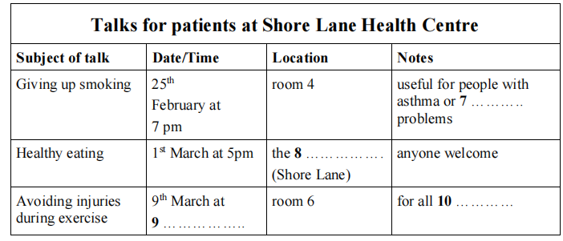

Post-listening activity. Label the diagram below.
Choose THREE answers from the box and write the correct letter, A-E, next to questions 11-13.
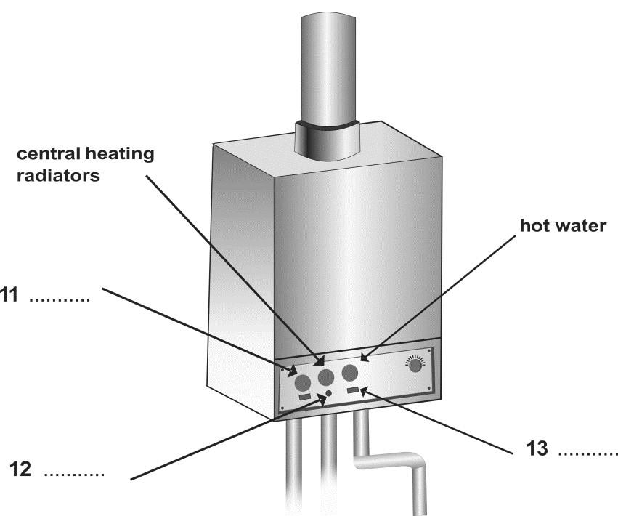

A electricity indicator
B on/off switch
C reset button
D time control
E warning indicator

Useful health-related words and their definitions:
Hypertension: A condition characterized by high blood pressure, increasing the risk of heart disease and stroke.
Nutrition: The process of consuming and utilizing food and nutrients for growth, energy, and health maintenance.
Immunity: The body’s defense system against harmful pathogens, such as bacteria and viruses.
Cholesterol: A waxy substance found in the blood; necessary for cell functions but harmful at high levels.
Metabolism: The set of chemical processes in the body that convert food into energy.
Cardiovascular Health: The condition of the heart and blood vessels, crucial for overall health.
Inflammation: The body's response to injury or infection, often causing redness and swelling.
Mental Health: A person’s emotional, psychological, and social well-being.
Dehydration: A condition caused by excessive loss of body fluids.
Wellness: The active pursuit of health, happiness, and well-being.

Theme 5. Change and consequences

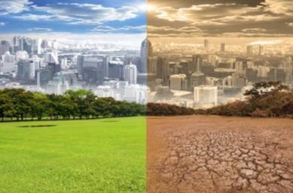

A. Predict
Look at a picture showing a city before and after development or a community affected by environmental changes. Discuss in pairs:
"How would you describe change in three words?"
"What positive or negative consequences might change bring to a community?"
B. Share Information
Work in pairs and ask questions about life changes and their consequences.
1. What is the most significant change you have experienced? Why?
2. Who has helped you navigate a challenging change in your life?
3. What do you think is more important when facing change: preparation or adaptability? Why?
4. How do you stay positive when faced with unexpected changes?
C. Vocabulary
Match the words with their definitions:
- Evolution
- Stability
- Consequence
- Transition
- Innovation
- Impact
- Progress
- Resilience
- Transformation
- Adaptability
a) The ability to adjust to new conditions.
b) A significant change in form or nature.
c) The ability to recover quickly from difficulties.
d) Forward movement toward improvement or a goal.
e) The effect or influence of one thing on another.
f) The introduction of new ideas, methods, or devices.
g) The process of changing from one state or condition to another.
h) The result or effect of an action or decision.
i) A state of being steady and unchanging.
j) A gradual process of change and development over time.
D. Fill in the blanks.
Complete the sentences below with appropriate cause-and-effect connectors (due to, because of, as a result, therefore).
People are working remotely nowadays ______ technological advancements.
The government introduced new environmental policies; ______, pollution levels have decreased.
The project was delayed ______ unexpected budget cuts.
He didn’t prepare well for the interview; ______, he didn’t get the job.
______ the rise in fuel prices, many people are opting for public transportation.
To discuss change and consequences in writing or speaking, use conjunctions effectively:
For change: use however, on the other hand, although, and whereas.
For consequences: use therefore, thus.

E. Complete the sentences by adding appropriate effects for each use.
Due to advancements in technology, __________________.
Because of the pandemic, __________________.
As a result of climate change, __________________.
For example:
Due to advancements in technology, remote work has become more common.
Because of the pandemic, many businesses shifted their operations online.
As a result of climate change, we are witnessing more extreme weather events.

F. Role-Play Activity
Student A: Pretend to be a change management consultant (e.g., a life coach, environmental planner, or business strategist).
Student B: Ask at least 5 questions about how to manage change, prepare for consequences, and adapt successfully.
Switch roles and repeat.
Share one insightful tip you learned from your partner's role-play.
Discussion Questions
Answer the following questions in 2-3 sentences.
Describe a personal experience where a change led to positive consequences.
How can unexpected changes help people grow?
What are some strategies for dealing with the consequences of change?

Listening
Pre-listening activity
Complete the notes below.
Write ONE WORD ONLY for each answer.
DIFFERENCES BETWEEN INDIVIDUALS
IN THE WORKPLACE
Individuals bring different:
• ideas
• 1………………….
• learning experiences
Work behaviour differences are due to:
• personality
• 2 …………………
Effects of diversity on companies:
Advantage: diversity develops 3 ………
Disadvantage: diversity can cause conflict



While-listening activity

Choose the correct letter, A, B or C.
4. Janice thinks that employers should encourage workers who are
A potential leaders.
B open to new ideas.
C good at teamwork.
5. Janice suggests that managers may find it difficult to
A form successful groups.
B balance conflicting needs.
C deal with uncooperative workers.
6. Janice believes employers should look for job applicants who
A can think independently.
B will obey the system.
C can solve problems.
7. Janice believes managers should
A demonstrate good behaviour.
B encourage co-operation early on.
C increase financial incentives.



Questions 28-30
Complete the sentences below.
Write ONE WORD ONLY for each answer.
8. All managers need to understand their employees and recognise their company's …..
9. When managing change, increasing the company's ………………………. may be more important than employee satisfaction.
10.During periods of change, managers may have to cope with increased amounts of …..

Post-listening activity
Questions 1-6
Complete the table below.
Write NO MORE THAN ONE WORD AND/OR A NUMBER for each answer.

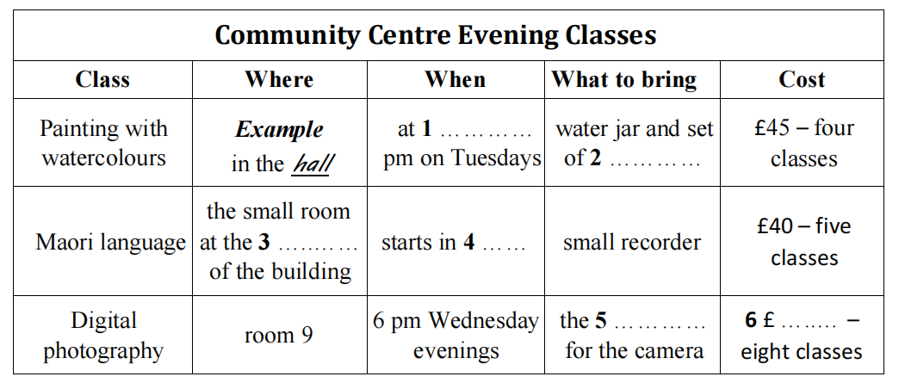

Questions 7-11
Label the map below.
Write the correct letter, A-H, next to Questions 7-11

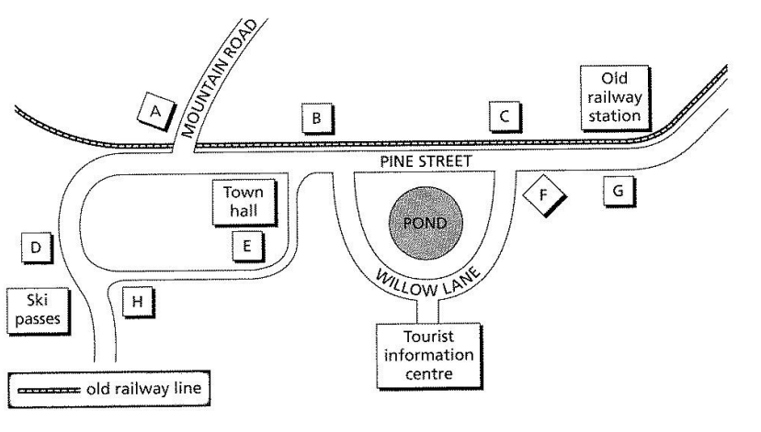
7. supermarket …………
8. climbing supplies store …………
9. museum …………
10. bike hire……….
11. café……….



The people in the picture look …
- Write your own advertisement (15-20 words). This can be based on your own accommodation.
- Complete sentences a—g with the words in the list
Example
Here in Australia, I live in a large frit in a twenty-storey tower block.

- I’d love to live in a ___________ on the top floor of a tower block.
- In my home country, I live in the capital in a spacious detached ___________
- I can’t afford to live in a large flat so I am renting a small ___________
- My parents live in a remote two-storey ___________ on a mountainside.
- As my grandmother can’t climb stairs and hates lifts, she lives in a ___________ in the suburbs.
- My host family live in a red-brick ___________ right in the middle of a long row.
- There are six of us living together in a ___________ in a student area of town.
- Add extra information to four of the sentences in exercise 4 using phrases 1-4 below.
1) with spectacular views of the city, especially at night.
2) with lots of open fields around them and plenty of fresh air.
3) which has a kitchen, bedroom and living room all in one. It suits me fine.
4) which can get a bit noisy if all our friends are around.
6. Decide which adjective in a-g below is the opposite of the other two.
a) boring dull fascinating
b) cramped spacious sizeable
c) traditional modern old-fashioned
d) bustling quiet peaceful
e) cosy uncomfortable inviting
f) smart elegant shabby
g) vibrant boring lively
7. Which type of accommodation do you live in? Make a list of adjectives to describe where you live.
8. Match the questions with the answers.
1 Where do your host family live?
2 How close to the city is it?
3 Is your accommodation modern or old-fashioned?
4 Can you tell me what the area you live in is like?
5 What is your family home like?
A The neighbourhood where I live is very peaceful.
B My parents’ apartment is in a very dynamic part of the city,
c The family I’m staying with live in a very chic part of town.
The house is very high tech,
It is in a very good location,
9 Develop the sentences a-e in exercise 8 by adding one of the following sentences.
1 because it is well connected to the city centre by train and bus.
2 so it is always noisy and full of people.
3 with plasma screens, remote controls for the lighting and wireless computers.
4 The area is residential with tree-lined streets, no shops and not many cars.
5 At all times of the day it is really tranquil. I have to say I love it there.
10 Which items in exercise 9 give these extra types of information?
Reason __________________________________________________
Consequence ______________________________________________
11 Ask and answer the questions in exercise 8.

Listening skills Predicting in tables
- Choose the best title a-c for each table 1-3.
- Climate change over 50 years
- Transport use by type
- Comparison of housing by area
- Complete each table with the information below.
1
District | Typical style | Average price | Transport
Aberton | bungalows | £180,000 | 1 ____________
Hunborough | 2 ____________ | £225,000 | Poor
Millview | flats | 3 ____________ | excellent

2
 | 1955 | 2013
Average temperature | 17.4º C | 4 ____________
Annual rainfall | 5 ____________ | 652 mm

3
 | Bus | Train | Bicycle
Price of fare | £1.50 | 7 ____________ | N/A
Total journeys | 6 ____________ | 2504 | 962
Male passengers | 34% | 62% | 8 ____________
Female passengers | 66% | 38% | 9 ____________

*£125,000 * £4.50 *18.2ºC *25% *3567 * 612 mm *75%
* good * terraced houses

- The table below is taken from a table completion task. Read the table contents and answer questions a—d. Then predict the answers.
 | Price now | Main advantage | Second advantage | Length of guarantee | Main disadvantage
Analogue radio | Example: £29.99 | Cheap | Excellent 3 _______ with expensive systems | 4 _______ | Service will finish soon
Digital radio | 1 £_______ | 2 Lots of _______ | Little or no interference | 2 years | 5 ________ is short

- What is the topic of the table?
- How many products are discussed?
- How many aspects of each product are considered?
- Which answers may be numbers?

TECHNIQUE
Pay special attention to the rubric, the headings and the numbering in table completion tasks. Use this information to predict the type of information which is missing.

- Listen to the recording, follow the instructions below and complete the gaps in the table in exercise 3.
“Write NO MORE THAN TWO WORDS AND / OR A NUMBER for each answer”
- The table below is also taken from a table completion task. Read through the table carefully and answer the questions.
- In which order will you hear the information?
- Which answers can you predict?
Then listen to the recording and complete the gaps in the table. Write NO MORE THAN ONE WORD AND / OR A NUMBER for each answer.

 | Old Value Card | New Super Value Card
Points | Standard number | Double points
Free credit period | One month | 6 ___________ months
Interest rate | 18.5% | 7 __________ %
Cardholder shopping evenings | 8 __________ per month | Two per month
Benefits | Free delivery within 9 ______________ miles | Free delivery within 50 miles
Fee | Nil | 10 £___________

Speaking
- Answer these questions
- Has your attitude to your free time changes since you were a child? (In what way?)
- What value is there in teaching history to children?
- What is the best way to learn about history?
- Do you think older people are more interested in the past than children are? (Why? Why not?)
- What influence do you think the past has over the present?
- Do the words in the box refer to the past or the present? Complete the sentences with the words in the box. Check collocations with the words in bold. There may be more than one possible answer.
retrospect contemporary bygone immediate preceding current topical status quo

- The exhibition contains faded photographs reminding us of a ____________ era.
- He mixes ____________ ideas which those of years gone by.
- There will always be people who resist change and want to maintain the ____________.
- The ____________ effect of the war was a breakdown in law and order on the streets.
- In ____________, and with the benefit of hindsight, it is clear that this was a bad decision.
- I prefer this newspaper because it covers the most ____________ news stories
- On New Year’s Day, people often stop and reflect on all that happened in the ____________ year.
- In previous years, the library was always very busy, but our ____________ students seem to prefer to study in the privacy of their own room.
- The adjectives in the box can describe the nature or speed of change. Highlight or underline the synonyms of change in the sentences below. Then complete the sentences with adjectives from the box.

Change is often used in the active form when it has a passive sense, e.g. My home town has changed recently.
Try to use a wide range of adjectives and adverbs to intensify or weaken the word change, e.g. There was a profound change in the attitude. Or Attitudes changed completely.

Smooth gradual turbulent abrupt sudden rapid temporary

- Everyone was grateful that there had been a very _______________ transition between governments.
- The stock market crash led to a very ____________________ reversal in fortunes for many people.
- The government is hoping that this is only a __________________ shift in
- public opinion.
- There was a _____________________ improvement in our sales figures from 1990 to 2010, and this helped bring about our transformation from a small local company to a global leader.
- This has been a ______________ period involving a great deal of struggle and hardship. But it has a necessary part of our evolution.
- We are slowly witnessing a ___________________ movement in favour of surveillance.

PRACTISE TEST
Section 2
Questions 11-15
Write NO MORE THAN THREE WORDS for each answer
What three kinds of people are listening to the talk?
- ………………………………………….
- ………………………………………….
- …………………………………………
- What will you need to do to visit the Fieldhouse Library?
………………………………………….
- What is necessary for gaining access to the library?
…………………………………………
Questions 16-20
Write NO MORE THAN TWO WORDS AND / OR A NUMBER for each answer.
What are the two collections which have not yet been fully moved in?
- …………………………………………
- …………………………………………
- What is currently being built?
………………………………………….
- How many computer places have been installed?
………………………………………….
- What else can you get from the librarians if you ask?
……………………………………
Theme 6 The concept of family in different cultures
Family is a central unit of society. While the idea of family is universal, the definition and structure of family differ widely across cultures. For some, family means a nuclear structure (parents and children), while for others, it includes extended family members such as grandparents, aunts, uncles, cousins, and even close family friends. In some cultures, family bonds are seen as being more collective, with an emphasis on communal living and responsibility, while in others, the family structure can be more individualistic.

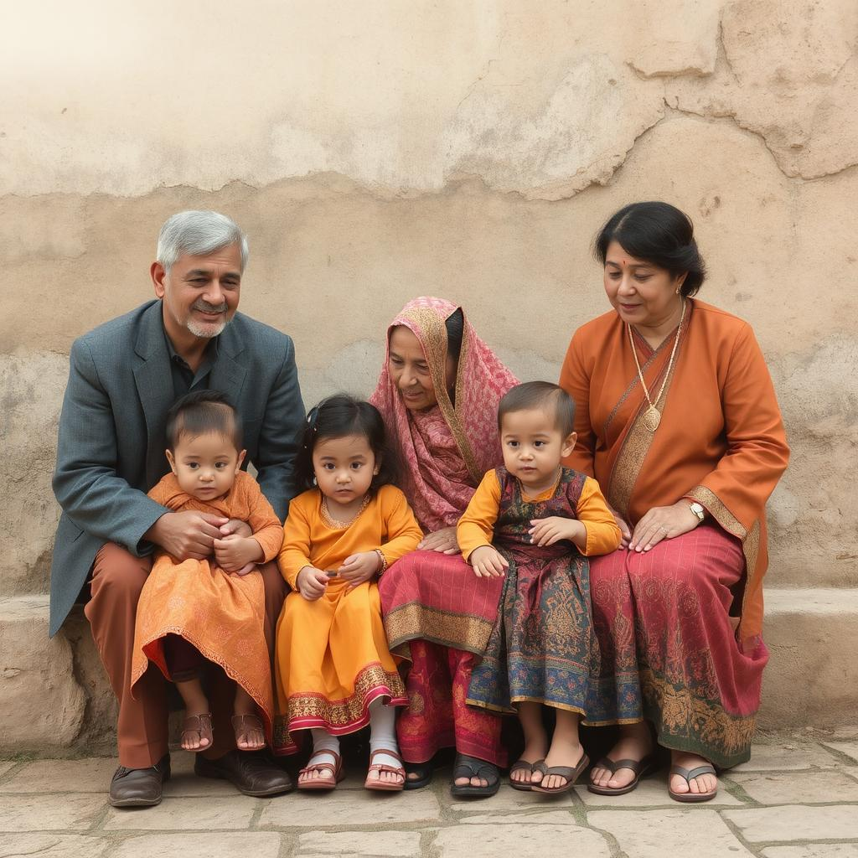

I Group Discussion: In small groups, discuss the following questions:
How do you define "family"?
What family structure is most common in your culture? (Nuclear, extended, or other?)
Who plays important roles in your family? Why?

2.After the group discussion, each pair will share what they discussed with the class.
3.Match the words with their correct definitions.

Word | Definition

1. Nuclear Family | A. The parents of your mother or father.

2. Siblings | B. The family structure with two parents and children.

3. Aunt | C. A child of your uncle or aunt.

4. Cousin | D. Brothers and sisters.

5. Grandparents | E. Family members who are the parents of a spouse.

6. In-laws | F. Close emotional relationships between family members.

4. Complete the sentences with the correct vocabulary word from the list.
- In many countries, it is common for the ________ family, including grandparents and cousins, to live together.
- After their parents divorced, Jenny and her brother lived with their mother and her new ________ family.
- During family holidays, all of my ________ come to our house to celebrate.
- My ________ help take care of my children when I’m at work.
- It’s important to build strong ________ in a family to support each other through difficult times.
- My ________ is a wonderful cook, and she always makes the best holiday meals.

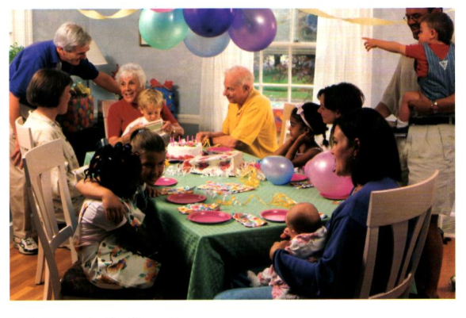
6 Find someone in the photo who:
is fair-haired is middle-aged has curly hair looks tired
is in blue jeans is wearing glasses is smiling is pointing

7 Now describe the photo. Begin like this:
This is a picture of a family party. There are people of all ages here. Most of them are sitting down at a table, but two men ...

II Listening skill
5. Listen to the audio and answer the following question
- What is the most common family structure in the United States and many Western countries?
- How does the family structure in the Middle East and Asia differ from Western countries?
- In some African cultures, who is considered part of the family?

! After listening, ask students to compare their answers in pairs and discuss why they think these family structures exist.
6. Based on the audio, lead a class discussion about family structures in different cultures.
Think about the differences in family structures between your own culture and the ones mentioned in the audio.
What are the advantages and disadvantages of nuclear and extended families?
How does the concept of family influence daily life, social values, and relationships in different cultures?

- Listen to the conversation between a father and his daughter, Sonia. Decide if each sentence is correct or incorrect. If it is correct, put a tick (✔)for YES. If it is not correct, put a cross(x) for NO.

1 Sonia would like a car for her birthday.
2 Sonia's friend Maria has her own car.
3 Sonia has talked to Maria about learning to drive.
4 Sonia offers to get a job at weekends.
5 Sonia's father understands how his daughter feels.
6 Sonia suggests cooking a meal on her birthday.
- Listen to the young woman who has applied for an office job talking about her jobs abroad. For each question, fill in the missing information in the numbered space.
Name: Vicky Brownlow
Age: 1……………..
Position applied for: 2………..
Two years' experience abroad
First job:
-worked for 3………….
-length of time stayed 4 …………
Second job-worked as 5 ……….. in a hotel
Third job - worked for 6………
got up at 7……….
Bank International:
-worked in 8……..
9.Listen to the speaker and fill in the table
Westfield Language Academy-Spring Schedule
Course Title | Days | Ages | Cost
1 | Monday and Wednesday | Adults over 18 | $575
Advanced Spanish | Tuesday | Adults over 18 | 2…….
Beginning Chinese | 3 | Children 4……. | $325
Beginning French | 5 | Children 6-10 | $325

III Speaking skill
- In pairs, students will prepare a short presentation comparing the family structure of their own culture with another culture (e.g., Middle Eastern, Asian, African). Practice speaking and using new vocabulary related to family structures and traditions.
III Speaking skill
11. In small groups, students will research family traditions from a country or culture of their choice. Each group will prepare a short presentation (5-7 minutes) for the class.
The presentation should cover:
- Family structure in the chosen country
- Common family celebrations or holidays
- Roles of family members during these celebrations
- Students should include pictures or other visual aids to enhance their presentations.
12. Role play with a partner.
Discuss the differences between their family structures.
What does "family" mean in their culture?
What roles do parents, grandparents, and children play in the family?
What are some family traditions that are unique to their culture?

Theme 7 Relaxation and well-being
Discuss these questions with a partner:
- Which of these words and phrases describe someone’s state of mind or well-being?
peaceful, stressed, energetic, anxious, calm, relaxed, exhausted, cheerful, tense, frustrated, happy, tired, content, nervous
- How do you feel when you are most relaxed? Describe your feelings and surroundings.
When I’m most relaxed, I feel ... because ... (e.g., peaceful, calm, joyful). I usually relax by ... (e.g., taking a walk, doing yoga, reading a book).
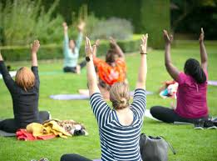
- What do you do to relieve stress and take care of your mental health?
To relieve stress, I usually ... because it helps me to ... (e.g., listen to music, meditate, exercise).

II. Vocabulary skill
- Choose the correct word to form proper collocations (verbs or adjectives commonly paired with the following nouns):
relaxation (achieve, experience, reduce)
well-being (improve, promote, affect)
stress (manage, relieve, reduce)
mood (improve, affect, change)
mindfulness (practice, promote, focus)
- Fill in the gaps using these vocabularies
- To __________ deep relaxation, it’s important to find a quiet, comfortable space where you can unwind.
- Many people __________ a sense of peace when they take a walk in nature.
- One of the best ways to __________ stress is through deep breathing exercises.
- Regular exercise can __________ both your physical and mental well-being.
- Meditation and mindfulness practices are excellent ways to __________ your emotional health.
- Lack of sleep can negatively __________ your overall health and happiness.
- Learning how to __________ stress effectively is crucial in today’s fast-paced world.
- A hot bath or reading a book can help to __________ stress after a long day.
- There are many techniques to __________ anxiety, such as yoga or talking to a friend.
- A good night’s sleep can greatly __________ your mood the next day.
- Sometimes, small acts of kindness can __________ your mood in a positive way.
- Listening to your favorite music can help __________ your mood when you’re feeling down.
- It’s important to __________ mindfulness every day to experience its full benefits.
- Mindfulness can be used to __________ awareness and presence in the moment.
- During meditation, you need to __________ your attention on your breath and clear your mind.
III. Listening Exercise
- Listen to a short conversation about relaxation techniques. After listening, answer the following questions:
What relaxation techniques does the speaker mention? 
Why does the speaker think these techniques are helpful?
- Listen to the audio and find the correct answers
1. What is the speaker’s role at UC Berkeley?
A) A student in the neuroscience department
B) A professor of psychology
C) A researcher in the field of health
D) A healthcare professional
2. What has the speaker studied for the past 25 years?
A) The science of mindfulness
B) The neuroscience of happiness
C) The challenges of the Covid-19 pandemic
D) The effects of stress on the body
3. According to the speaker, what can mindfulness bring?
A) Greater intelligence
B) Calmness, resilience, and strength
C) Financial stability
D) Relief from physical pain
4. Who does the speaker mention benefits from practicing mindfulness?
A) Only people with mental health conditions
B) Healthcare professionals and first responders
C) People with no stress at all
D) Only people in academic roles
5. What kind of exercise does the speaker lead listeners through in the podcast?
A) A physical workout
B) A mindful breathing exercise
C) A deep relaxation session
D) A guided visualization
6. What does the speaker suggest you do if your attention drifts during the mindful breathing exercise?
A) Focus on something else
B) Bring your attention back to the breath
C) Stop the exercise immediately
D) Continue without any focus
7. What does the speaker encourage listeners to do in their daily life?
A) Avoid stressors at all costs
B) Practice mindfulness while doing simple activities
C) Focus solely on their work tasks
D) Take long breaks throughout the day
8. Where can listeners find more mindfulness practices according to the speaker?
A) By visiting local wellness centers
B) On the Greater Good Science Center website
C) On YouTube
D) At local yoga studios
III. Speaking Skill
- Imagine you are talking to a friend who is feeling stressed. Offer them advice on how to relax and take care of their well-being. Use expressions like:
“I recommend …”
“You could try …”
“It might help if you …”
“Have you thought about …?”
- Listen to the recording and complete the sentences
Taking time for relaxation is essential for your well-being. When you relax, you can __________ (1) a sense of calm and peace, which helps to reduce stress. One effective way to relax is through deep breathing. This can help to __________ (2) your stress levels and make you feel more at ease. People who __________ (3) relaxation techniques regularly often experience improvements in their emotional health.
Good physical health can also __________ (4) your mental well-being. For example, exercise is known to __________ (5) your mood and increase energy. A simple walk or stretching routine can make a big difference. It’s important to focus on activities that __________ (6) well-being, like getting enough sleep and staying hydrated. The way you manage your daily routines can strongly __________ (7) your overall health.
- Role play
Person 1 (Wellness Coach): You are an expert on relaxation techniques and well-being. Your job is to listen to your client’s concerns and suggest ways to improve their relaxation and well-being.
Person 2 (Client): You are seeking advice on how to improve your relaxation and overall well-being. Share your challenges and ask for suggestions on how to achieve better relaxation and well-being.

- Mind Map: Relaxation Ways and Challenges
Relaxation Ways |  |  |  |  |  |  |  | Challenges
Deep Breathing |  |  |  |  |  |  |  | Lack of Time

Relaxation Ways: In the first column, list various ways people relax. Some suggestions are given, but feel free to add your own ideas.
Challenges: In the second column, write down the common challenges or obstacles that make relaxation difficult. Think about things that prevent you from achieving relaxation effectively.

Theme 8 How technology has changed language use
I Discussion point

1. Look at the picture and answer the questions below
- How has instant messaging influenced the way people write and communicate?
- Do you think social media platforms have contributed to the shortening of words and phrases? Why or why not?
- How do emojis and GIFs affect the way we express emotions in writing?
- Has the rise of autocorrect and predictive text made us more dependent on technology for communication? How so?
- Do you think technology has made language more informal or more formal? Give examples.
- How has the internet changed the way we learn new words or phrases?
- How do you think technology will continue to evolve language use in the next 10 or 20 years?
- Are all of the attributes below suitable for technology and language use? Why\Why not?
- Clarity
- Creativity
- Efficiency
- Formality vs. Informality
- Globalization
- Interpersonal Connection
- Language Evolution
- Cultural Influence
- Dependence on technology
II Vocabulary skills
Texting | Sending messages using a mobile phone.
Emojis | Small digital images used to express emotions or ideas.
Abbreviation | A shortened form of a word or phrase (e.g., “LOL” for “laugh out loud”).
Hashtag | A word or phrase preceded by the symbol "#" used on social media to categorize or find posts.
Acronym | A word formed from the initial letters of a phrase (e.g., “SMS” for "Short Message Service").
Voice recognition | Technology that allows a device to understand and respond to human speech.
Slang | Informal, often playful language used in casual conversation.
Social media | Platforms like Instagram, Twitter, or Facebook where users can share content and communicate.
Shorthand | A quick way of writing by using abbreviations or symbols, often used in texting or online chats.

1. Match the vocabulary word on the left with its correct definition on the right.

- Texting
- Emojis
- Abbreviation
- Hashtag
- Acronym
- Voice Recognition
- Slang
- Social Media
- Shortha
A. A type of online language used in casual conversation, often unique to specific groups or regions.
B. Technology that completes words for you while typing.
C. Shortened form of a word or phrase, like "TV" for "television."
D. Digital symbols that show emotions or ideas in messages.
E. A feature that helps devices understand spoken language.
F. Platforms where people communicate, share photos, and post updates.
G. The act of sending short messages on mobile phones.
H. A symbol used before a word to categorize posts on social media.
I. A quick way to write by using symbols or shortened words.
J. A word made from the first letters of a phrase, like “USA” for “United States of America.”
2. Fill in the blanks using the correct vocabulary word from the list above.
- When I use my phone to talk instead of typing, it uses __________ to understand my voice.
- Many people use __________ on Twitter to find posts related to a specific topic, like #TravelTips.
- In my message, I added a smiley face __________ to show I’m happy.
- She sent me a message with “BRB,” which is an __________ for “Be Right Back.”
- Instead of writing out the full word, I just type “lol,” which is an __________.
- Young people often use __________ like “lit” or “fam” in their conversations.
- My phone’s __________ suggests the next word as I type, which makes texting faster.
- People communicate with friends and family on Facebook or Instagram, which are popular __________ platforms.
- Instead of writing “Laughing out loud,” you can just write “LOL,” which is an example of an __________.
- __________ is a way of writing that shortens words, like “gr8” for “great.”

3. Read the statements below and decide if they are true or false.
- Texting involves sending long, detailed letters to someone.
- Using emojis is a way to express feelings without using words.
- An acronym is a word like "BRB" or "LOL" that stands for a longer phrase.
- Voice recognition allows us to speak into our phones and have them type out our message.
- Slang is formal language used in business settings.
- Hashtags help people find posts related to specific topics on social media.
- Shorthand is used only in professional writing.
- Predictive text helps you finish your words while typing on a phone or computer.
III Listening skill
  - Listen to the audio and complete the sentences
On, to, on, away, out, up, in, up

1. Technology has been worked …….. to everyone's day-to-day life.

2. It is the first thing I do when I wake ……… and when I go to bed.

3. It's easy to just pick up your phone, turn it ………. .

4. It takes ……… a bunch of my day.

5. He should just throw his phone ……… .

6. You need to chill …… .

7. Most people hate ………. technology.
8. It's up …………. us as to what we do with the technology.
2. Listen to the audio again and find the correct answers
- What is the first thing the speaker does when they wake up?
A) Call a ride
B) Pick up their phone
C) Eat breakfast
D) Check their math grade
- What is the speaker's biggest issue with technology?
A) Not knowing how to use it
B) It takes up too much time
C) It makes people tired
D) It doesn't help with school work
- How does the speaker feel when their phone is dead for half the day?
A) They feel relaxed
B) They feel crazy
C) They feel productive
D) They feel happy
- What does the speaker believe about technology when it is used for good things?
A) It is a necessary evil
B) It is a useful tool
C) It is harmful
D) It is unnecessary
- What does the speaker suggest people do to stay in control of technology?
A) Throw their phone away
B) Limit their phone use
C) Never use technology
D) Learn to use technology more
3.Listen to the audio and fill in the gaps with the correct word or phrase
- The speaker says that technology is the first thing they do when they __________ up in the morning.
- They use their phone to call a __________ and go wherever they want.
- The speaker believes it’s important to set a __________ and control your phone instead of letting it control you.
- When their phone is dead, the speaker feels like they are going __________.
- The speaker’s biggest problem with technology is that it takes up a lot of __________ during the day.
- The speaker believes technology can be a “necessary __________” depending on how people use it.
- The speaker met their girlfriend through an __________ dating app.
- The speaker notices that their __________are getting tired because of too much screen time.

Theme 9 Changes and consequences: Challenges and Implications
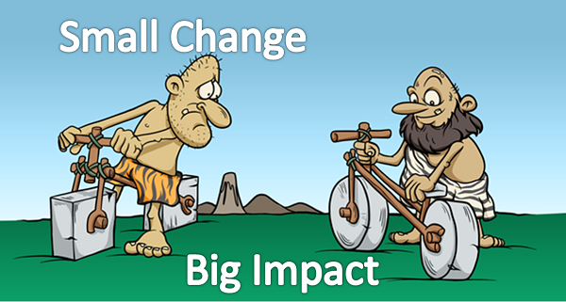
I Discussion point
      - What are some changes you have seen in your neighborhood or city in the last few years? How have these changes affected the people living there?
      - How can changes in technology, like using smartphones or the internet, make life easier or harder for people?
      - If the weather becomes hotter or colder because of climate change, what are some possible consequences for the world? How can we prepare for this?
II Vocabulary skill
1. Challenge - A difficult task or situation that requires effort to overcome.
2. Adapt - To change or adjust to new conditions or environments.
3. Impact- The strong effect or influence something has.
4. Consequence- A result or effect of an action or situation.
5. Solution - A way to solve a problem or deal with a challenge.
6. Crisis - A time of intense difficulty or danger that requires urgent action.
7. Progress - Movement forward or improvement in a situation.
8. Sustainable - Able to be maintained over a long period of time without harming the environment.
9. Risk- The possibility of harm or loss.
10. Innovation - A new idea, method, or device that improves something.

1. Match the vocabulary words with their correct definitions.

1. Challenge
2. Adapt
3. Impact
4. Consequence
5. Solution
6. Crisis
7. Progress
8. Sustainable
9. Risk
10. Innovation

A. The result of something happening.
B. A difficult situation that requires action.
C. To change or adjust to something new.
D. A new idea or method to improve something.
E. The possibility of something harmful happening.
F. Moving forward or making improvements.
G. A problem that needs a fix.
H. To keep something going without harming the environment.
I. The strong effect something has.
J. A difficult task or situation.
2. Find the correct answers according to the vocabularies above
1. What does it mean to “adapt” to a new environment?
A. Change the environment to fit your needs.
B. Change yourself to fit the environment.
C. Ignore the environment and do what you want.
2. What is a “consequence” of not taking care of the environment?
A. Good weather
B. Harmful effects like pollution
C. More jobs
3. What is an example of sustainable living?
A. Throwing away all your trash
B. Using less water and recycling
C. Traveling by car everywhere
4. If a company is facing a “crisis”, what should they do?
A. Wait and see what happens
B. Take urgent action to fix the problem
C. Ignore the issue and hope it goes away
3. Read the statements and decide if they are true or false.
1. A “challenge” is an easy task that everyone can do without any effort.
2. “Innovation” means coming up with new ideas to improve things.
3. “Risk” means there is no chance of harm or loss in a situation.
4. “Impact” refers to the strong effect or influence something has on a situation or environment.

III Listening skill
1.Listen to the audio and fill in the information sheet
Name: Mike Davis
Age: 13 years
Favourite subject: 1………….…………………………
Favourite sport: 2…………….………………………...
Usual transport: 3……………..………………………..
On Saturday: 4………………..………………………..
On 5………… ………………: Young Farmers' Group
Future job: 6…………………………………………...
2.Look at the six sentences for this part. You will hear a conversation between a boy, Jim, and his mother. Decide if each sentence is correct or incorrect. If it is correct, put a tick (✔)YES. If it is not correct, put a tick (x)for NO.
1. Jim's bicycle needs to be mended.
2. He's keen to start saving money.
3. His mother thinks a mountain bike is suitable for their area.
4. She encourages Jim to manage his money better.
5. His mother offers to lend him some money.
6. Jim is disappointed by his mother's suggestion.

3.Listen to the talking on the radio about a Language Study Fair. For each question, fill in the missing information in the numbered space.
Dates:17th to 19th 1……….
Place: National Education Centre
Fair includes:
- stands with textbooks
- 2………………………
- by educational speakers
- exhibition of furniture
- demonstrations of latest 3………..
Opening hours: 9.30 a.m.-5.00 p.m. Thursday and Friday 9.30 a.m.-4.00 p.m 4…………..
Tickets: £5 or £3 for 5…………
Tickets can be booked by ringing the hotline on 6…………

III Speaking skill
1. Role Play: The Impact of Change
Class can be divided into pairs or small groups. Students will be given a different scenario where a significant change occurs. After the role-play, they have a class discussion on the implications of change in general. What challenges might people face? How can we adapt to changes in society or at work?
  - A new law is introduced that changes the way people work.
  - A country changes its education system.
  - A company implements a new technology that affects employees.
2. Debate: The Positive and Negative Consequences of a Change. Organize a class debate on the topic of changes in society or the workplace. For example:
  - “The rise of automation in the workplace is more beneficial than harmful.”
  - “Social media has brought more positive than negative changes to society.”
5. Future Predictions: Changes in the Next 10 Years. Students are asked to think about changes that might happen in the future (e.g., in technology, the environment, or social structures). In small groups or pairs, students discuss the following questions:
What major changes do you think will happen in the next 10 years?
How will these changes affect our daily lives, jobs, or relationships?
What challenges might people face as a result of these changes, and what can we do to prepare for them?

- Theycan use future tenses (will, might, may, etc.) and phrases like "I think that..." or "In my opinion..." while speaking.

6. Storytelling: A Change in My Life. Think about a time when something big changed in your life. This could be:
  - Moving to a new city
  - Changing schools
  - Achieving something important (like winning a prize or learning something new)
- Tell your story to the class. Talk about:
What changed
What challenges you faced
How you dealt with the change
- After each person tells their story, ask questions or give advice. You can ask:
How did it feel?
What would you do differently?

Theme 10 City and country life: Urbanization

I Discission part
In small groups, discuss the following questions related to City and Country Life:
- How do you define “city life” and “country life”?
- What are some advantages and disadvantages of living in a city versus the countryside?
- What are the biggest differences in lifestyle, environment, and culture between living in the city and living in the countryside?
- Which do you prefer and why? Would you ever consider living in a rural area if you currently live in a city, or vice versa?

II. Vocabulary
1 Match the words with their correct definitions:
Word | Definition
1. Urban | A. A person who lives in the countryside or rural areas.
2. Rural | B. Relating to a city, town, or the population living there.
3. Suburbs | C. An area just outside a city or large town.
4. Countryside | D. An area of land that is not developed or heavily populated.
5. Public transport | E. The system of buses, trains, and other vehicles used for travel.
6. Skyscraper | F. A tall building typically found in a city.

2 Complete the sentences with the correct vocabulary word from the list:
- In the ________, life is usually slower and there’s more open space.
- Many people living in the ________ prefer to drive rather than use public transport.
- The city has many tall ________ that are used for offices and apartments.
- We live in the ________ area of the city, which is quieter and more residential.
- The ________ in my city are usually crowded during rush hour.
- After spending many years in the ________ , I find the hustle of city life overwhelming.
  - Find the best answer
I. Multiple Choice:
1. Which of the following is a characteristic of urban life?
A. Quiet environment
B. Lots of public transport options
C. Small houses with large gardens
D. Close-knit communities
2. What is the best definition of the word "suburbs"?
A. A rural area far from the city
B. The outer part of a city, often residential
C. A large commercial center in a city
D. An area with no transportation options
3. A skyscraper is:
A. A small, one-story house in the countryside
B. A type of tree found in the city
C. A very tall building typically found in cities
D. A street that runs through the city center
4. Which of these best describes rural life?
A. Busy streets and lots of people
B. Large buildings and office spaces
C. Quiet environment with lots of open space
D. Many public transportation options
5. What is the main advantage of using public transport in the city?
A. It’s very expensive
B. It’s less environmentally friendly
C. It’s more convenient for getting around the city
D. It requires a lot of personal space
4 According to the vocabularies decide that definitions given are True or False
1. The countryside is typically more crowded than the city.
2. Public transportation is a common and convenient way to get around in urban areas.
3. Suburbs are always very far from the city center.
4. Skyscrapers are only found in rural areas.
5. Rural areas usually have more green spaces and less pollution than cities.
6. City life tends to have a slower pace compared to life in the countryside.
7. People in urban areas often need to travel long distances for work or school.
8. The countryside is a perfect environment for people who enjoy outdoor activities and peace.
    - Describe the Image:
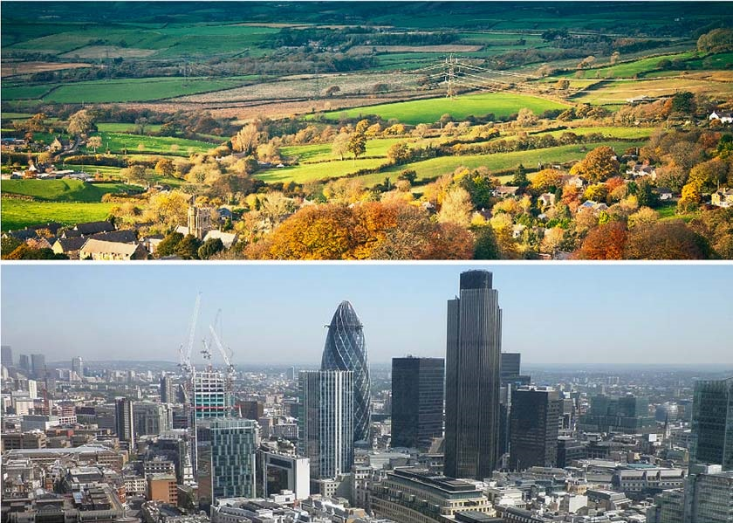
Describe the photo. Begin like this:
“This is a picture of a city street. There are tall buildings, cars, and many people walking along the sidewalk. The atmosphere is busy, and the streets are filled with noise. In contrast, the countryside is much quieter. There are fields and fewer buildings, and the air looks much cleaner.”

III Listening Skill
1 Listen to the audio and answer the following questions:
- What are some features of life in the city mentioned in the audio?
- How does the lifestyle in the countryside differ in terms of work, social life, and transportation?
- According to the speaker, what are some challenges people face when moving from
2 Listen to the talk and look at the map below. Choose the correct letter, A-D.

1 benches…………………
2 storage shed…………….
3 fish pond……………….
4 flower garden………….

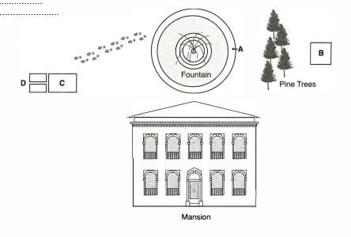
3 Listen to the conversations and find the correct answers

Conversation 1

1 What does the student say about the Introductory Spanish class?

A He took it already.

B It's too easy.

C His schedule doesn't have room for it.

2 Why does the woman suggest Intermediate Spanish?

A A foreign language class is required.

B The schedule is convenient.

C It's preparation for the student's trip to Mexico.

3 What class will the student take on Monday and Wednesday afternoons?

A Intermediate Spanish

B European History

C Latin American History

Conversation 2

1 What has the woman not done yet?

A chosen a research topic

B made a resource list

C spoken about her project with the professor

2 What does she have to include as part of her project?

A interviews

B photographs

C charts and graphs

3 When is the project due?

A in two weeks

B next month

C the end of the semester

Conversation 3

1 People originally grew knotweed

A as a screen for hiding structures.

B for its attractive flowers.

C to repel bees.

2 The best way to get rid of knotweed is to

A cover the ground with plastic.

B apply herbicides.

C dig up the roots.

3 Knotweed can be used as

A food.

B medicine.

C rat poison.

Conversation 4

1 Why is the professor meeting with the student?

A To discuss her classwork

B To give her the semester grade

C To help her plan the next assignment

2 The professor wants the student to

A improve her attendance.

B turn her assignments in on time.

C participate more in class discussions.

2 According to the professor, what aspect of the student's recent paper needs improvement?

A the organization

B the clarity

C the conclusion

IV Speaking Skill
1 Lead a class discussion on the advantages and disadvantages of living in the city versus the countryside.
- What are the most important factors for people when deciding where to live (e.g., job opportunities, environment, access to services)?
- How does the city influence people's daily routines and social lives? How does the countryside affect these things differently?
- Are there any ways to combine both lifestyles (living near a city but still having access to nature, for example)?
2 In pairs, students will prepare a short presentation comparing city life with country life.
They should cover:
- Key differences between the two lifestyles (e.g., work, transport, environment).
- Advantages and disadvantages of each.
- Which lifestyle is more suited to different people or families (considering factors like age, job, or interests).

Role Play:
In pairs, role-play a scenario where one person is a city dweller, and the other is a person from the countryside. They discuss:
- The pros and cons of their lifestyles.
- What they like about their living environments.
- Which one they would prefer to live in, and why.

Project Work:
In small groups, students will research and present a comparison between two cities (e.g., New York vs. a small rural town).
The presentation should include:
- Lifestyle differences (e.g., work, family life, social activities).
- Environmental contrasts (e.g., pollution levels, green spaces).
- Transportation and infrastructure.
- Visual aids (pictures of the city vs. countryside)

Theme 11 Recalling the past
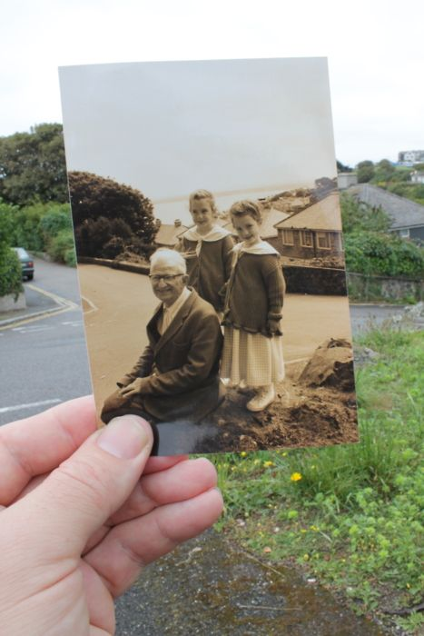
A.Predict
Look at the picture and discuss in pairs:
“Do you think it’s important to remember the past? Why?”
“How do you feel when you remember something from when you were younger?”
What kind of stories do people tell about the past?
B. Share information
Work in pairs and ask questions about personality.
What’s a memorable event from your childhood?
Have you ever traveled somewhere that you’ll never forget? What happened there?
What’s the best or worst birthday you’ve ever had?
What accident happened in the past can you remember?

1.Complete the sentences below using the words and phrases provided. Try to use each word or phrase only once.
recalled, reminisced, recounted, reflected on, used to, would, back in the day, in those days, ages ago, a long time ago, once upon a time, way back when

1. My grandparents often __________ about their childhoods during the war.
2. I vividly __________ the day I met my best friend.
3. She __________ the story of her travels through South America.
4. He __________ his decision to quit his job and travel the world.
5. __________ I __________ play the piano every day, but I haven't touched it in years.
6. __________ we __________ go to the beach every summer.
7. __________, people didn't have cell phones.
8. __________, there were no computers in schools.
9. We went on a family trip to Disneyland __________.
10. I haven't seen her in __________. It feels like __________.
11. __________ there was a wise old king... (This sentence starter encourages creative storytelling.)
2. Match the words with their correct meanings:
- Witness
- Recollect
- Era
- Journey
- Remarkable
- Once in a lifetime
- Overcome
- Memento
a. A period in history or a person's life
b. A souvenir or keepsake
c. To remember something from the past
d. To conquer or defeat something difficult
e. Something extraordinary or special
f. A trip or voyage
g. To see or observe something happen
h. A rare event or opportunity
3. Fill in the blanks with the correct past tense form of the verbs in parentheses:
- Last summer, we (travel) to Italy and (visit) the Colosseum.
- When I was a child, I (play) outside every day until sunset.
- She (not, enjoy) the movie because it (be) too long.
- We (celebrate) my grandmother's 80th birthday last week, and it (be) a beautiful day.
- I (never, see) anything like that before—it (be) amazing!
D. Listening
Pre-listening activity
Before you are going to listen to the news report about a parashute jump answer the following questions:
1.Have you ever seen or heard about someone jumping out of an airplane? What do you think it would feel like?
2.What do you think could go wrong during a parachute jump?
While-listening activity 
1. Listen to the news report on Track 6. Are the following sentences True or False? Write T or F in the brackets.

a Someone died. [ ]

b A parachute failed to open properly.[ ]

c The second parachute opened properly. [ ]

d Two people broke bones. [ ]

e The man has terrible injuries, the woman is less seriously injured. [ ]

f It was the woman's first parachute jump.[ ]

g The woman wants to do a parachute jump again. [ ]

2. Listen to Track again and answer the questions with the names from the box.
Beverly Dennis Jim Kevin Peter Sue
Beverly Dennis Jim Kevin Peter Sue

Who:

a… parachuted together?

b... is reporting from France?

c... is in the studio in London?

d... is in hospital?

e... reported from the United Nations?

f... was on honeymoon?

g... thinks it was just pure luck?

h... has a broken leg, a broken ankle and two broken feet?

i... has just a broken leg?

j… enjoys seeing the daylight and the birds?

Post-listening activity

Complete the audioscript with words and phrases from the box.

emergency chute
faster and faster
first parachute (x2)
going to die
hit the ground
pure luck
second, emergency parachute
solve the problem

REPORTER: The accident happened when the (a)______________ didn't open. Mr McIlwee tried to (b)______________, but when he couldn't, he tried to get rid of that chute and use the (c)_____________ that skydivers always carry with them. A few hours ago I spoke to Beverly's father, Dennis Murtaugh, who explains what happened next. His words are spoken by an actor because the line was not good when we talked.

DENNIS: Unfortunately, Kevin wasn't able to jettison the (d)_____________ properly so the (e)____________ wouldn't open and they just fell (f)______________. Kevin told me that they thought that was it, they were (g)____________.

REPORTER: So how did they survive?

DENNIS: It was (h)____________. I mean they only had half a parachute to slow them down. They (i)_____________at an absolutely fantastic speed.

It could have killed them.

Listen to Track 6 to check if you were correct.

Speaking

Do the following speaking exercises:

1. Interview Role Play
Pair up with a classmate. One person will be the interviewer, and the other will be the interviewee. The interviewer will ask questions using the words from the list below. The interviewee will respond using the words correctly.
Words: witness, recollect, remarkable, journey, overcome
Example Questions:
- Can you recollect a time when something remarkable happened to you?
- Have you ever been on a journey that you’ll never forget?
- Tell me about a time when you had to overcome a big obstacle in your life.

2.Timeline Exercise
Create a timeline with past, present, and future sections. Think about events from your life or from history, and place them in the appropriate sections. Use the vocabulary words to describe the events.
Example:
- In the past: "When I was a child, back then, there were no smartphones."
- Nowadays: "Now, we all have smartphones, and it has changed how we communicate."
- In the future: "In the future, I think technology will keep evolving in ways we can’t even imagine."

Theme 12. Work

A.Predict
Look at the picture and discuss in pairs:
“Do you arrive on time and ready to work each day??”
“Do you keep track of deadlines and manage your time effectively?”
How well do you handle stress or challenging situations at work?”
B. Share information
Work in pairs and ask questions about personality.
 | Questions | Answers
1 | What qualities do you think are most important for being a good worker? Why?
2 | Can you describe a time when you worked in a team? How did you collaborate with others?
3 | How do you stay organized at work or university? What tools or methods help you?
4 | Have you ever had to adapt to changes at work or school? How did you handle it?
C. Vocabulary
- Below is a list of vocabulary words related to being a good worker. Read the definitions and match each word with its meaning.
  - Punctual
  - Dependable
  - Motivated
  - Proactive
  - Collaborative
  - Organized
  - Accountable
  - Efficient
  - Flexible
  - Detail-oriented

Definitions:
a) Able to make decisions on your own without needing others to tell you what to do.
b) Consistently arrives on time for work or appointments.
c) Able to work well with others and enjoy teamwork.
d) Focuses on completing tasks quickly and accurately.
e) Willing to change your approach or tasks as needed.
f) Takes responsibility for their actions and decisions.
g) Pays attention to small details and ensures nothing is overlooked.
h) Can be relied on to complete tasks without constant supervision.
i) Has a strong desire to achieve goals and overcome challenges.
j) Keeps things in order and is able to plan and arrange tasks effectively.
2. Using the vocabulary words used in exercise 1 complete the following sentences:
- She is always on time for meetings and rarely misses a deadline. She is very _______.
- A good team member should be _______ and willing to share ideas with others.
- If you want to finish your tasks quickly and without wasting time, you need to be _______.
- Being _______ means being able to take responsibility for your actions, especially when mistakes are made.
- To be a good employee, it’s important to be _______ and willing to change your plans when necessary.
- He always anticipates problems and solves them before anyone else notices. He’s very _______.
- As a manager, you should have an _______ system for keeping track of deadlines and projects.
- When working with others, it’s important to be _______ and contribute positively to the group’s success.
- She works really hard and has a lot of energy to get things done. She is very _______.
- John never misses any details in his reports. He’s very _______.
D. Listening
Pre-listening activity 
Listen to Track 1. This is an extract from an interview with 22-year-old April Considine. Can you guess which of the following is her occupation?

teacher

design engineer

doctor

pilot

While-listening activity 
1. Listen to Track 2 and answer the following questions.

a Who first encouraged April to be interested in engineering?

b On the whole, does April think that being a woman in a male environment is a good thing or a bad thing?

Are the following sentences True or False? Write T or Fin the brackets.

a April's father is Irish.

b A glider is an aeroplane without an engine.

c April can fly a glider.

d April sometimes works at Marshall's at the weekend.

e April's work is usually checked by four other people.

f A hangar is a big building where you put aeroplanes.

g April works in the hangars.

h There were many girls in the hangars.

i Nobody spoke to April in the hangars.

2. Check the meaning of the following phrases. Listen to Track 2 again and tick (✔) the things that April says are important in her job. Put a cross (X) beside the things that she does not mention.

It is important to:

a arrive and leave work on time

b be a hard worker

с be able to communicate

d be able to prove yourself

e be able to work on your own

f be decisive

g be courteous

h be energetic

i be good-looking

j be organised

k be well-dressed

1be young and enthusiastic

m go out in the evening with colleagues

n love your job

o make sure it's right

p show initiative

Post-listening activity
April used the following expressions in Track 2. Explain the meaning of the words and phrases in blue.

a He's always been really keen on engineering.

b He's always working on cars and bits and pieces.

c He did a little bit himself.

d I got involved with that.

e It still comes down to you.

f if you sit there and just do the minimum.

g They all keep an eye on what I'm doing.

h to find out how I was getting on.

Speaking

Exercise 1: Role-Play – Job Interview
- Preparation:
In pairs, one student will be the interviewer and the other will be the candidate applying for a job. Use the following prompt:
Interviewer’s Role:
  - Ask the candidate about their work habits, strengths, and how they handle work challenges.
  - Use the vocabulary from the previous exercise (punctual, dependable, motivated, proactive, etc.) in your questions.

Candidate’s Role:
  - Respond to the questions and explain how you embody the qualities of a good worker.
  - Give examples from past experiences (work, school, etc.) to support your answers.
Example Questions for Interviewer:
  - “Can you describe a time when you demonstrated strong teamwork at work?”
  - “How do you stay motivated when you face a difficult task?”
  - “Do you consider yourself to be organized? How do you plan your day?”
  - “Tell me about a situation where you had to adapt to a sudden change at work.”
  - “How do you ensure you are being efficient with your tasks?”
Follow-Up:

- Follow-Up:
After the role-play, switch roles and repeat the exercise with new questions or scenarios.

Exercise 2: Describe a Good Worker
- Task:
In pairs, one student will describe a good worker to the other without saying their name. The other student will try to guess what kind of worker they are describing based on the vocabulary used.
For example:
  - “This worker is always on time and never misses deadlines. They take full responsibility for their work and never blame others. They are very reliable, and their colleagues can always count on them.”
  - The second student guesses: "Is this worker dependable?"
- Switch Roles:
After one description, switch roles and repeat the exercise. The goal is to use the vocabulary words naturally in conversation while describing traits of a good worker.

Theme 13. Life experiences
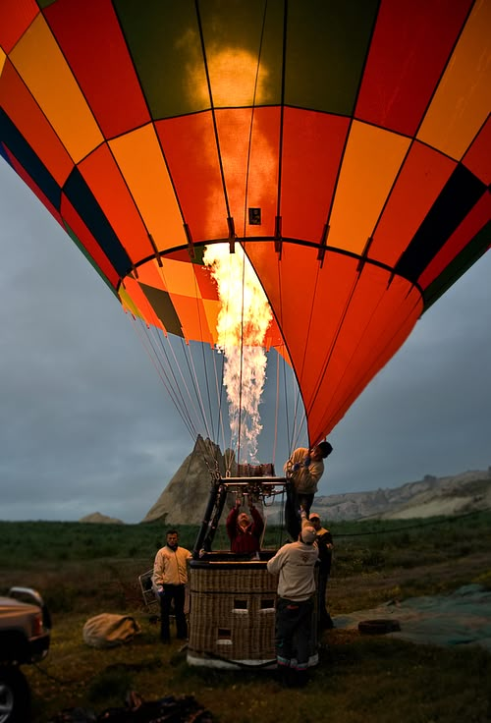
A.Predict
Look at the picture and discuss in pairs:
“What was a moment when you felt truly proud of yourself?”
“When was the last time you tried something completely new? How did it feel??”
What’s a mistake you made that you’re now grateful for?”
B. Share information
Work in pairs and ask questions about personality.
 | Questions | Answers
1 | What is the most significant life-changing event you've experienced?
2 | Describe a time when you had to overcome a difficult challenge.
3 | What were the ups and downs of a major decision you've made?
4 | What are the most important milestones you're hoping to achieve in the next five years?

C. Vocabulary
1. Below is a list of words and phrases related to life experiences. Read through them and make sure you understand the meanings.
- Milestone (noun) - An important event or stage in life.
- Turned out (phrasal verb) - The result of a situation or experience.
- Overcome (verb) - To deal with and successfully defeat difficulties.
- Make the most of (expression) - To take full advantage of an opportunity.
- Ups and downs (expression) - The good and bad times in life.
- Life-changing (adjective) - Having a significant impact on one’s life.
- Growth (noun) - Development or improvement in a person’s abilities, character, or life.
- Challenge (noun) - A difficult task or situation.
- Take risks (phrase) - To do something that involves danger or uncertainty.
- Regret (verb) - To feel sorry about a past decision or event.
- Overwhelmed (adjective) - Feeling a lot of pressure or stress, unable to cope.
- Grateful (adjective) - Feeling thankful for something or someone.
- Pivotal (adjective) - Extremely important or central to a situation or development.

2. Fill in the blanks with the correct vocabulary word from the list above.
- After moving to a new country, she experienced many ______________ moments that changed the way she viewed life.
- Although I made some mistakes, I don’t ______________ any of my decisions because they helped me learn.
- The job offer was a ____________ moment in his career, opening up many opportunities for growth.
- It was a really difficult time, with a lot of _______________, but I learned a lot about myself.
- Sometimes life gets tough, but if you _____________, you can grow stronger.
- She felt completely ____________ after her final exams, but now she’s able to relax.
- His decision to study abroad turned out to be a ______________ experience for him.
- It’s important to take risks if you want to ______________ opportunities and explore new things.
- I’m so ______________ for all the help my family has given me throughout my life.
- The most important ______________ in my life was moving to a new city at
D. Listening
Pre-listening activity
Before you are going to listen to the track answer the following questions:
• What subjects do you think are most difficult in university?
• What subjects are often required in courses like Mechanical Engineering?
• What might be some challenges for students in a university setting?

While-listening activity
Questions 1-2
Choose TWO letters, A-E.
Which TWO subjects did Martina like before going to university?
A Art
B English
C French
D History
E Science

Questions 3-6

Complete the summary below.
Write NO MORE THAN TWO WORDS for each answer.
George's experience of university
George is studying Mechanical Engineering which involves several disciplines.
He is finding 1 ……………….. the most difficult. At the moment, his course is
mainly 2 ……….……. .
He will soon have an assignment which involves a study of 3 …………………………..
He thinks there are too many 4 ……………..………. and would like less of them.

Post-listening activity

Answer the following True or False Questions:
- Martina liked Science before university. (True/False)
- George is studying Mechanical Engineering, which involves several different subjects. (True/False)
- George finds his university course easy and enjoyable. (True/False)
- Martina prefers subjects like Art over Science. (True/False)
- George’s course is mostly focused on Science and Math at the moment. (True/False)
- George will soon have an assignment that involves studying History. (True/False)
- George finds the study of Mechanical Engineering straightforward and simple. (True/False)
- George’s assignments mostly focus on writing papers rather than practical work. (True/False)
Speaking

Do the following speaking exercises:

1. What If?
- Create a Scenario: Imagine a life situation where you made a significant decision. Think about how it could have turned out differently if you had made another choice. Use vocabulary like regret, life-changing, and pivotal.
- Discuss Your “What If?” Scenario: Work in pairs or small groups. One person will describe a key decision or experience they had, then explain what might have happened if they had made a different choice. They should use phrases like:
  - "If I had done this differently, I might have…"
  - "I think my life would have been very different if I had…"
- Use Vocabulary in Your Answers: Make sure to use words such as regret, challenge, growth, milestone, and overcome as you discuss the consequences of different decisions.
Example:
  - “If I had decided not to move abroad, I would have missed a huge life-changing experience. Although it was a challenge at first, it led to personal growth, and I don't regret it.”

2. Life Experience Superlatives
- Choose Superlatives: Think about the most significant events in your life. These could be both positive and negative experiences. Choose the one that stands out the most in each of the following categories:

  - The most life-changing event.
  - The most difficult challenge you've faced.
  - The most memorable achievement.
  - The most overwhelming situation you've encountered.
  - The most pivotal moment in your life.

- Share with a Partner: Work with a partner to share your choices. Explain why each event is the most important or impactful in its category. Use vocabulary such as milestone, overcome, regret, and growth.

- Ask Questions: After sharing, ask each other follow-up questions like:
  - “What was the hardest part about that experience?”
  - “How did that event shape your future decisions?”
  - “What did you learn from that experience?”

Theme 14. Extreme news
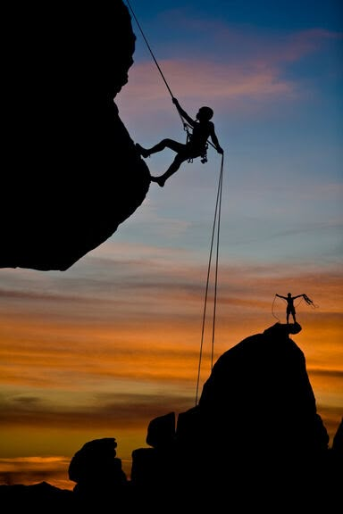
A.Predict
Look at the picture and discuss in pairs:
“What kind of news stories do you think are extreme?”
“Why do you think people are interested in extreme news??”
Do you think extreme news stories are always true? Why or why not?”
B. Share information
Work in pairs and ask questions about personality.
 | Questions | Answers
1 | What is the most shocking news story you’ve heard recently?
2 | Have you ever followed a scandal in the news? What was it about?
3 | Have you ever heard of a conspiracy theory in the news? What was it, and how did it spread?
4 | What’s an example of a controversial news story that caused a lot of debate?

C. Vocabulary
1. Read through the following list of words and phrases related to extreme news. Make sure you understand each term.
- Breaking news (phrase) - News that is happening right now, often being reported as it occurs.
- Headlines (noun) - The most important or attention-grabbing news stories.
- Shocking (adjective) - Very surprising, often in a way that causes strong feelings of surprise or disbelief.
- Unbelievable (adjective) - So extraordinary or extreme that it is hard to believe.
- Disturbing (adjective) - Causing anxiety or worry, often related to unsettling events or situations.
- Sensational (adjective) - Designed to get strong reactions, often exaggerated for dramatic effect.
- Groundbreaking (adjective) - Very innovative, introducing something completely new or different.
- Scandal (noun) - A public event or situation that causes a lot of outrage or shock.
- Outrageous (adjective) - Very shocking or excessive, beyond what is acceptable.
- Global impact (phrase) - A situation or event that affects people all over the world.
- Conspiracy theory (noun) - A belief or theory that suggests events or situations are being controlled secretly, often in a negative or harmful way.
- Controversial (adjective) - Causing a lot of debate or disagreement, often because of strong differing opinions.
- Devastating (adjective) - Causing great damage or destruction, especially emotionally.

2. Fill in the blanks with the correct vocabulary word from the list above.
- The recent __________ about the celebrity’s secret life was all over the media.
- The earthquake had a __________ effect on the community, with many buildings destroyed.
- The news of the political leader's corruption was __________ and sparked a lot of protests.
- The new scientific discovery was considered __________ because it could change everything we know about biology.
- The online rumors turned into a __________ when people began to spread false information about the virus.
- The journalist was reporting live when the __________ event happened in the city center.
- Some news stories are designed to be __________ to get people’s attention, even if the information is exaggerated.
- It was an __________ story when the little girl survived an entire week lost in the forest.
- The politician’s comments were so __________ that they created a huge divide in public opinion.
- The story of the plane crash was so __________ that many people refused to believe it at first.
D. Listening
Pre-listening activity
Read through the following words and phrases. Discuss their meanings with a partner or write down your understanding.
company collapse, computer virus, cure for cancer, earthquake, election results, Internet romance, mountain rescue, peace talks, plane crash, rocket launch for Pluto expedition.

While-listening activity 
1.Listen to Track 20. Which of the following topics are discussed in the news broadcast? Tick (✔) those that are mentioned.

a company collapse [ ] [ ]

b computer virus [ ] [ ]

c cure for cancer discovered [ ] [ ]

d earthquake [ ] [ ]

e election results. [ ] [ ]

f Internet romance [ ] [ ]

g mountain rescue [ ] [ ]

h peace talks [ ] [ ]

i plane crash [ ] [ ]

j rocket launch for Pluto expedition [ ] [ ]

2.In the second column above, number the stories that you have ticked in the order you hear them.

Post-listening activity

Listen to Track 20 again, and then write answers to the questions.

What is the connection between:

a... a mobile phone and a mountain?

b... K2 and Paris?

c... a computer virus and Puerto Rico?

d... Bella Karsfeld and 'Money for jam'?

Oxford and Tuscaloosa?

f... 35 and 65?

g... $70 million and holiday homes?

3. Answer the following questions about the news reports.

a Who was saved from almost certain death?

b Where were there appalling weather conditions?

c Who got over his surprise?

d Who is trying to trace the source of what?

e Who eventually agreed to marry?

f Who had lied about her age?

g Who or what is to cease business?

h Who expects more business failures?

Speaking

Do the following speaking exercises:

1.Guess the News Headline
- Prepare: Write down a few extreme or unusual news stories, leaving out the headlines (for example, a strange event, a dramatic rescue, a shocking political scandal, etc.). You can leave some key information out, so the students need to guess the rest of the headline.
Example Headlines:
  - "Man Survives __________ for 5 Days in the Desert"
  - "__________ Breaks Records with __________"
  - "__________ Causes Global Outrage Over __________"

- In Pairs: One student will give a short description of the news event (without revealing the headline), and the other will try to guess the headline.
Example:
  - Student A: "A man was stranded in the desert after his car broke down. He survived by drinking rainwater and eating cactus."
  - Student B: "Was it a groundbreaking survival story? What about... 'Man Survives Harsh Conditions for 5 Days in the Desert'?"

Example:
- Discussion: After the headline is guessed, students should discuss the possible impact of the event. Did it cause a global impact? Was it controversial? Was it sensationalized by the media?

2. Extreme News Story Creation
- Create a News Story: In pairs or small groups, students will come up with their own extreme news story. They should use the vocabulary they’ve learned, such as “shocking,” “groundbreaking,” or “unbelievable.”

- Story Ideas: You could provide them with some prompts to help them get started:
  - A scientific breakthrough that changes everything.
  - An extreme weather event that affects a large part of the world.
  - A political scandal that involves global leaders.
  - An unbelievable rescue that happens under extreme conditions.
  - A controversial decision made by a celebrity or public figure.

- Present the Story: Once the story is ready, each group will present their “breaking news” to the class. They should explain why it is extreme, its impact, and how the media would likely report it. The other students will guess whether the story is real or fictional.

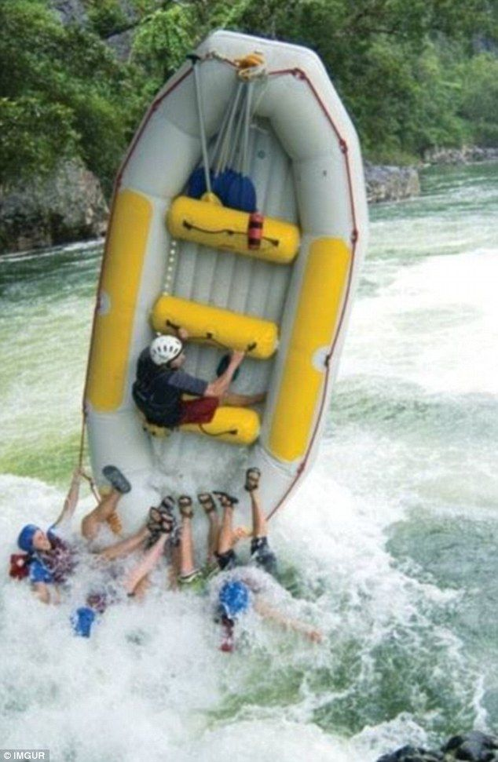
Theme 15. Volunteering
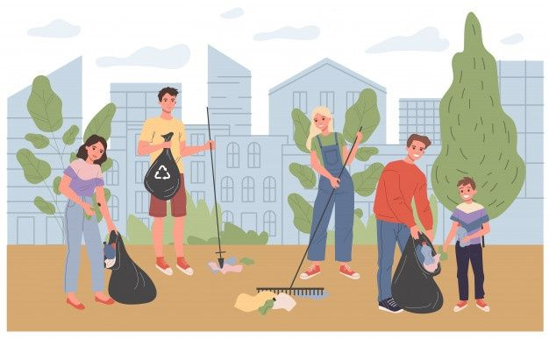
A.Predict
Look at the picture and discuss in pairs:
“What are some reasons people choose to volunteer??”
“What are some popular types of volunteer work in your country?”
Have you ever volunteered? What was your experience like?”
B. Share information
Work in pairs and ask questions about personality.
How does volunteering benefit a community?
Do you think volunteers should be paid for their work? Why or why not?
Do you think volunteering is more common in some countries than others? Why do you think that is?
How can volunteering affect your personal life and career?

C. Vocabulary
1. Match each word related to volunteering with its correct definition.
- Volunteer
- Nonprofit organization
- Fundraising
- Charity
- Donation
- Community service
- Outreach
- Social impact
A. An organization that operates without the goal of making a profit, typically focused on social causes.
B. The act of raising money for a particular cause.
C. An individual who offers their time and effort to help others without payment.
D. A gift or contribution, usually money, made to a cause or charity.
E. Organized activities that support and help the community, often unpaid.
F. The work or activities designed to spread awareness and support a cause, often reaching underserved groups.
G. The effect or influence that something (e.g., a volunteer project) has on society or a community.
H. An organization or group dedicated to helping others, usually focused on social good and needs.

2. Fill in the blanks
Complete the sentences with the correct word from the vocabulary list.
- Many people choose to _______ at animal shelters or food banks to make a difference in their community.
- A _______ is a place where you can donate money to help those in need, like the Red Cross or UNICEF.
- The team raised over $5,000 through _______ events to support their local hospital.
- Volunteering for _______ allows individuals to help people who are facing poverty, homelessness, or other social issues.
- Last year, our company made a large _______ to a local children’s hospital.
- One of the most important aspects of _______ is that it focuses on giving back to society and improving people's lives.
- The organization’s _______ program helped thousands of children in underserved areas receive educational support.
- Their volunteer work has had a positive _______ on the local environment.
D. Listening
Pre-listening activity
Match the volunteer tasks with their correct definitions.
Volunteer Task | Definition
1. Widening pathways | A. Removing waste and keeping the environment clean.
2. Planting trees | B. Building barriers or structures to define areas or provide protection.
3. Picking up rubbish | C. Digging holes and placing trees in the ground to help them grow.
4. Putting up signs | D. Making paths or trails wider for easier access.
5. Building fences | E. Placing signs to provide directions, warnings, or information.

While-listening activity
Questions 1-2
Choose TWO letters, A-E.
Which TWO tasks will the volunteers in Group A be responsible for?
A widening pathways
B planting trees
C picking up rubbish
D putting up signs
E building fences
Questions 3-4
Choose TWO letters, A-E.
Which TWO items should volunteers in Group A bring with them?
A food and water
B boots
C gloves
D raincoats
E their own tool

Post-listening activity

1. In small groups, discuss the following:
- Why do you think volunteers need specific items like boots and gloves for this task?
- What other tasks or items might be needed for a similar volunteering project, like cleaning a beach or helping with construction?
- In your opinion, what is the most important volunteer task that could help improve the environment? Why?

2. Write down the correct volunteer tasks for each of the following items:
- Gloves: ______________________
- Boots: _______________________
- Food and water: ______________________

Speaking

"Volunteer Scenarios"
In pairs, read the following scenarios and discuss how you would respond or act in each situation. Use at least 3 vocabulary words in your responses.
Scenarios:
- You want to volunteer at an animal shelter, but you are not sure how much time you can commit. How would you talk to the volunteer coordinator about your availability?
- Your friend is hesitant about donating money to a charity because they are unsure where the money will go. How would you convince them to make a donation?
- You are interested in helping a local school with an outreach program, but you have no experience. What would you say to the volunteer coordinator to explain your enthusiasm and willingness to learn?
Example Phrases:
- "I can only commit 2 hours a week, is that enough?"
- "Donating money is a great way to support the cause, and you can always ask for transparency."
- "Although I don't have experience, I believe I can contribute by assisting with administrative tasks."

"Volunteer Interview"
One student will act as a volunteer coordinator, and the other will be a potential volunteer. The coordinator will ask questions about the volunteer’s motivations and experience. The potential volunteer will answer.
Questions for the Volunteer Coordinator:
- Why do you want to volunteer with our organization?
- What kind of volunteer work have you done in the past?
- How much time can you commit each week?
- Do you prefer working with a community service project or a charity event? Why?
- How do you think you can make a social impact in our community?
Example answers from the volunteer:
- "I’ve always wanted to help those in need, so I think volunteering is a great opportunity."
- "I can commit around 5 hours a week."
- "I believe volunteering at a charity event will allow me to directly see the difference we make."

GLOSSARY
People and personalities
Identity
Community
Personality
Relationships
Influence
Heritage
Communication
Interaction
Reputation
Citizenship
Responsibility
Diversity
Tradition
Leadership
Empathy
Motivation
Collaboration
Culture
Individuality
Socialization
Youth
Adolescence
Ambition
Peer
Freedom
Rebellion
Trends
Aspirations
Challenges
Innovation
Role models
Pressure
Curiosity
Confidence
Development
Learning
Exploration
Risk-taking
Empowerment
Creativity
Growth
Education
Curriculum
Literacy
Pedagogy
Assessment
Learning
Scholarship
Instruction
Academic
Knowledge
Evaluation
Training
Innovation
Collaboration
Discipline
Motivation
Classroom
Higher education
Research
Syllabus
Competence
Health
Wellness
Nutrition
Fitness
Diagnosis
Prevention
Therapy
Recovery
Hygiene
Immunity
Mental health
Treatment
Rehabilitation
Exercise
Symptoms
Illness
Healthcare
Lifestyle
Medication
Stress
Vaccination

Change
Transformation
Adaptation
Innovation
Evolution
Transition
Progress
Development
Adjustment
Disruption
Reform
Modification
Shift
Renewal
Revolution
Alteration
Growth
Dynamics
Breakthrough
Challenge
Resilience
Home
Shelter
Family
Comfort
Security
Architecture
Belonging
Residence
Space
Tradition
Ownership
Stability
Environment
Furniture
Privacy
Neighborhood
Household
Design
Dwelling
Hospitality
Maintenance

Nature
Environment
Ecosystem
Climate
Wildlife
Conservation
Biodiversity
Sustainability
Habitat
Flora
Fauna
Landscape
Pollution
Renewable
Natural resources
Weather
Geology
Seasons
Ecology
Preservation
Atmosphere
Machines
Automation
Robotics
Mechanism
Innovation
Technology
Engineering
Tools
System
Manufacturing
Efficiency
Productivity
Electronics
Programming
Devices
Industry
Design
Maintenance
Invention
Functionality
Digitalization

Arts and Sciences
Creativity
Innovation
Research
Expression
Experimentation
Knowledge
Discovery
Design
Culture
Technology
Performance
Inspiration
Analysis
Invention
Tradition
Interpretation
Aesthetics
Collaboration
Vision
Synthesis
Culture
Tradition
Heritage
Customs
Language
Values
Rituals
Diversity
Identity
Norms
Expression
Festivals
Community
Artifacts
Innovation
Storytelling
Influence
Legacy
Representation
Globalization
Preservation

The Importance of the Past
History
Memory
Heritage
Tradition
Legacy
Remembrance
Ancestors
Records
Artifacts
Chronicles
Preservation
Revolution
Reflection
Evolution
Influence
Documentation
Continuity
Foundations
Lessons
Narratives
Work
Employment
Productivity
Innovation
Industry
Collaboration
Skills
Occupation
Career
Management
Responsibility
Professionalism
Efficiency
Workplace
Commitment
Achievement
Motivation
Training
Performance
Development
Business

Extremes
Intensity
Adversity
Danger
Challenge
Survival
Risk
Endurance
Isolation
Competition
Record-breaking
Harshness
Limitations
Exceed
Fearlessness
Resilience
Adventure
Scarcity
Magnitude
Unpredictability
Peak
Life
Existence
Growth
Experience
Purpose
Challenges
Opportunities
Happiness
Survival
Balance
Journey
Adaptation
Development
Nature
Interaction
Evolution
Reflection
Learning
Emotions
Choices
Fulfillment

Individual and Society
Identity
Rights
Responsibility
Interaction
Citizenship
Community
Cooperation
Norms
Values
Influence
Equality
Diversity
Participation
Justice
Conflict
Development
Communication
Freedom
Welfare
Integration

